FINAL PROJECT REPORT

SQL INJECTION AND CROSS SITE SCRIPTING PREVENTION USING OWASP WEB APPLICATION FIREWALL

Robinson
NIM. 1455301068

Mentor
Memen Akbar, S.Si., M.T.
Muhammad Arif Fadhly Ridha, S.Kom., M.T.

INFORMATICS ENGINEERING STUDY PROGRAM
POLITEKNIK CALTEX RIAU
2018

HALAMAN JUDUL

FINAL PROJECT REPORT

SQL INJECTION AND CROSS SITE SCRIPTING PREVENTION USING OWASP WEB APPLICATION FIREWALL

Robinson
NIM. 1455301068

Mentor
Memen Akbar, S.Si., M.T.
Muhammad Arif Fadhly Ridha, S.Kom., M.T.

INFORMATICSS ENGINEERING STUDY PROGRAM
POLITEKNIK CALTEX RIAU
2018

LEGALIZATION PAGE
SQL INJECTION AND CROSS SITE SCRIPTING PREVENTION USING OWASP WEB APPLICATION FIREWALL

Robinson
NIM. 1455301068

This Final Project is proposed as one of the requirements for obtaining a Bachelor of Applied Science (S.S.T ) at
Politeknik Caltex Riau

Pekanbaru, 23 January 2018
Approved By:
Mentor, | Reviewer,
- Memen Akbar, S.Si., M.T.  NIP. 078313 | - Ardianto Wibowo, S.Kom., M.T.  NIP. 078517
2. Muhammad Arif Fadhly Ridha, S.Kom.,M.T.  NIP. 138701 | - Rahmat Suhatman, S.T., M.T.  NIP. 048110
- Dewi Hajar, S.A.B.,M.T.
NIP. 148905
Known,
Head of Informatics Engineering Study Program

Ananda, S.Kom., M.T.
NIP. 108501

Statement

I hereby declare that in the final project entitled :
“SQL Injection and Cross Site Scripting Prevention using OWASP Web Application Firewall”
It is true of my work, and does not contain any scientific or writing work ever submitted in a College.
Each written word contains no plagiarism, never written or published by others expet those referred to this final project report and mentioned in the bilbliography. I am ready to bear all the consequences if proven plagiarism.

Pekanbaru, 23 January 2018

Robinson

ABSTRACT
Web application or website are widely used to provide functionality that allows companies to build and maintain relationships with their customers. The information stored by web applications is often confidential and, if obtained by malicious attackers, its exposure could result in susbtantial losses for both consumers and companies. SQL Injection and Cross Site Scripting are attacks that aiming web application database vulnerabilities. Its can allow malicious attackers to manipulate web server database that can cause various data lost, information thieving, and incosistent of data. Therefore, this research propose the Open Web Application Security Project (OWASP) ModSecurity Core Rule et which can help administrator securing the web servers. OWASP operate by blocking IP Address which try to breaking the security rule, monitoring network traffic and preventing suspicious network requesting from outside.All request by the client will be filter by the OWASP ModSecurity first before send it into web application and getting response. For the result, OWASP ModSecurity successfully securing Web Application from SQL Injection (manual ), SQL Injection using SQLmap exploitation tool and also Cross Site Scripting using XSSer exploitation tools, but in otherside, ModSecurity failed to detect and securing web application from Cross Site Scripting Stored type which test by using BeEF Exploitation tool. Using OWASP ModSecurity didn’t affect the web application performance.
Key Word: Web Application, SQL Injection, Cros Site Scripting, Open Web Application Security Project.

FOREWORD
All praise to the presence of Almighty God who has bestowed His mercy and love so that the writer can finish the final project entitled “SQL Injection and Cross Site Scripting Prevention using OWASP Web Application Firweall”. This final project is arranged as one of the requirements to complete the level of Diploma IV in Informatic Engineering Study Program of Polytechnic Caltex Riau. On this occasion, the author would like to thank the parties who have provided many assistance and no finite either directly or indirectly. The author’s thanks to go:
- Almighty God on His mercy and grace, so the author can complete this final task on time.
- Mom, Dad, Jenny and Erdian Lee for unlimited support and affection, so the author can complete the final task on time.
- Mr. Memen Akbar, S.Si., M.T. and Mr. Muhammad Arif Fadhly Ridha, S.Kom., M.T. as mentors, who has given knowledge and guidance with patience to the author in the final project.
- Dr. Hendriko, S.T., M.Eng. as the Director of the Polytechnic Caltex Riau who has provided support in the final project.
- Mr. Ananda, S.Kom., M.T. as the head of Informatics Engineering Study Program which has given permission to complete this final project.
- All Informatic Engineering Lecturer who has provided knowledge for the author in the final project completion.
The author is very aware of the contents of this final report is still far from perfect, therefore all kinds of criticism, suggestions and inputs that writers hope can provide insight for readers and most importantly the author himself.
Pekanbaru, 23 January 2018

Robinson

TABLE OF CONTENTS
HALAMAN JUDUL ii
LEGALIZATION PAGE i
Statement ii
RESUME iii
FOREWORD iv
TABLE OF CONTENTS vi
LIST OF FIGURES viii
LIST OF TABLES xi
CHAPTER I INTRODUCTION 1
I.1 Background of the Problem 1
I.2 Statement of the Problem 2
I.3 Scope of the Problem 2
I.4 Objectives 3
I.5 Contributions 3
I.6 Research Method 3
I.7 Organization of the Writing 4
CHAPTER II LITERATURE REVIEW 5
II.1 Review of Related Research 5
II.2 Related Literature 7
II.2.1 Web Application 7
II.2.2 Cross Site Scripting 8
II.2.3 SQL Injection 9
II.2.4 Differences between SQL Injection and Cross Site Scripting 11
II.2.5 Web Application Firewall 13
II.2.6 OWASP ModSecurity Core Rule Set 15
II.2.7 Attack Application 15
II.2.8 Cpanel 19
II.2.9 CloudLinux OS 19
II.2.10 Simple Network Management Protocol 20
CHAPTER III RESEARCH DESIGN 21
III.1 Network Topology 22
III.2 Hardware Specification 23
III.3 Testing Method 24

III.3.1 SQL Injection 24
III.3.2 SQL Injection using SQLmap tool 25
III.3.3 XSS ( Cross Site Scripting ) using BeEF Framework tool 25
III.3.4 XSS ( Cross Site Scripting ) using XSSer 25
III.3.5 Performance Testing 26
III.4 Analyze 26
CHAPTER IV RESULT AND ANALYSIS 28
IV.1 RESULT 28
IV.1.1 Server Configuration 28
IV.1.2 DNS Server centosTA 30
IV.1.3 Web Server web1 and Web Server web2 30
IV.1.4 WHM Configuration 31
IV.1.5 Cpanel Configuration 33
IV.1.6 OWASP ModSecurity Configuration 35
IV.1.7 OWASP ModSecurity Rule Explanation 38
IV.2 Testing and Analyze 40
IV.2.1 SQL Injection 40
IV.2.2 SQL Injection using SQLmap Tool 53
IV.2.3 XSS ( Cross Site Scripting ) using BeEF Framework tool 63
IV.2.4 XSS ( Cross Site Scripting ) using XSSer 64
IV.2.5 Implementation Testing 68
IV.2.6 Performance Testing 73
IV.2.7 Analyze 75
BAB V CONCLUSION AND ADVICE 78
V.1 CONCLUSION 78
V.2 ADVICE 78
REFERENCES 79
ATTACHMENT A A1

LIST OF FIGURES
Figure 2. 1 Demonstrate of data requesting and response by Client 7
Figure 2. 2 Operation of XSS 9
Figure 2. 3 How SQL Injection work 11
Figure 2. 4 SQL Injection Architecture 12
Figure 2. 5 Cross Site Scripting Architecture 13
Figure 2. 6 Web Application Firewall Architecture 15
Figure 2. 7 SQLmap Tools in Kali Linux 17
Figure 2. 8 BeEF XSS Framework Application view in Kali Linux 18
Figure 2. 9 How XSSer work 18
Figure 2. 10 Testing vulnerable website using XSSer 19
Figure 3.1 Network Topology 22
Figure 4. 1 Physic server IP Address 29
Figure 4. 2 em1 Connection File Configuration 29
Figure 4. 3 virbr0 Connection File Configuration 29
Figure 4. 4 Kernel Virtual Machine List 30
Figure 4. 5 NSlookup to web server result 30
Figure 4. 6 Download and start Cpanel Installation 30
Figure 4. 7 Cpanel Installation on Progress 31
Figure 4. 8 Create Account Menu in WHM 31
Figure 4. 9 Account Information Form 32
Figure 4. 10 List Account on web1 server 32
Figure 4. 11 List Account on web2 server 33
Figure 4. 12 Cpanel Login Form 33
Figure 4. 13 Cpanel User Index Interface on web1 server 34
Figure 4. 14 Cpanel User Index Interface on web2 server 34
Figure 4. 15 web1 server File Manager Interface 34
Figure 4. 16 web2 server File Manager Interface 35
Figure 4. 17 (i) web1 access using IP (ii) web2 access using IP 35
Figure 4. 18 (i) web1 access using domain (ii) web2 access using domain 35
Figure 4. 19 OWASP ModSecurity™ Activation in WHM on web1 server 36
Figure 4. 20 OWASP ModSecurity™ Hit List on Tools Menu 36
Figure 4. 21 Rule List Configuration I 37
Figure 4. 22 Rule List that provided by OWASP ModSecurity™ Tool 38
Figure 4. 23 One of the default SQL Injection prevention Rules 38
Figure 4. 24 Cross Site Scripting Prevention Rule provided by OWASP 39
Figure 4. 25 Cross Site Scripting cuztomization rule 39
Figure 4. 26 Tautology Query 40
Figure 4. 27 Tautology result on OWASP web1 server 40
Figure 4. 28 Tautology result on NOOWASP2 web server 41
Figure 4. 29 Tautology OWASP ModSecurity Tools Detection 41
Figure 4. 30 Logically incorrect Query 42
Figure 4. 31 Logically Incorret Querires result on OWASP web1 server 42
Figure 4. 32 Logically Incorret Querires result on NOOWASP web2 server 42
Figure 4. 33 OWASP ModSecurity Tools Logically Incorrect Query Injection Detection 42
Figure 4. 34 Union Query 43
Figure 4. 35 Union Query Result on OWASP web1 server 43
Figure 4. 36 Union Query Result on NOOWSP web2 server 44
Figure 4. 37 OWASP ModSecurity™ Tools Union Query Deteciton 44
Figure 4. 38 Piggy-backed Query 45
Figure 4. 39 Piggy-backed Query result on OWASP web1 server 45
Figure 4. 40 Piggy-backed Query result on NOOWASP web2 server 45
Figure 4. 41 OWASP ModSecurity Tools Piggy-backed Query Detection 45
Figure 4. 42 Stored Procedure Query 46
Figure 4. 43 Stored Procedure Query result on OWASP web1 server 46
Figure 4. 44 Stored Procedure Query result on NOOWASP web2 server 47
Figure 4. 45 OWASP ModSecurity Tools Stored Procedure Query Detection 47
Figure 4. 46 Blind Injection Query 48
Figure 4. 47 Blind Injection Query result on OWASP web1 server 48
Figure 4. 48 Blind Injection Query result on NOOWASP web2 server 48
Figure 4. 49 OWASP ModSecurity Tools Blind Injeciton Query Detection 49
Figure 4. 50 Timing Attack Query 49
Figure 4. 51 Timing Attack result on OWASP web1 server 50
Figure 4. 52 Timing Attack result on NOOWASP web2 server 50
Figure 4. 53 OWASP ModSecurity Tool Timing Attack Detection 50
Figure 4. 54 Response time after 3 OS SQLmap exploitation on web1 server 59
Figure 4. 55 Response time after 3 OS SQLmap exploitation on web2 server 59
Figure 4. 56 CPU Load after 3 OS SQLmap exploitation on web1 server 60
Figure 4. 57 CPU Load after 3 OS SQLmap exploitation on web2 server 60
Figure 4. 58 Free Memory after 3 OS SQLmap exploitation on web1 server 61
Figure 4. 59 Free Memory after 3 OS SQLmap exploitation on web2 server 61
Figure 4. 60 Free Disk after 3 OS SQLmap exploitation on web1 server 62
Figure 4. 61 Free Disk after 3 OS SQLmap exploitation on web2 server 62
Figure 4. 62 Performance result in chart 63
Figure 4. 63 BeEF failed to be installed on Parrot OS 64
Figure 4. 64 PCR site implemented on OWASP web1 server 68
Figure 4. 65 PCR site implemented on OWASP web2 server 69
Figure 4. 66 PCR site file in OWASP web server File Manager 69
Figure 4. 67 Directory access is forbidden 70
Figure 4. 68 BeEF Inject Testing on Kontak Page form 71
Figure 4. 69 Kontak page script 72
Figure 4. 70 Web Stress Performance Testing Result 73
Figure 4. 71 Performance after 100 client testing 74

LIST OF TABLES
Table 2. 1 Research Comparison 6
Table 3. 1 IP Address Table 22
Table 3. 2 Server PC Specification 23
Table 3. 3 Node Specification 24
Table 3. 4 Attacker PC Specification 24
Table 3. 5 Research Testing I 27
Table 3. 6 Research Testing II 27
Table 4. 1 Status Code Description 36
Table 4. 2 15 times SQL Injection result on OWASP web server 51
Table 4. 3 15 times SQL Injection result on NOOWASP web server 52
Table 4. 4 SQLmap Exploitation on OWASP web1 server using Kali Linux OS 52
Table 4. 5 SQLmap Exploitation on NOOWASP web2 server using Kali Linux OS 53
Table 4. 6 SQLmap Exploitation on OWASP web1 server using Back Box OS 54
Table 4. 7 SQLmap Exploitation on NOOWASP web2 server using Back Box OS 55
Table 4. 8 SQLmap Exploitation on OWASP web1 server using Parrot OS 56
Table 4. 9 SQLmap Exploitation on NOOWASP web2 server using Parrot OS 56
Table 4. 10 XSSer Exploitation on OWASP web1 server using Kali Linux OS 63
Table 4. 11 XSSer Exploitation on NOOWASP web2 server using Kali Linux OS 64
Table 4. 10 XSSer Exploitation on OWASP web1 server using Parrot OS 65
Table 4. 13 XSSer Exploitation on NOOWASP web2 server using parrot OS 65
Table 4. 14 SQLmap Exploitation Result on PCR Site at both servers 69
Table 4. 15 XSSer Exploitation Result on PCR Site at both web Server 70
Table 4. 16 Performance Result after Web Stress simulation for 100 Clients 72

CHAPTER I
INTRODUCTION

Background of the Problem
Web application or website are widely used to provide functionality that allows companies to build and maintain relationships with their customers.The information stored by web applications is often confidential and, if obtained by malicious attackers, its exposure could result in substantial losses for both consumers and companies. (Mate Vibhakti, 2014). There are a lot of technique that commonly use by the attackers such as SQL Injection, Cross Site Scripting, Brute Force, Worm, deface, etc to intrude web application. By using methods which are specifically aimed at exploiting potential weak spots in the web applications, the attackers were not easily detected by the System with sufficient accuracy.
SQL Injection and Cross Site Scripting (XSS) are attacks that aiming web application database vulnerabilities. These two kind of attacks allow the malicious attackers to manipulate web server database that can cause various data lost, information thieving, and inconsistent of data. Commonly administrator using a secondary database to backup data or information from main database. When there was an attack, the administrator will retrieve the database by recovery it using the backup one. But this kind of plan can’t preventing the data lost or information thieving. One of information thieving damage example is the attackers can get the username and password from database, and using it for login to the website as an administrator. It will giving the attackers the privillage of administartor to control the web application.
Open Web Application Security Project (OWASP) ModSecurity Core Rule Set (CRS) is a web application firewall that can help administrator securing the web servers. OWASP operate by blocking IP Address which try to breaking the security rule, monitoring network traffic, and preventing suspicious network requesting from outside. ModSecurity works by gathers malicious payloads from various web sources and consolidates them into a blacklist. ModSecurity rules then use a fast pattern matching algorithm to inspect outbound html for signs of this malicious code. ModSecurity can then alert/block/clean the malicious code to prevent infecting web application.
OWASP ModSecurity Core Rule Set is a solution for covering web application vulnerabilities and securing web application or website from malicious attacks that could result in substantial losses for counsumers and companies. OWASP ModSecurity Core Rule Set also will be implemented to Politeknik Caltex Riau web application especially for academic and student sites.

Statement of the Problem
Based on the background of the problem, the problem statement of this final project are:
- How to prevent SQL Injection and Cross Site Scripting attack using OWASP ModSecurity Web Application Firewall.
- How to implement OWASP ModSecurity Web Application Firewall to Politeknik Caltex Riau web application.

Scope of the Problem
Scope of the problem for this final project are:
- This research only limit in web server or web application scope.
- Politeknik Caltex Riau web application that will be target for SQL Injection and Cross Site Scripting testing are akademik.pcr.ac.id and mahasiswa.pcr.ac.id.
- OWASP ModSecurity Core Rule Set will be used as Web Application Firewall in this research.
- OWASP ModSecurity Core Rule Set will be implemented on Politeknik Caltex Riau Cpanel.
- Attack Application that will be used for attack testing are SQLmap, BeEF and XSSer in differences Operating System such as: Kali Linux OS, BackBox OS, Parrot OS.

Objectives
Objectives of this final project are:
- Securing web server from SQL Injection and Cross Site Scripting attacks by using OWASP ModSecurity Core Rule Set as Web Application Firewall.
- As a guide in implementing OWASP ModSecurity Core Rule Set as Web Application Firewall in web server.

Contributions
Contributions of this final project are:
- OWASP ModSecurity Core Rule Set can secure Politeknik Caltex Riau web server from SQL Injection and Cross Site Scripting.
- Administrator can get information whenever there was a path or vulnerable in the web server.

Research Method
      - Literature Review
The collection of references in this research come from the journals, books, e-books, and articles which have correlation with this final project topic.
      - Library Study
The collection of references in this research come from the final project reports and papers which have correlation with this final project topic.
- Implementation
OWASP ModSecurity Web Application Firewall will be implemented and configure on Politeknik Caltex Riau web application server Cpanel.
- Testing
Testing activities will be done after web application firewall already been implemented on web application server by trying some several vulnerabilities testing.
- Analyze and Conclusion
Analyzing and taking conclusion of the testing activities results.

Organization of the Writing
The organization in this final project report consists of four chapters which are divided into sub-chapters. Subject matter of each chapter are broadly explained as follows:
CHAPTER I INTRODUCTION
In this chapter outlines background of the problem, problem statement, scope of the problem, objective and contribution of the research, organization of the writing and research method.
CHAPTER II LITERATURE REVIEW
This chapter briefly discusses previous research and literature that relevants with this research..
CHAPTER III RESEARCH DESIGN
This chapter includes topology, hardware specification and testing method that will be used in this final project.
CHAPTER IV TESTING AND ANALYZING
Bab ini berisi hasil proyek akhir, data pengujian beserta analisis.
CHAPTER V CONCLUSION
Bab ini berisikan kesimpulan dan saran dari proyek akhir.

CHAPTER II
LITERATURE REVIEW

Review of Related Research

One of related research is proposed by Rudi Rinaldi et.al (2011) entitled “Membangun Server yang Tahan Terhadap Serangan Brute Force Menggunakan Fail2ban pada Debian 2.0 Squeeze”. This research used Fail2ban and Denyhost as a firewall to protect SSH Server which was installed on Debian 2.0 Squeeze. The reasearch compare Fail2ban method and DenyHost method when protecting SSH Server from malicious Brute Force Attack. In addition, these methods also can blocking attackers IP Address which trying to brute force server.

Other related research is proposed by Feri Setiyawan et.al (2014) entitled “Implementasi Firewall Aplikasi Web untuk Mencegah SQL Injection Menggunakan Naxsi”. This is the similiar research which also preventing SQL Injection for web server. But this research is using NAXSI Firewall which specified use only for Nginx Operating System Web Server. The results of this research is showing that NAXSI successfully in protecting nginx web server but giving impact on server performance.

Further related research is proposed by Yulianingsih et.al (2017) entitled “Melindungi Aplikasi dari Serangan Cross Site Scripting (XSS) dengan Metode Metacharacter”. This research is using metacharacter script which especially use to change special character in PHP into HTML formatting. The results of this research prove that by using Metacharacter method can prevent Cross Site Scripting attacks.

This research proposes “SQLInjection and Cross Site Scripting (XSS) Prevention Using OWASP Web Application Firewall. ( Case Study : Politeknik Caltex Riau ) ”. OWASP Web Application Firewall will be implemented in Politeknik Caltex Riau Web Server Cpanel. When there was a SQL Injection attack or Cross Site Scripting (XSS), OWASP will counter it and reject the attacker’s request.
Furthermore, Table 2.1 will show the researches comparison between last related researches and proposed research
Table 2.1 Research Comparison
Description | Technology or Firewall | Attack’s Name | Attack’s Target | Result
Rudi Rinaldi et.al (2011) | Fail2ban & DenyHost | Brute Force | SSH server | Fail2ban and DenyHost that installed in Firewall Machine can preventing malicious request from attackers and filter it before passing to SSH Server
Feri Setiyawan et.al (2014) | Naxsi Web Application Firewall | SQL Injection | Nginx Web Server | Naxsi Firewall successfully in protecting nginx web server but giving impact on server performance
Yulianingsih et.al (2017) | Metacharacter method | Cross Site Scripting | Web Server that build using PHP Coding | Metacharacter method can prevent Cross Site Scripting attacks.
Proposed Research | OWASP ModSecurity Core Rule Set | SQL Injection and Cross Site Scripting (XSS) | Web Server | OWASP ModSecurity Core Rule Set as Web Application Firewall will secure web application from SQL Injection and Cross Site Scripting by malicious attackers

Related Literature

Web Application
A web application builds on, or extends, a web system to add business functionality. In its simplest terms, a web application is a web system that allows its users to execute business logic with a web browser. For the purpose of this research, a web application is a web site where user input (navigation through the site and data entry) affects the state of the business (access logs, hit counters, and database). Commonly, web applications is a intermediate media between a client and database. When a client is requesting data from database, the request will first pass through internet to Web Server, Web Server then checking the request then pass it too application server. Application server will interact with database to gain the data as the client request. After that, the data will be pass back to web server then send it back to client in response of the request. Figure 2.1 will show the demonstration of data flow from client requesting until the client get the response.
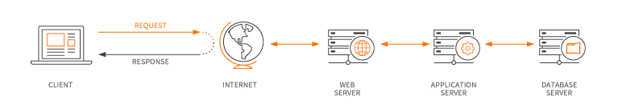

Figure 2.1 Demonstrate of data requesting and response by Client

Cross Site Scripting

Cross-site scripting (XSS) occurs when dynamically generated web pages display input that is not properly validated. This allows an attacker to embed malicious JavaScript code or script into the generated page and execute the script on the machine of any user that views that site. Cross-site scripting could potentially impact any site that allows users to enter data. This vulnerability is commonly seen on:
  - Search engines that echo the search keyword that was entered
  - Error messages that echo the string that contained the error
  - Forms that are filled out where values are later presented to the user
  - Web message boards that allow users to post their own messages.

An attacker who uses cross-site scripting successfully might compromise confidential information, manipulate or steal cookies, creating requests that can be mistaken for those of a valid user, or execute malicious code on the end-user systems.

Since cross-site scripting attacks are closely related to the web server package and the user’s web browser, a brief overview of HTML and HTTP will be useful before discussing the mechanics of specific cross-site scripting examples. (Spett, 2005).

The executable code of XSS is normally written in popular scripting and programming languages like JavaScript, vbscript, php etc. The pseudo code and the figure 2.2 show little demonstration of an XSS attack (Shah Junaid Latief, 2014).

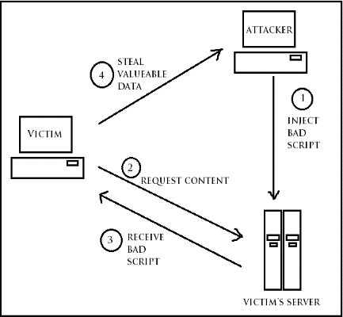

Figure 2.2 Operation of XSS

SQL Injection
SQL Injection is a vulnerability that results when you give an attacker the ability to influence the Structured Query Language (SQL) queries that an application passes to a back-end database. By being able to influence what is passed to the database, the attacker can leverage the syntax and capabilities of SQL itself, as well as the power and flexibility of supporting database functionality and operating system functionality available to the database. Any code that accepts input from an untrusted source and then uses that input to form dynamic SQL statements could be vulnerable.
These are the classification of SQL injection types according to Halfond, Viegas and Orso researches (Justin, 2009) .
- Tautology
This attack bypasses the authentication and access data through vulnerable input field using “where” clause by injecting SQL tokens into conditional query statements which always evaluates to true.
- Logically incorrect queries
The error message sent from database on being sending wrong SQL query may contain some useful debugging information. This could help in finding parameters which are vulnerable in the web application and hence in the database of the application.

- Union queries
The “Union” keyword in SQL can be used to get information about other tables in the database. And if used properly this can be exploited by attacker to get valuable data about a user from the database
- Piggy-backed Querie
This is the kind of attack where an attacker appends “;” and a query which can be executed on the database. It could be one of the very dangerous attacks on database which could damage or may completely destroy a table. If this attack is successful then there could be huge loss of data.
- Stored Procedure
It is an abstraction layer on top of database and depending on the kind of stored procedure there are different ways to attack. The vulnerability here is same as in web applications. Moreover all the types of SQL injection applicable for a web application are also going to work here.
- Blind Injection
It’s difficult for an attacker to get information about a database when developers hide the error message coming from the database and send a user to a generic error displaying page. It’s at this point when an attacker can send a set of true/false questions to steal data.
- Timing Attacks
In this kind of attack timing delays are observed in response from a database which helps to gather information from a database. SQL engine is caused to execute a long running query or a time delay statement with the help of if-then statement which depends on the logic that has been injected. It is possible to determine whether injected statement was true or false depending on how much time condition is true this code is injected to produce response delay in time.

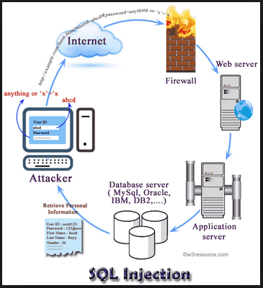

Figure 2.3 How SQL Injection Work
Some impact if attackers are success injecting SQL to web servers:
- An attacker can use SQL Injection to bypass authentication or even impersonate specific users.
- An SQL Injection vulnerability could allow the complete disclosure of data residing on a database server.
- An attacker could use SQL Injection to alter data stored in a database. Altering data affects data integrity and could cause repudiation issues.
- An attacker could use an SQL Injection vulnerability to delete data from a database. Even if an appropriate backup strategy is employed, deletion of data could affect an application’s availability until the database is restored.
- An attacker could use SQL Injection as the initial vector in an attack of an internal network that sits behind a firewall.

Differences between SQL Injection and Cross Site Scripting
Basically, both of it are aiming web application which has a form field which can be input by the user. But, SQL Injection is an attack which only trying to aiming web application database by injecting SQL query (database language query). In otherside, Cross Site Scripting is an attack which aiming user PC whose visit the site / page that already set up by the attackers, Cross Site Scripting specifically injecting some script such as javascript which will redirecting page into Hook Page ( page that is a trap set by attacker ).
Example of SQL Injection query:
- Select * from table user ;
- Drop table user;

Example of Cross Site Scripting script:
- <script>document.location’http://www.XSShookpage.com’ </script>
- <script>alert(‘document.cookie’)</script>

For more detail, I will show it in the two figure about the architecture of SQL Injection (Figure 2.4 SQL Injection Architecture) and Cross Site Scripting (Figure 2.5 Cross Site Scripting Architecture)
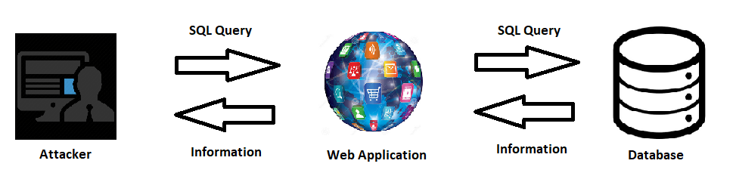

Figure 2.4 SQL Injection Architecture

Figure 2.4 show that the attacker by injecting SQL Query, the attacker can request all information directly into database.

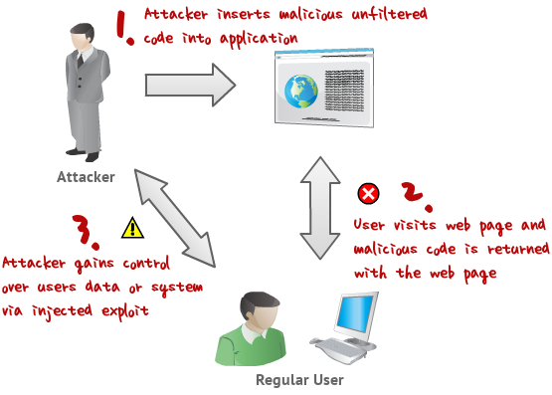

Figure 2.5 Cross Site Scripting Architecture

Figure 2.5 show that the attacker at first insert a hook page into web application page and then whenever there was an user visit that page, it will redirect into attacker page that make the attackers gains control over users data or system via injected exploit.

Web Application Firewall
To prevent malicious attacks, there are network appliances that are added to the computer network such as Intrusion Prevention System (IPS) and Intrusion Detection System (IDS). Both IPS and IDS help monitor the network but are only limited to detecting and notifying administrators about the abnormal network behavior and can still succumb to complex attacks or attacks that may not have been recognized by the system. IPS checks the signature of the attacks and must rely on patterns to determine if there is an attack. IPS do not have the ability to understand web application protocol logic and also cannot fully distinguish if a request is normal or malformed at the application layer. When IPS interrogate traffic against signatures and anomalies, WAF interrogate the behavior of logic of what is request and returned.
Firewalls are the first line of defense for web servers and by extension the rest of the network. Firewalls allow connections to pass through by following rules managed by network administrators. However, these rules are inadequate as time passes because it is difficult to distinguish whether a packet pattern is malicious or not, thus some legitimate connections are blocked, and some illegitimate connections are permitted. To better protect the network, the state-full packet inspection (SPI) firewall was developed. A SPI firewall checks the header and footer of a packet ensuring that it belongs to a valid session, but it does not check the data inside the packet. Which may still contain malicious content. Finally, a third generation of firewall known as Application Firewalls was developed, which checks not only the header and footer part of the packet but also the data portion. Based upon on the content of the packet the firewall now decides on whether to allow the packet or reject it and controls what type of traffic can be passed to the application layer of network service.
The web application firewall is a type of firewall that checks the data level of the packets to protect the application layer of the OSI model. By checking the data portion of the packets, more detailed information is revealed which is referred to as the granularity of a packet. For example, inside the HTTP header there would be http requests and inside http request would be user agents, cookies and more. Now being able to see this information, a more informed decision is now made in regards to the security controls for specific packets passed to the application.
The protection models used by existing web application firewalls are pertaining to traffic control. The inclusion of an access control on web application entities such as pages and files provide additional security. Examples of access control models are Role-based Access Control (RBAC) and Mandatory Access Control (MAC). RBAC model which is an access control technique where administrators can specify privileges and roles to provide access. This could be used to protect that web application from traffic flood from illegitimate users. MAC on the other hand provides control over file access. Access can be granted on a particular file based on the particular permission set.
The Web Application Firewall is installed as a running service in the web server or system it needs to protect, particularly the application layer level. Its main purpose is to check all incoming HTTP traffic, then accepts and drops the incoming HTTP traffic according to the rules that was set by the network administrator. The administrator through a text editor configures the rule-sets of the Web Application Firewall. A manual is provided for the syntax and format of the rules. The structure of the rules has the keywords “allow” or “reject” as its basis for the decision, followed by the different options of HTTP request headers and the value which the administrator wants to be checked in the payload. (Endraca, King, Nodalo, Maria, & Sabas, 2013). Figure 2.4 below will show the position of Firewall and Web Application Firewall.
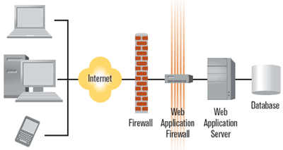

Figure 2.6 Web Application Firewall Architecture

OWASP ModSecurity Core Rule Set
Open Web Application Security Project or OWASP ModSecurity Core Rule Set (CRS) is a set of generic attack detection rules for use with ModSecurity or compatible web application firewalls. The CRS aims to protect web applications from a wide range of attacks, including the OWASP Top Ten, with a minimum of false alerts. (Curphey & Groves, 2006).

Attack Application
In this research, there will be needed some attack applications for testing ModSecurity in securing web Server from SQL Injection and Cross Site Scripting attacks. Those attack applications will be tested from 3 differences Operating System:
- Kali Linux Operating System
Kali Linux is an open source project that is maintained and funded by Offensive Security, a provider of world-class information security training and penetration testing services. (Kali.org)
- BackBox Operating System
BackBox is a penetration test and security assessment oriented Ubuntu-based Linux distribution providing a network and informatic systems analysis toolkit. BackBox desktop environment includes a complete set of tools required for ethical hacking and security testing. (Backbox.org)
- Parrot Operating System
Security GNU/Linux distribution designed with cloud pentesting and IoT security in mind.
It includes a full portable laboratory for security and digital forensics experts, but it also includes all you need to develop your own softwares or protect your privacy with anonymity and crypto tools. (Parrotsec.org)

Those attack application are:
- SQLMap
Sqlmap is an open source command-line automatic SQL injection tool that was released under the terms of the GNU GPLv2 license by Bernardo Damele A. G. and Daniele Bellucci.
Sqlmap is a command line tool that can assist an attacker in finding vulnerable injection points. Once it detects one or more SQL injections on the target host, attacker can perform an extensive back-end DBMS fingerprint; retrieve the DBMS session user and database, enumerate users, password hashes, privileges, and databases; dump the entire DBMS table/columns or the user’s specific DBMS table/columns; run custom SQL statements; read arbitrary files, and more.
Sqlmap will automatically test all the provided GET/POST parameters, the HTTP cookies, and the HTTP User-Agent header values; alternatively, attacker can override this behavior and specify the parameters that need to be tested. (Justin, 2009)

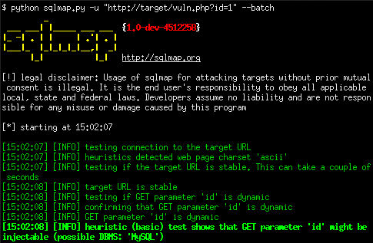

Figure 2.7 SQLmap Tools in Kali Linux

- BeeF XSS Framework
BeEF (Browser Exploitation Framwork) is a browser-based exploit package that "hooks" one or more browsers as beachheads for launching attacks. A user can be hooked by accessing a customized URL and continue to see typical web traffic, while an attacker has access to the user's session. BeEF bypasses network security appliances and host–based, antivirus applications by targeting the vulnerabilities found in common browsers, such as Internet Explorer and Firefox.
BeEF hooks one or more web browsers as beachheads for the launching of directed command modules. Each browser is likely to be within a different security context, and each context may provide a set of unique attack vectors. The framework allows the penetration tester to select specific modules (in real-time) to target each browser, and therefore each context.
The framework contains numerous command modules that employ BeEF's simple and powerful API. This API is at the heart of the framework's effectiveness and efficiency. It abstracts complexity and facilitates quick development of custom modules. (Muniz Jospeh, 2013)

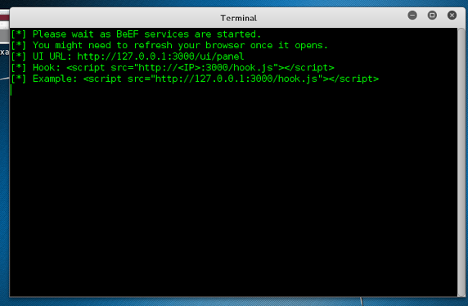

Figure 2.8 BeEF XSS Framework Application View in Kali Linux

- XSSer
Cross Site “Scripter” (aka X S Ser) is an open source penetration testing tool that automates the process of detecting, exploiting and reporting XSS vulnerabilities in web-based applications.
XSSer work by trying to inject Script to each line of the web server then return the result if the inject is success or fail. The Figure below will show the example of testing the vulnerable website for XSS Injections using XSSer. (Kali.org)
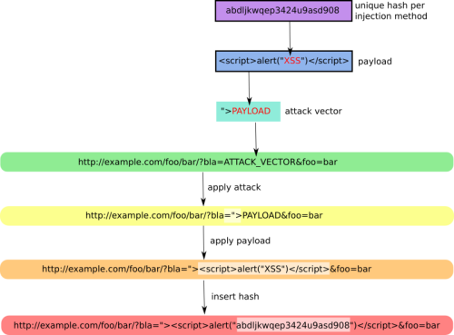

Figure 2.9 How XSSer work

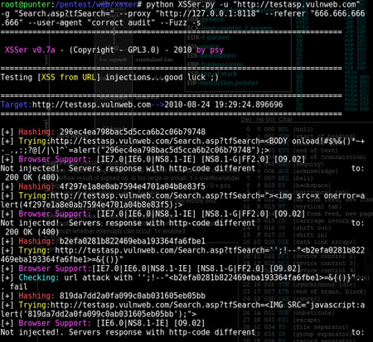

Figure 2.10 Testing vulnerable website using XSSer

Cpanel
Cpanel is a web hosting control software that can be accessed using any modern web browser. It is designed to make the complex task of managing hosting account easy. (Pedersen, 2006)

CloudLinux OS
CloudLinux OS is the leading platform for multitenancy. It improves server stability, density, and security by isolating each tenant and giving them allocated server resources. This creates an environment that feels more like a virtual server than a shared hosting account. By doing so, CloudLinux OS reduces operating costs and churn rates, and increases profitability.
CloudLinux OS is designed for shared hosting providers. It isolates each customer into a separate “Lightweight Virtualized Environment” (LVE), which partitions, allocates, and limits server resources, like memory, CPU, and connections, for each tenant. This ensures that tenants cannot jeopardize the stability of your servers, causing all sites to slow down or even come to a halt. CloudLinux OS also “cages” tenants from one another to avoid security breaches. This way, unstable scripts or malware are not able to sprawl across your customer sites, causing severe harm. (CloudLinux.com)

Simple Network Management Protocol
Simple Network Management Protocol (SNMP) is a protocol used to monitor and control networks from elsewhere (remote) (Syafrizal, 2005). There are several elements in SNMP such as:
  - Manager is the implementer and network management. This manager is an ordinary computer that resides on the network and operates software for network management. Manager will collect information from the agent in the form of information coming from the network requested by the administrator only.
  - Manager Information Base (MIB) is a database structure that describes what data has been obtained and what data can be controlled.
  - Agent is software that runs in every managed network element. Each agent has a local variable data abse that describes the state and the file of its activity and its effect on the operation. (Wardana, Novan & Handoko, 2009).

CHAPTER III
RESEARCH DESIGN
Web application will be assemble using KVM virtualization that consists of three virtual machines with CentOS operating system. The first virtual machine will be built as DNS server, the second and the third virtual machines will be built as web server.There will be also 3 PC that connect to the server to use as an Attacker Computer with Kali Linux, Backbox and Parrot Operating System.
Cpanel WHM version 66 will be installed on both web server. OWASP ModSecurity CRS package will be installed on of them. OWASP ModSecurity rules that will be configured are:
    - Request-901-Initialization
    - Request-905-Common-Exceptions
    - Request-910-IP-Reputation
    - Request-912-DOS-Protection
    - Request-913-Scanner-Detection
    - Request-920-Protocol-Enforcement
    - Request-921-Protocol-Attack
    - Request-930-Application-Attack-LFI
    - Request-931-Application-Attack-RFI
    - Request-933-Applicaton-Attack-PHP
    - Request-941-Application-Attack-XSS
    - Request-942-Application-Attack-SQLI
    - Request-943-Application-Attack-Session
    - Request-949-Blocking-Evaluation
    - Response-950-Data-Leakages
    - Response-951-Data-Leakages-SQL
    - Response-952-Data-Leakages-Java
    - Response-953-Data-Leakages-PHP
    - Response-954-Data-Leakages-IIS
    - Response-980-Correlation

Network Topology
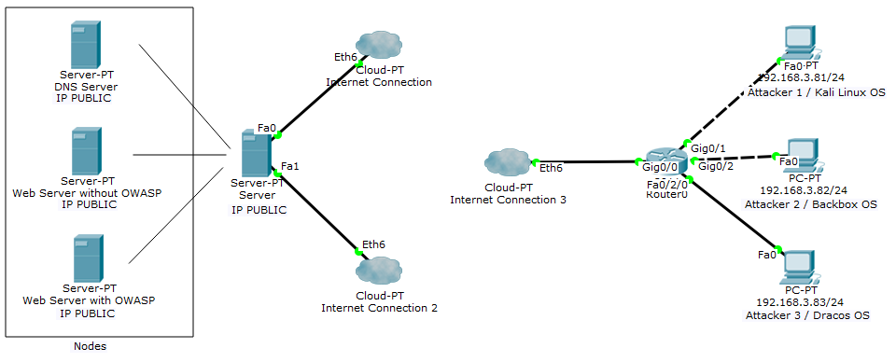
Network Topology that will be built in this research can be seen in the Figure 3.1:

Figure 3.1 Network Topology
Base on Figure 3.1, there are two networks that been connected using a router. In the left network, there are 3 servers: DNS Server, Web Server without OWASP, and Web Server with OWASP, and in the right network are 3 computer that will be use as attacker computer. Detail information will be put in the Table 3.1:
Table 3.1 IP Address Table
Device | Interface | IP Address | Prefix Length | Function
Server | Fa0 | Public IP | /24 | Physic Server
Node1 | Fa0 | Public IP | /24 | DNS Server
Node2 | Fa0 | Public IP | /24 | Web Server without OWASP
Node3 | Fa0 | Public IP | /24 | Web Server with OWASP
PC 1 | Fa0 | 192.168.3.81 | /24 | Attacker 1
PC 2 | Fa0 | 192.168.3.82 | /24 | Attacker 2
PC 3 | Fa0 | 192.168.3.83 | /24 | Attacker 3
Router 1 | Gig0/0 | Public IP | /24 | Router to Switch
 | Gig0/1 | 192.168.3.1 | /24 | Router
 | Gig0/2 | 192.168.3.1 | /24 | Router
 | Fa 0/2/0 | 192.168.3.1 | /24 | Router

Hardware Specification
Detail information of the hardware that will be use in this Final Project:
- Server
PC Server that will be use as Server with specification as Table 3.2:
Table 3.2 Server PC Specification
Information | Specification
Processor | Intel(R) Core(TM) i7-4790 CPU @ 3.60GHz (8 CPUs),~3.6GHz
Hard Disk | 100 GB
Memory | 8 GB
IP Address | Public

- Node
Specification for the Node:
Table 3.3 Node Specification
Information | Specification
Processor | 1 unit
Hard Disk | 50 GB
Memory | 2 GB
Role | Node1 = DNS Server,  Node2 = Web Server without OWASP,  Node3 = Web Server with OWASP

- Attacker PC
Specification for Attacker PC:
Table 3.4 Attacker PC Specification
Information | Specification
Processor | Intel(R) Core(TM) i7-4790 CPU @ 3.60GHz (8 CPUs),~3.6GHz
Hard Disk | 100 GB
Memory | 2 GB
Operating System Attacker 1 | Kali Linux OS
Operating System Attacker 2 | Backbox OS
Operating System Attacker 3 | Parrot OS

Testing Method

There will be some testing method in this final project such as:

SQL Injection
This testing method will try to injecting SQL using 7 classification types of SQL Injection according to Halfond, Vegas, and Orso researched (Justin, 2009). This testing is use to checking the parse method of the web application, GET and POST, are they vulnerable to be do a SQL Injection. The Scenario will be one of those attackers will visit target website using browser, then testing 7 kinds of SQL Injection for checking vulnerable. This testing will be done in both web server (webserver with OWASP Web Application Firewall and webserver without OWASP Web Application Firewall).

SQL Injection using SQLmap tool
Second testing method will be done by using SQLmap application in Kali Linux. SQLmap will scan and find vulnerable of the web server then inform it to the attacker, this testing will try to check if attackers can get information such as database name, table information and also SQL inject to the database. This testing method will be done thrice at differences Operating System (Kali Linux, Backbox and Parrot). Each of the Operating System will use SQLmap to penetrate the servers (Web Server with OWASP and Web Server without OWASP) for 10 times for each web server.
Response time, CPU Load, Disk Usage, Memory Usage, OWASP response and the result of SQL injection using SQLmap will be used for analysis.

XSS ( Cross Site Scripting ) using BeEF Framework tool
Third testing method is Cross Site Scripting testing using BeEF Framework. Attacker will using BeEF for doing a penetration tester to assess the actual security posture of a target environment by using client-side attack vectors. If BeEF can successfully penetrating web server, it can inject a script that can get user information such as cookies, etc. This testing method will be done thrice at differences Operating System (Kali Linux, Backbox and Parrot). Each of the Operating System will use BeEF Framework to penetrate the servers (Web Server with OWASP and Web Server without OWASP) for 10 times for each web server.
Response time, CPU Load, Disk Usage, Memory Usage, OWASP response and the result of Cross Site Scripting using BeEF will be used for analysis.

XSS ( Cross Site Scripting ) using XSSer
Fourth test will be use XSSer. This application will be scanning whole HTML or PHP coding that use to build a web server then try to inject a code to each line. The result of the scan is, XSSer will inform the number of success and fail injection. This testing method will be done thrice too at three Operating System (Kali Linux, Backbox and Parrot). XSSer will be used to penetrate the servers (Web Server with OWASP and Web Server without OWASP) for 10 times for each web server.
Response time, CPU Load, Disk Usage, Memory Usage, OWASP response and the result of Cross Site Scripting using XSSer will be used for analysis.

Performance Testing
The last testing will be performance testing, this testing will be do for comparing the performance of the web server that already implementing OWASP with the one without OWASP. Some metric that will be use are:
- Percentage of CPU Load, Disk Space, Memory and Network Statistic when service is on going.
- Response time that need by the web server to responsing request from the client.
This testing will using SNMP tool that will be install in physic server with maximal 100 clients access or requesting in the same time and using PRTG Network Monitor to collecting the data from SNMP for analyze it specifics.

Analyze
After doing some testing at web servers. All the data that collected by PRTG Network Monitor will be analyze to make a conclusion of this research. Details of the research testing can be see at the table 3.5 and table 3.6:
Table 3.5 below will show the result of Web Server with OWASP response by kind of attacks.

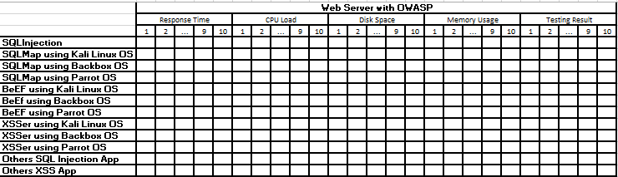
Table 3.5 Research Testing I

Table 3.6 below will show the result of Web Server with OWASP response by kind of attacks.
Table 3.6 Research Testing II
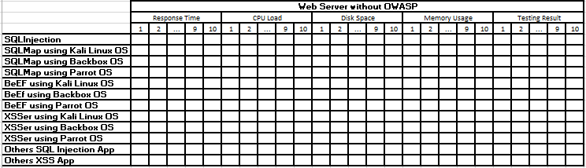

Response Time, CPU Load, Disk Space and Memory Usage are use to analyze the performance of the server while implementing OWASP and without implementing OWASP. The Testing Result is for analyze are the response of OWASP when there was an attack by attackers before and after implementing OWASP. In the report, both of the table also will be presented in chart for analysis purpose.

CHAPTER IV
RESULT AND ANALYSIS

RESULT
WHM/Cpanel is a hosting application that been installed on a server. Physic Server was built using CentOS as the operating system and using KVM as virtualization. This server contain three virtual machines, which also using CentOS Operating System. The first virtual machine named centosTA is used to build DNS Server for naming the second and third virtual machines into a hierarchy of domains. Second virtual machine named web1 is used to installing WHM/CPanel hosting application with OWASP ModSecurity Web Application Firewall, the hostname of this server is web1.robinsonta.pcr.ac.id. Last virtual machine named web2 is used to installing WHM/CPanel hosting application without OWASP ModSecurity Web Application, the hostname of this server is web2.robinsonta.pcr.ac.id.
Three of those virtual machines include physic server are applied IP Public to make sure the domain can be connect from outside. After the connection has been successed, a damn vulnerabilities web application will be use as the content of both sites on the second and third web server for testing the vulnerabilities of the sites. OWASP ModSecurity Web Application Firewall also been installed on web1 to secure web1.robinsonta.pcr.ac.id damn vulnerabilities web application.

Server Configuration
At first, Network configuration was done in the server physic for bridging physic server connection with virtual machines and also applying Public IP address for network connection.
As shown below, at first there is three connections detected. Then, we have to set the em1 connection bridge with virbr0. After that, configure the Public IP Address at virbr0.
Figure 4.1 show the list of IP Address in Physic Server and Figure 4.2 show the config of em1 conneciton. Figure 4.3 show the config of the virbr0 connection.
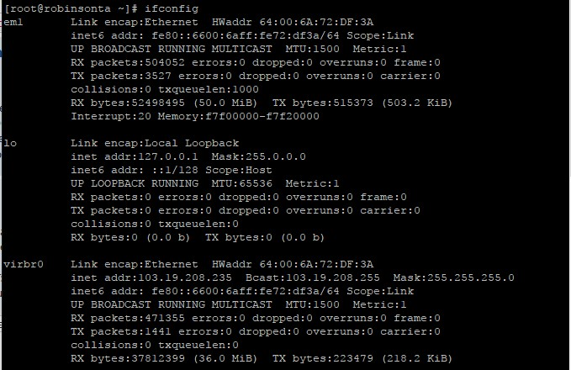

Figure 4.1 Physic Server IP Address
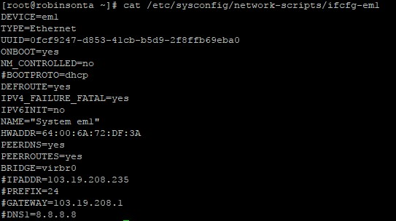

Figure 4.2 em1 Connection File Configuration
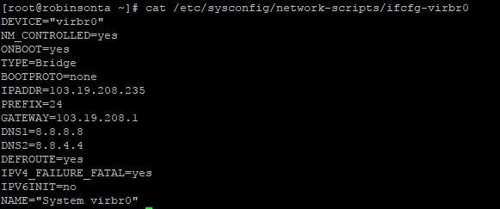

Figure 4.3 virbr0 Connection File Configuration

After physic server already been configured, the next step is installing KVM using virtualization to create 3 virtual machines as shown in the Figure 4.4:

Figure 4.4 Kernel Virtual Machine List

DNS Server centosTA
On the first virtual machine has been done configuration in named.conf file that place at /etc folder. After that, file forward and reverse also been configured same as the content of named.conf file and stored at /var/named/ folder. After all of those configuration has been done, DNS Server can be run with the result as shown on the Figure 4.5. :
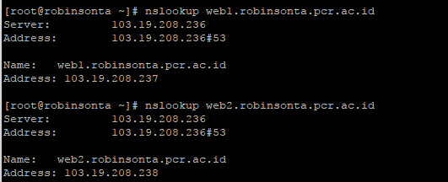

Figure 4.5 Nslookup to web server result

Web Server web1 and Web Server web2
Second and third virtual machine with name web1 and web2 will be use as web server to store and deliver web pages to clients. Cause of this research is using Cpanel/WHM, so web server only need to be installed cpanel/whm, for content of sites will be configure later using browser interface.
Figure 4.6 Download and start Cpanel Installation
After we type the command as shown on the Figure 4.6, the installation of the Cpanel will be start and it will be take about 1 till 2 hours time, we need to wait after the installation finish as shown on the Figure 4.7 below.
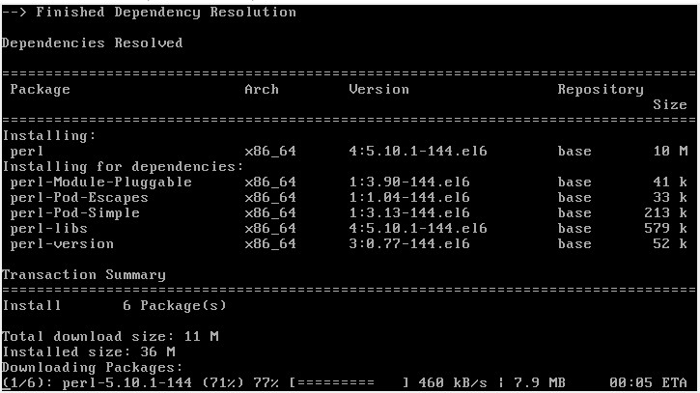

Figure 4.7 Cpanel Installation on Progress
After cpanel installation finish, we have to continue cpanel installation process in Graphic mode using browser from windows. To continue the configuration, we have to connect to port 2087 or whm.

WHM Configuration
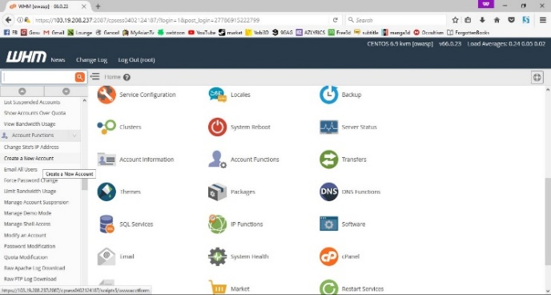
Otherside, after finish the installation of whm, we have to create an account of our domain for login into Cpanel. First, login into whm then choose the Create an Account menu on Account Function as shown on the Figure 4.8

Figure 4.8 Create Account Menu in WHM
Fill the domain information of first web server on the form as show on the Figure 4.9. The domain we use is web1.robinsonta.pcr.ac.id with user name web1.
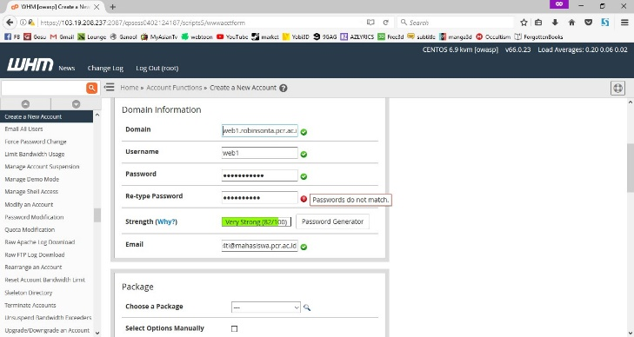

Figure 4.9 Account Information Form
We can check the account that we already created from the menu List Account in Account Information. Figure 4.10 below is the picture of account in first web server whm.
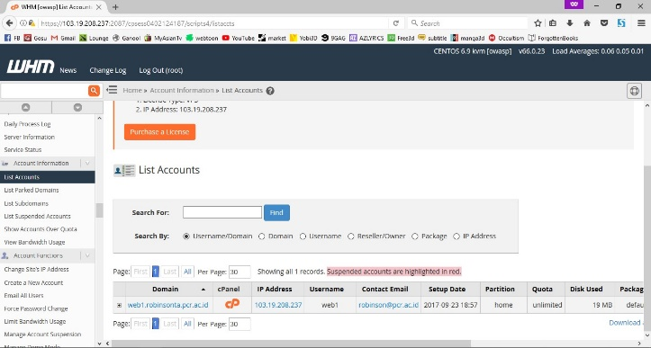

Figure 4.10 List Account on web1 server
Repeat the configuration for second web server with the IP 103.19.208.238 on port 2087 / WHM. After that the list account of the second web server will be shown at the Figure 4.11 below:

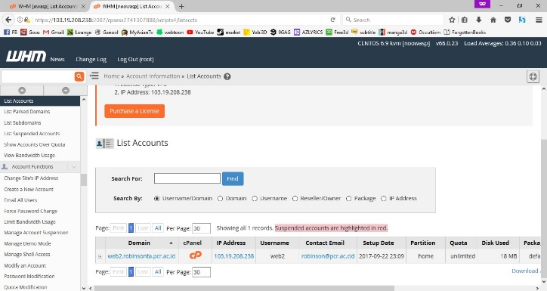

Figure 4.11 List Account on web2 server

Cpanel Configuration
For Cpanel Configuration, we need to open the web server using IP then with the port 2083. The picture below will show the interface of CPanel port of web1 web server. Then we have to login using the account we created before as show at the Figure 4.12.
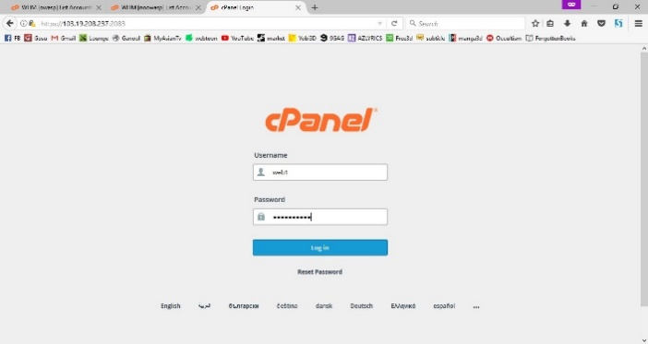

Figure 4.12 Cpanel Login Form
Information of our web server will be shown in the right side of the home interface in Cpanel as show at the Figure 4.13 and 4.14 below.

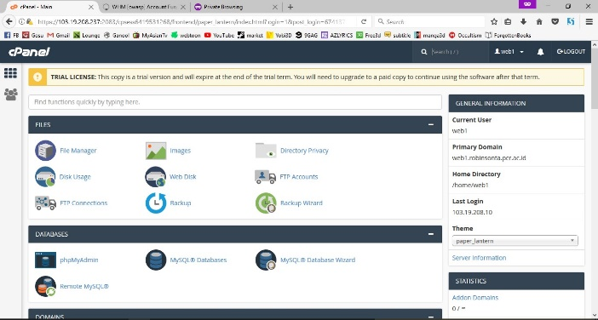

Figure 4.13 Cpanel User Index Interface on web1 server
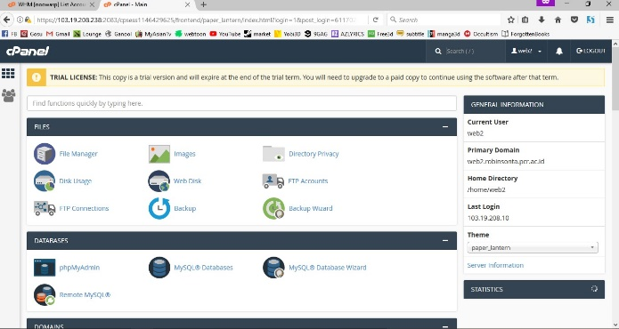

Figure 4.14 Cpanel User Index Interface on web1 server

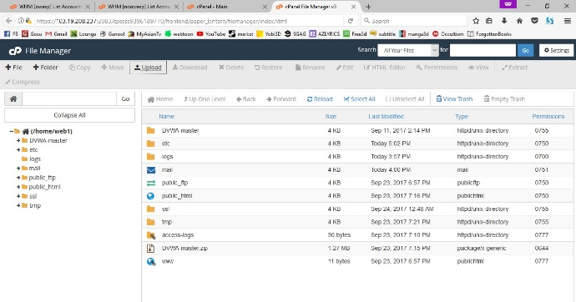
After that, we will use the DVWA as the content of the both server. On Cpanel, we choose File Manager then Upload the Damn Vulnerable Web Application as shown on the Figure 4.15.

Figure 4.15 web1 server File Manager Interface
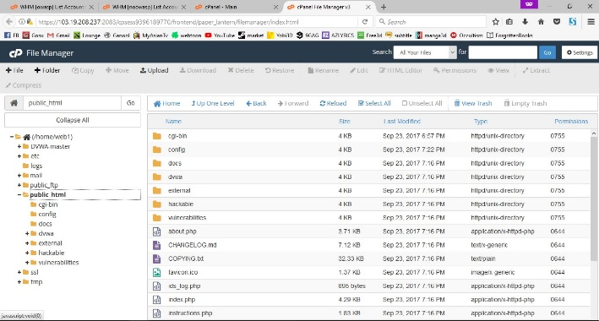
Then extract it and copy all of the files in DVWA-master folder to public_html folder as show in the Figure 4.16

Figure 4.16 web2 server File Manager Interface
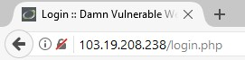
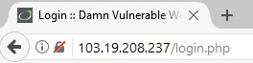
Now, both of the web server already for testing the vulnerable, we can access the web using domain such as web1.robinsonta.pcr.ac.id in web browser as Figure 4.17(i) and 4.17(ii) or by using IP address such as 103.19.208.237 as Figure 4.18(i) and 4.18(ii).

(ii)

(i)
Figure 4.17 (i) web1 access using IP (ii) web2 access using IP

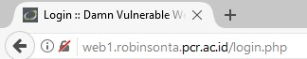
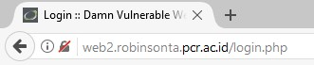
(ii)

(i)

Figure 4.18 (i) web1 access using domain (ii) web2 access using domain

OWASP ModSecurity Configuration
As the purpose of this research, now we would like to install a web application firewall on one of our web server (web1) or web1.robinsonta.pcr.ac.id.
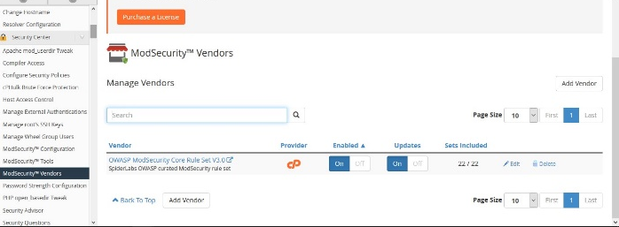
First we need to login into our whm then choose ModSecurity™ Vendors on Security Center menu. Click on the installation button to install OWASP ModSecurity Core Rule Set V3.0. The OWASP ModSecurity Core Rule Set now already installed on your Cpanel as show in the Figure 4.19.

Figure 4.19 OWASP ModSecurity™ Activation in WHM on web1 server

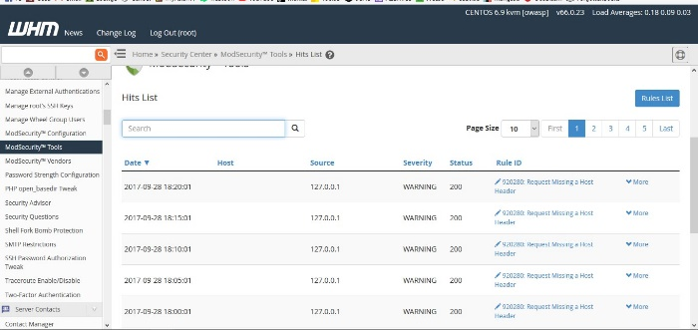
For checking the hits list or traffic log of the web server, we can choose menu ModSecurity™ Tools in Security Center menu as show in the Figure 4.20.

Figure 4.20 OWASP ModSecurity™ Hit List on Tools menu
Each number of the status above has its own definition which will be describe at the Table 4.1:
Table 4.1 Status Code Description
Status Code | Message | Description
200 | OK | Response to a successful REST API action. The HTTP method can be GET, POST,PUT,PATCH or DELETE
201 | Created | The request has been fulfield and resource created. A URI for the created resource is returned in the Location Header
202 | Accepted | The request has been accepted for processing, but processing is not yet complete
400 | Bad Request | The request is malformed, such as message body format error
401 | Unauthorized | Wrong or no authentication ID/password provided
403 | Forbidden | It’s used when the authentication succeded but authenticated user doesn’t have permission to the request resource
404 | Not Found | When a non-existent resource is requested
406 | Unacceptable | The client presented a content type in the Accept header which is not supported by the server API
405 | Method Not Allowed | The error for an unexpected HTTP method.
413 | Payload too large | Use it to signal that the request size exceeded the given limit e.g. regarding file uploads
415 | Unsupported Media Type | The requested content type is not supported by REST service
429 | Too Many Requests | The error is used when there may be DOS attack detected or the request is rejected due to rate limiting

For modify or add rule, we can choose menu Rules List. Rule List contains all of the rules that used to protect or secure our web server as show in the Figure 4.21. We can modify it according to what we want.
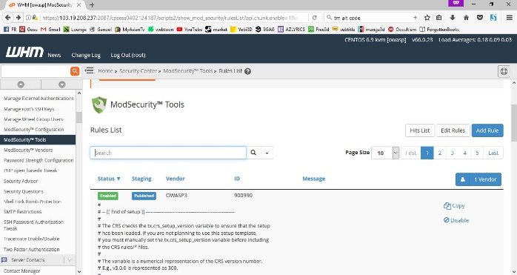

Figure 4.21 Rule List Configuration I
We can enable or disable OWASP rule in menu Config File on ModSecurity™ Vendor as show in the Figure 4.22.
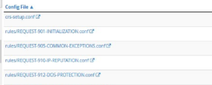

Figure 4.22 Rule List that provided by OWASP ModSecurity™ Tool

OWASP ModSecurity Rule Explanation
OWASP ModSecurity provided about 400 more rule to secure web application from malicious attacks. Among all of those attack, there is 49 Rules for SQL Injection Prevention and 35 Rules for Cross Site Scripting Prevention. For the rules that provided by OWASP ModSecurity, user only can choose to apply it or not but can’t modify the default rules. Rather than modify the default rule, Users are allow to make a new rule for own security condition.
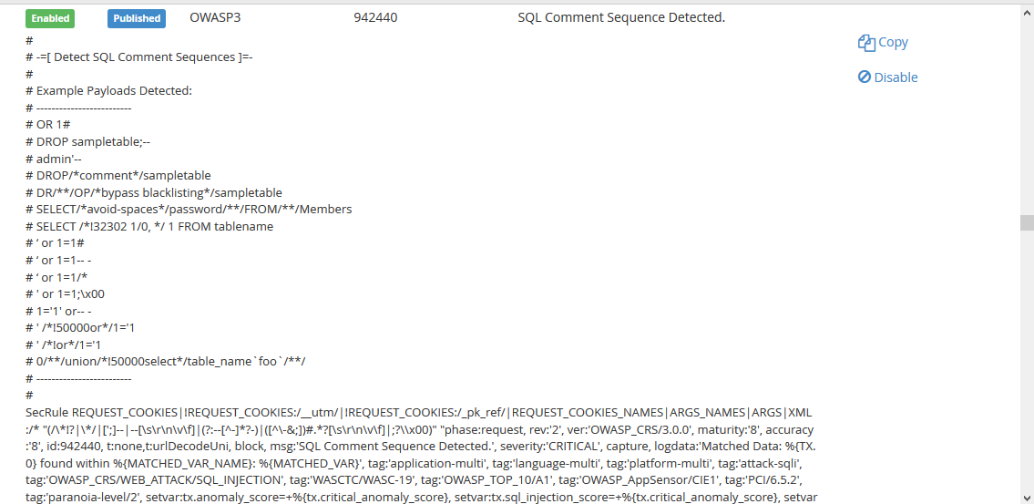
Figure 4.23 below will show one of the default SQL Injection rule provided by OWASP ModSecurity.

Figure 4.23 One of the default SQL Injection prevention Rules

Rule in the figure 4.23, works by comparing any input by users, are the inputs match the Payloads Example that are write down in the Rule such as : admin’--, OR 1#, ‘or 1=1 -- -, etc. If there is an input that match the payload, the Rule will be active and prevent the request also displaying the information into Hit List.
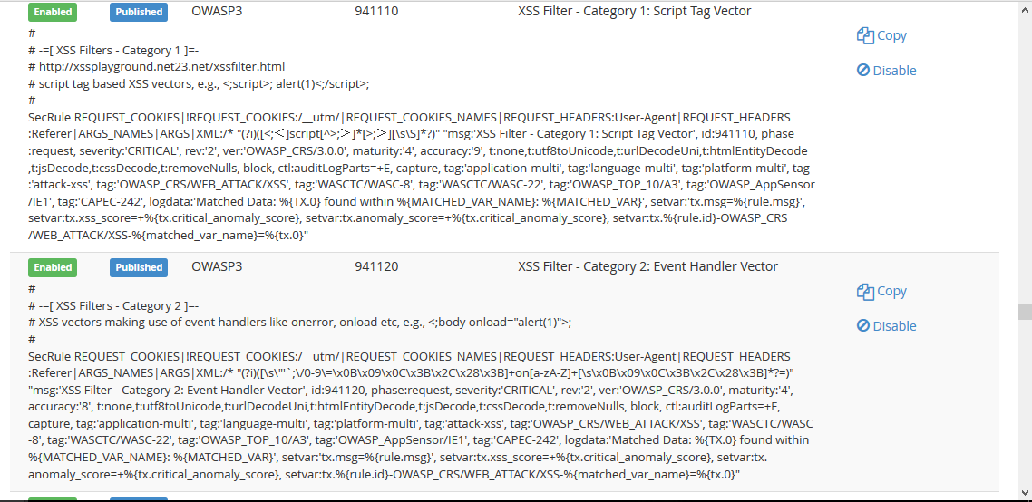
Figure 4.24 below will show some of the Cross Site Scripting rule provided by OWASP ModSecurity.

Figure 4.24 Cross Site Scripting Prevention Rule provided by OWASP

Rule in the figure 4.26 works by filtering the Header or URL of the web application, whenever there was a character such as : /*<;[]?\$ , etc inside the URL bar, it will return giving alarm and prevent in to making request.
Figure 4.25 will show the rule that add by the author for trying to counter Cross Site Scripting Stored type attack.
Figure 4.25 Cross Site Scripting customization rule

Rule in the figure 4.25 was made for preventing Cross Site Scripting Stored Type attack. This rule only filtering input in the page /vulnerabilities/xss_s , whenever there was a input that contain < > () \ “’; character by user, the rule will active and giving alarm in the Hit List.

Testing and Analyze

SQL Injection
This testing method will try to injecting SQL using 7 classification types of SQL Injection according to Halfond, Vsegas, and Orso researched (Justin, 2009). This testing is use to checking the parse method of the web application, GET and POST, are they vulnerable to be do a SQL Injection. The Scenario will be one of those attackers will visit target website using browser, then testing 7 kinds of SQL Injection for checking vulnerable.

Tautology
This attack bypasses the authentication and access data through vulnerable input field using “where” clause by injecting SQL tokens into conditional query statements which always evaluates to true.
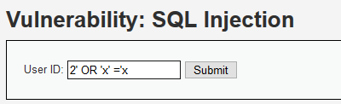
Query: a’ OR ‘1=1

Figure 4.26 Tautology Query
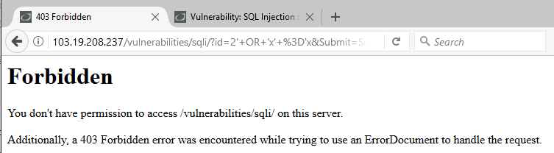
Injection Result in OWASP web1 server will be show in the Figure 4.27:

Figure 4.27 Tautology result on OWASP web1 server
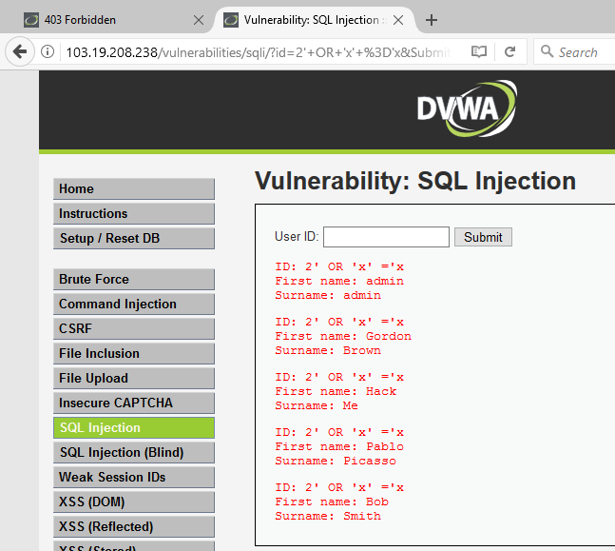
Injection Result in NOOWASP web2 server will be show in the Figure 4.28:

Figure 4.28 Tautology result on NOOWASP web2 server

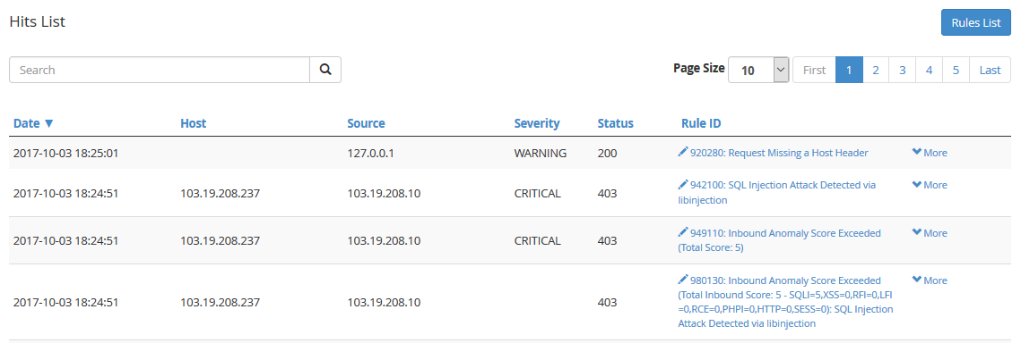
OWASP ModSecurity Tool Hit Lists:

Figure 4.29 Tautology OWASP ModSecurity Tools Detection

Description:
Query a’ or ‘1=1 was failed to inject into web1 server form field which also returning a 403 forbidden page, but in otherside, this query success to return true statement when placed over web2 server form field which cause the database to print all of the id, first_name, last_name inside database.

Logically incorrect queries
The error message sent from database on being sending wrong SQL query may contain some useful debugging information. This could help in finding parameters which are vulnerable in the web application and hence in the database of the application.
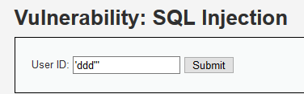
Query: ‘ddd'"

Figure 4.30 Logically incorrect Query
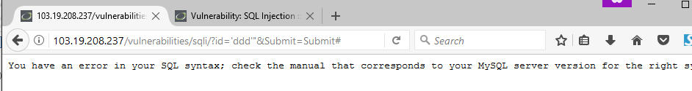
Injection Result in OWASP web1 server will be show in the Figure 4.31.

Figure 4.31 Logically Incorrect Queries result on OWASP web1 server

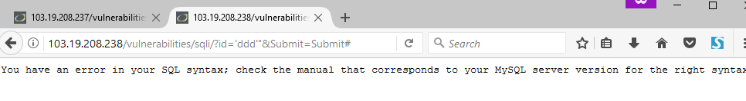
Injection Result in NOOWASP web2 server will be show in the Figure 4.32.

Figure 4.32 Logically Incorrect Queries result on OWASP web1 server

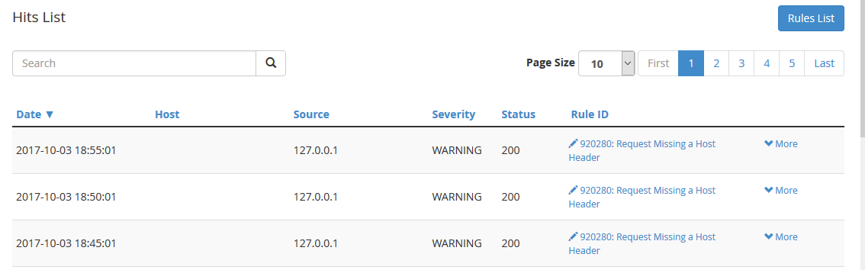
OWASP ModSecurity Tool Hit Lists:

Figure 4.33 OWASP ModSecurity Tools Logically Incorrect Query Injection Detection
Description:
Query ‘ddd’” which purpose to catch some useful debugging information of the database successfully inject to both of the web server. OWASP ModSecurity Tools failed to detect this attack cause of this action isn’t contain any harm SQL query that may cause data lost.

Union Queries
The “Union” keyword in SQL can be used to get information about other tables in the database. And if used properly this can be exploited by attacker to get valuable data about a user from the database
Query: 2' UNION SELECT password from users where user_id=1 - -"
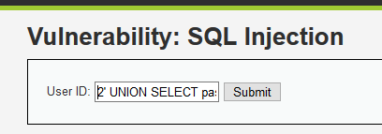

Figure 4.34 Union Query

Injection Result in OWASP web1 server will be show in the Figure 4.35:
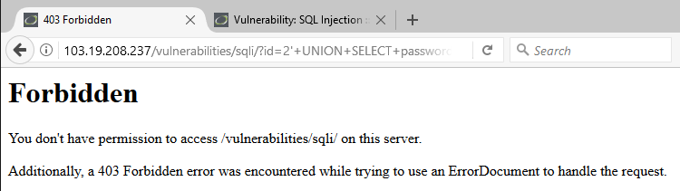

Figure 4.35 Union Query Result on OWASP web1 server

Injection Result Result in No OWASP web2 server will be show in the Figure 4.36:

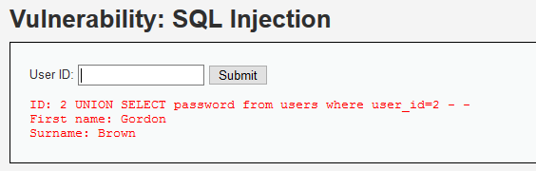

Figure 4.36 Union Query Result on NOOWASP web2 server
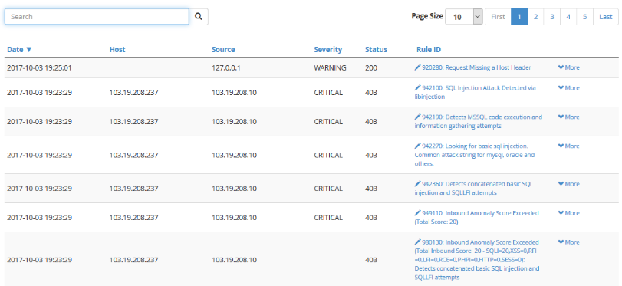
OWASP ModSecurity Tool Hit Lists :

Figure 4.37 OWASP ModSecurity™ Tools Union Query Detection

Description:
Union Query was failed to inject into web1 server form field which also returning a 403 forbidden page, but in otherside, this query success to inject into database when placed over web2 server. Figure 4.35 has been shown that the result of the injection didn’t show the password, that caused by the php file of web2 server, only display id, first_name, and last_name. So there isn’t any variable to be fill and display the password that has been retrieved.

Piggy-backed Queries
This is the kind of attack where an attacker appends “;” and a query which can be executed on the database. It could be one of the very dangerous attacks on database which could damage or may completely destroy a table. If this attack is successful then there could be huge loss of data.
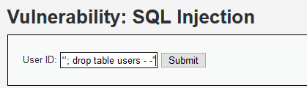
Query: “’; drop table users - -”

Figure 4.38 Piggy-backed Query
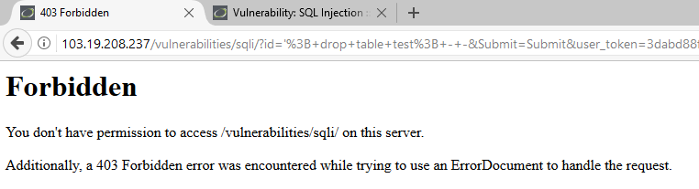
Injection Result in OWASP web1 server will be show in the Figure 4.39:

Figure 4.39 Piggy-backed Query result on OWASP web1 server

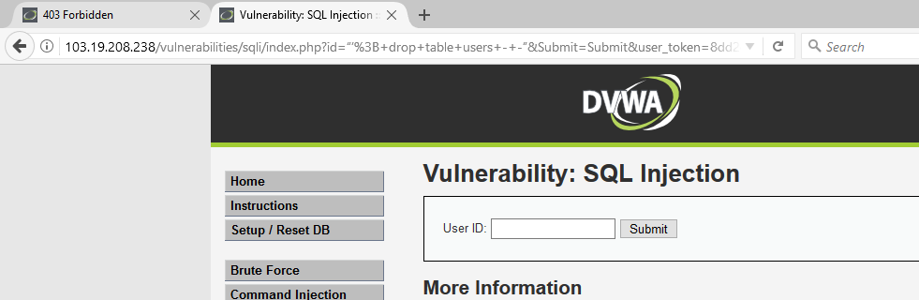
Injection Result in NOOWASP web2 server will be show in the Figure 4.40:

Figure 4.40 Piggy-backed Query result on NOOWASP web2 server

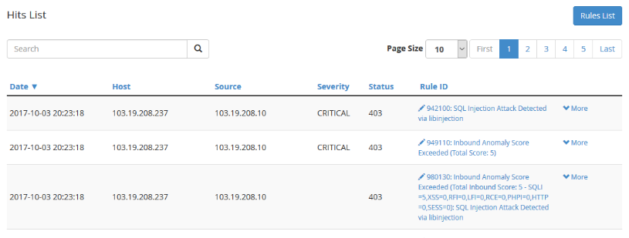
OWASP ModSecurity™ Tool Hit Lists :
Figure 4.41 OWASP ModSecurity Tools Piggy-backed Query Detection

Description:
Piggy-backed Query was failed to inject into web1 server form field which also returning a 403 forbidden page, but this query also failed to inject into database when placed over web2 server. NOOWASP web2 server isn’t drop any table cause by that query. This probably cause by the version patching by MySql itself. MySql database that used by both of the servers is the current up to date version, which may cause some harm or aprosthrope sql already been patch by the company itself.

Stored Procedure
It is an abstraction layer on top of database and depending on the kind of stored procedure there are different ways to attack. The vulnerability here is same as in web applications. Moreover all the types of SQL injection applicable for a web application are also going to work here.
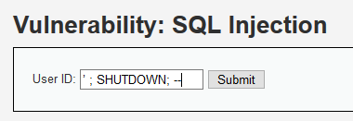
Query: ‘ ; SHUTDOWN; --

Figure 4.42 Stored Procedure Query
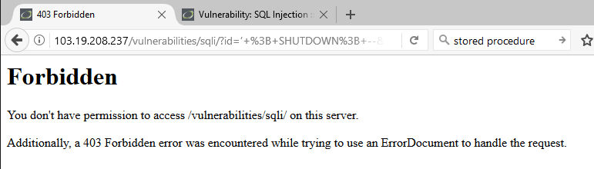
Injection Result in OWASP web1 server will be show in the Figure 4.43 :

Figure 4.43 Stored Procedure Query result on OWASP web1 server

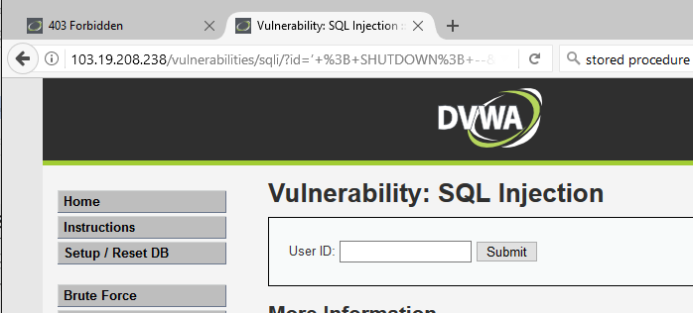
Injection Result in NOOWASP web2 server will be show in the Figure 4.44 :

Figure 4.44 Stored Procedure Query result on NOOWASP web2 server

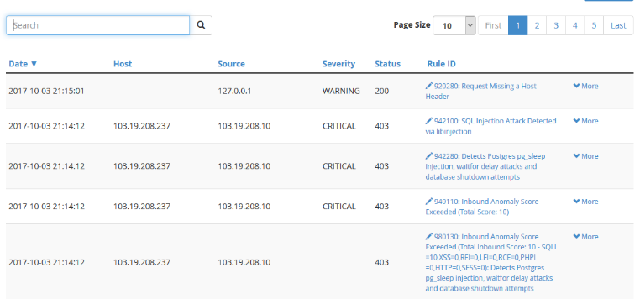
OWASP ModSecurity™ Tool Hit Lists :
Figure 4.45 OWASP ModSecurity™ Tools Stored Procedure Query Detection

Description :
The same problem with Stored Procedure Query Detection.This Query was failed to inject into web1 server form field which also returning a 403 forbidden page, but this query also failed to inject into database when placed over web2 server. NOOWASP web2 server isn’t drop any table cause by that query. This probably cause by the version patching by MySql itself. MySql database that used by both of the servers is the current up to date version, which may cause some harm or aprosthrope sql already been patch by the company itself.

Blind Injection
It’s difficult for an attacker to get information about a database when developers hide the error message coming from the database and send a user to a generic error displaying page. It’s at this point when an attacker can send a set of true/false questions to steal data.
Query: legalUser’ and 1=1 - -“
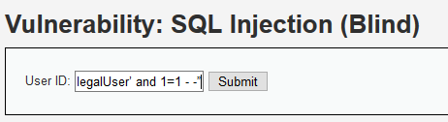

Figure 4.46 Blind Injection Query
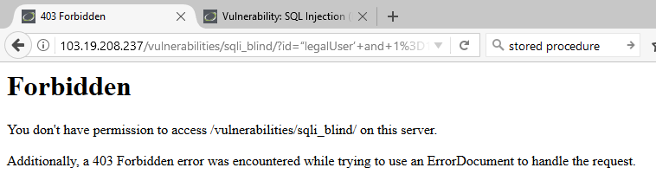
Injection Result in OWASP web1 server will be show in the Figure 4.47:

Figure 4.47 Blind Injection Query result on OWASP web1 server
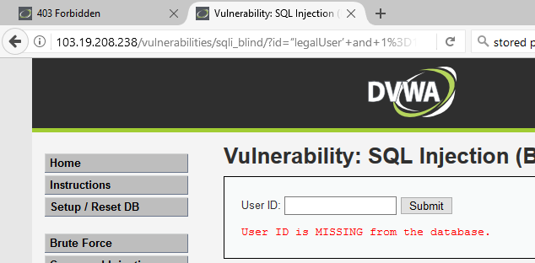
Injection Result in NOOWASP web2 server will be show in the Figure 4.48:

Figure 4.48 Blind Injection Query result on NOOWASP web2 server

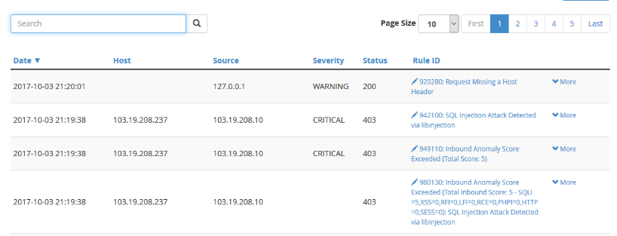
OWASP ModSecurity™ Tool Hit Lists:

Figure 4.49 OWASP ModSecurity Tools Blind Injection Query Detection

Description:
Stored Procedure Query Detection Query was failed to inject into both web server. OWASP web1 server returning a 403 forbidden page. NOOWASP web2 server also only return missing ID from database. This probably cause by the version patching by MySql itself. MySql database that used by both of the servers is the current up to date version, which may cause some harm or aprosthrope sql already been patch by the company itself.

Timing Attacks
In this kind of attack timing delays are observed in response from a database which helps to gather information from a database. SQL engine is caused to execute a long running query or a time delay statement with the help of if-then statement which depends on the logic that has been injected. It is possible to determine whether injected statement was true or false depending on how much time condition is true this code is injected to produce response delay in time.

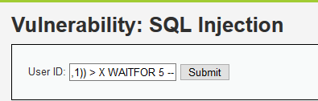
Query: legalUser’ ASCII (SUBSTRING((select top 1 name from sysobjects),1,1)) > X WAITFOR 5 –

Figure 4.50 Timing Attack Query
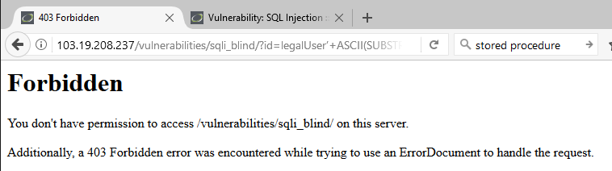
Injection Result in OWASP web1 server will be show in the Figure 4.51.

Figure 4.51 Timing Attack result on OWASP web1 server

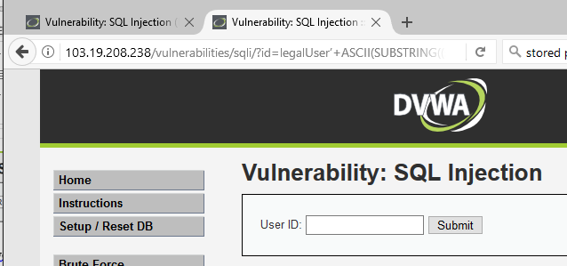
Injection Result in NOOWASP web2 server will be show in the Figure 4.52:

Figure 4.52 Timing Attack result on NOOWASP web2 server

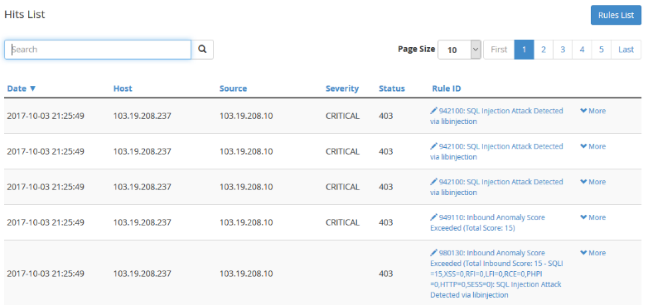
OWASP ModSecurity™ Tool Hit Lists:

Figure 4.53 OWASP ModSecurity Tool Timing Attack Detection

Description:
Timing Attack Query was failed to inject into web1 server form field which also returning a 403 forbidden page, but this query also failed to inject into database when placed over web2 server. NOOWASP web2 server isn’t show any information in return. This probably cause by the version patching by MySql itself. MySql database that used by both of the servers is the current up to date version, which may cause some harm or aprosthrope sql already been patch by the company itself.

15 times 7 kind SQL Injection
7 kind of SQL Injection as the point IV.2.1.7 was also done 15 times in 3 difference OS (Kali Linux OS 5 times, Back Box OS 5 times, and Parrot OS 5 times). The result of the Testing will be show in the Table 4.2 and 4.3.
Table 4.2 15 times SQL Injection result on OWASP web server.
SQL Injection type | Testing Variabel
 | HTTP Response | CPU Load /5 Minutes | Free Memory | Free Disk
Before Testing | 11 Msec | 0,056 | 3% or 36 Mbyte | 2,398 Mbyte
Tautology | 13 Msec | 0,048 | 5% or 56 Mbyte | 2,396 Mbyte
Logically | 13 Msec | 0,067 | 6% or 59 Mbyte | 2,395 Mbyte
Union Query | 12 Msec | 0,072 | 7% or 67 Mbyte | 2,394 Mbyte
Piggy Back | 12 Msec | 0,075 | 7% or 69 Mbyte | 2,394 Mbyte
Stored Procedure | 13 Msec | 0,078 | 7% or 70 Mbyte | 2,393 Mbyte
Blind Injection | 20 Msec | 0,081 | 7% or 70 Mbyte | 2,393 Mbyte
Timing Attacks | 13 Msec | 0,082 | 7% or 69 Mbyte | 2,393 Mbyte
Analyzing from the result on table 4.2. SQL Injection didn’t affect too much the HTTP Response time, CPU Load, Free Memory and Free Disk on OWASP web server. As we can see from the HTTP response result showing the stable condition before and after attack, also other variable didn’t increasing or decreasing in a large number.
Table 4.3 15 times SQL Injection result on NOOWASP web server.
SQL Injection type | Testing Variabel
 | HTTP Response | CPU Load /5 Minutes | Free Memory | Free Disk
Before Testing | 13 Msec | 0,7 | 22% or 249 Mbyte | 2,173 Mbyte
Tautology | 13 Msec | 0,68 | 18% or 180 Mbyte | 2,169 Mbyte
Logically | 14 Msec | 0,72 | 16% or 147 Mbyte | 2,211 Mbyte
Union Query | 13 Msec | 0,72 | 14% or 123 Mbyte | 2,225 Mbyte
Piggy Back | 13 Msec | 0,7 | 12% or 121 Mbyte | 2,224 Mbyte
Stored Procedure | 13 Msec | 0,68 | 12% or 117 Mbyte | 2,225 Mbyte
Blind Injection | 15 Msec | 0,74 | 12% or 117 Mbyte | 2,225 Mbyte
Timing Attacks | 13 Msec | 0,75 | 11% or 109 Mbyte | 2,225 Mbyte
Analyzing from the result on table 4.3. SQL Injection also didn’t affect too much the HTTP Response time, CPU Load, Free Memory and Free Disk on NO OWASP web server. As we can see from the HTTP response result showing the stable condition before and after attack, also other variable didn’t increasing or decreasing in a large number.

SQL Injection using SQLmap Tool
Second testing method will be done by using SQLmap application in Kali Linux. SQLmap will scan and find vulnerable of the web server then inform it to the attacker, this testing will try to check if attackers can get information such as database name, table information and also SQL inject to the database. This testing method will be done thrice at differences Operating System (Kali Linux, Backbox and Parrot). Each of the Operating System will use SQLmap to penetrate the servers (Web Server with OWASP and Web Server without OWASP) for 10 times for each web server.

KaliLinux SQLmap
OWASP web1 server :
The result of SQLmap Exploitation using Kali Linux on OWASP web1 server will be show in the tables 4.4 and 4.5.
Table 4.4 SQLmap Expoitation on OWASP web1 server using Kali Linux OS
SQLmap Expoitation on OWASP web1 server using Kali Linux OS
 | Before | After | Description
Result | - | Failed | SQLmap detected WAF/IPS/IDS and stop to inject any query.
Http Response | Max 17 Msec | Max 21 Msec | 4 miliseconds more than average before. But cause of the time is in milliseconds, seems like it didn’t affect to much to the web server.
CPU Load | 0,2 – 0,4 | Max 1,71 | 5 times bigger than normal but the coverage still 100%, so its didn’t make affect for the server at all.
Memory Free | Min AVG 19% | Min AVG 7% | Available memory was descreasing during exploitation but become normal after the exploitation finished. I doesn’t affect too much when there is only one attack, but may cause out of available memory when there was a lot of attack in the same times.
Free Disk | Total available memory 7.3 Mb | Total available memory 6.8 Mb | Decrease a little but didn’t affected too much if there is only one SQLmap exploitation in time.
OWASP Hit List |  | 800+ logs | -
Table 4.5 SQLmap Expoitation on NOOWASP web2 server using Kali Linux OS
SQLmap Expoitation on NOOWASP web2 server using KaliLinux OS
 | Before | After | Description
Result | - | Successed | SQLmap successed to been injected and got username and password in the result.
Http Response | 39 Msec | 42 Msec | Three miliseconds more than average before. But cause of the time is in milliseconds, seems like it didn’t affect to much to the web server.
CPU Load | 0,05 – 0,06 | 0,49 | 9 times bigger than normal but still can be coverage by the web server.
Memory Free | 42% | 5% | Memory Load was up and down during the injection moments. It became normal after the exploitation already finish. Its can be concluded that if there is a lot of exploitations done in the same time, the web server isn’t only risk the data lost, it will be also possibly cause memory flooding that can make the server down for seconds.
Free Disk | Total 90% Free | Total 65 % Free | This may be cause by the attacks log that use the disk of the web server
Further information will be show in the Kali Linux OS SQLmap Tools exploitation attachment page point A on page A-1 ‘ Kali Linux SQLmap Tools Exploitation ‘ .

Backbox SQLmap
The same SQLmap tools expoitation also done using Backbos OS. The result of this testing will be show in the tables 4.6 and 4.7:
Table 4.6 SQLmap Expoitation on OWASP web1 server using BackBOX OS
SQLmap Expoitation on OWASP web1 server using BackBOX OS
 | Before | After | Description
Result | - | Failed | SQLmap detected WAF/IPS/IDS but still trying to inject dozen of querys for break the protection but failed.
Http Response | 1,012 Msec | 831-1,023 Msec | Didn’t affect web1 server response time.
CPU Load | 0.51 | 1.56 | 3 times bigger than normal but still in healthy condition without downtime.
Memory Free | 262 | 182 | During the exploitation time, memory usage was increasing.
Free Disk | 7.388 Mb | 7.320 Mb | Decrease a little but didn’t affected too much if there is only one SQLmap exploitation in time.
OWASP Hit List |  | 660+ logs | -
Table 4.7 SQLmap Expoitation on NOOWASP web2 server using BackBOX OS
SQLmap Expoitation on NOOWASP web2 server using BackBOX OS
 | Before | After | Description
Result | - | Successed | SQLmap successed to been injected and got username and password in the result.
Http Response | 113 Msec | 292-1,043 Msec | Average Response time was up to 1,043 Msec during exploitation but didn’t affect too much.
CPU Load | 0.51 | 1.56 | 3 times bigger than normal but still in healthy condition without downtime.
Memory Free | 401 | 334 | During the exploitation time, available memory down to 334Mb.
Free Disk | 6.379 Mb | 6.378 Mb | Decrease a little but didn’t affected too much if there is only one SQLmap exploitation in time.
Further information will be show in the BackBox OS SQLmap Tools exploitation attachment page point B on page A-14 ‘ BackBox SQLmap Tools Exploitation ‘ .

Parrot SQLmap
The result of SQLmap exploitation using Parrot OS will be display in the tables 4.8 and 4.9:
Table 4.8 SQLmap Expoitation on OWASP web1 server using Parrot OS
SQLmap Expoitation on OWASP web1 server using Parrot OS
 | Before | After | Description
Result | - | Failed | SQLmap detected WAF/IPS/IDS but still trying to inject dozen of querys for break the protection but failed.
Http Response | 13 Msec | 15-17 Msec | Didn’t affect web1 server response time too significant.
CPU Load | 2.1 | 2.06 | Didn’t affect
Memory Free | 234 | 207 | During the exploitation time, memory usage was increasing.
Free Disk | 7.200 Mb | 7.178 Mb | Decrease a little but didn’t affected too much if there is only one SQLmap exploitation in time.
OWASP Hit List |  | 700+ logs | -
Table 4.9 SQLmap Expoitation on NOOWASP web2 server using Parrot OS
SQLmap Expoitation on NOOWASP web2 server using Parrot OS
 | Before | After | Description
Result | - | Successed | SQLmap successed to been injected and got username and password in the result.
Http Response | 7 Msec | 21 Msec | Didn’t affect too much.
CPU Load | 0.4 | 0.510 | 0.1 Load bigger than before exploitation but downtime still in 0%.
Memory Free | 300+ | 170-300 | During the exploitation time, memory was unstable with the available memory increase and decreasing in a short time.
Free Disk | 70% | 20% | The Free Disk keep decreasing during exploitation time till 20% then back to normal when the exploitation was finished.
Further information will be show in the Parrot OS SQLmap Tools exploitation attachment page point C on page A-28 ‘ Parrot SQLmap Tools Exploitation ‘ .

Performance Comparison
After SQLmap has been done using three Operating System, the performance of both web server already been record using PRTG which will be shown and analyze below.
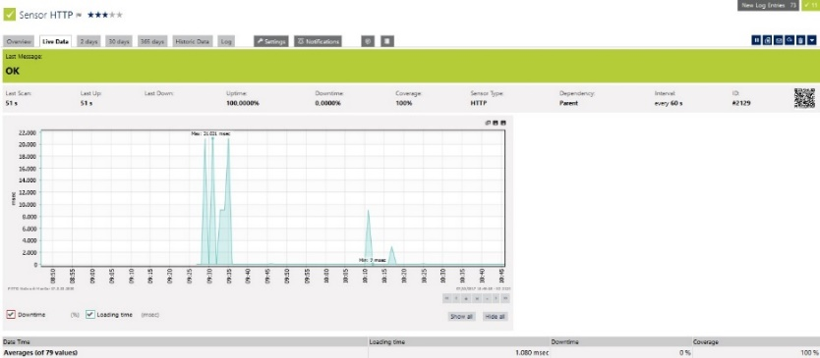
HTTP Response:

Figure 4.54 Response time after 3 OS SQLmap exploitation on web1 server

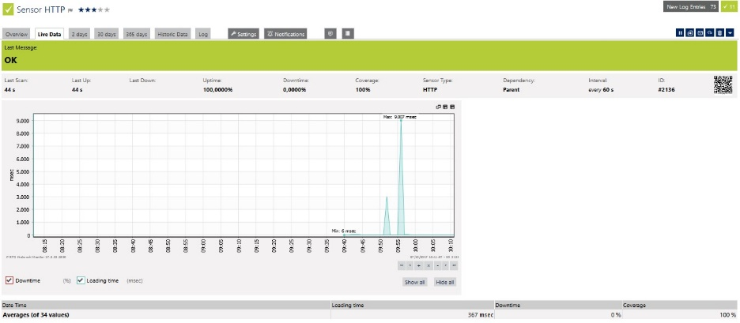
Figure 4.55 Response time after 3 OS SQLmap exploitation on web2server

Description:
Comparing those two graphs from Figure 4.54 and 4.55, on web1 server Response time, its maximal response time reach 21 msec during exploitation, when on web2 server response time only reach 9msec maximal response time. It is make the OWASP may take the responsibility when covering the web server, OWASP may cause a little time increase in response time.
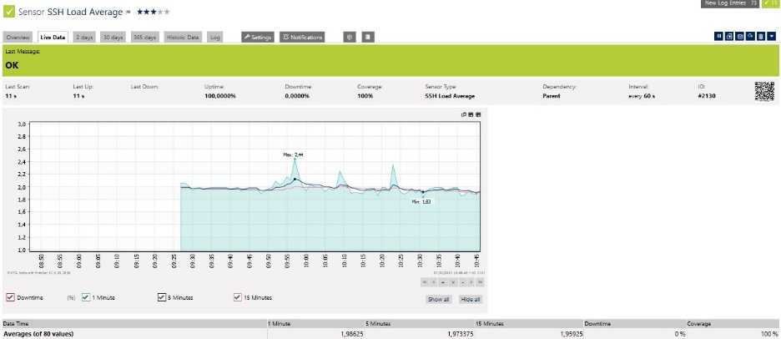
CPU Load Average:
Figure 4.56 CPU Load after 3 OS SQLmap exploitation on web1 server

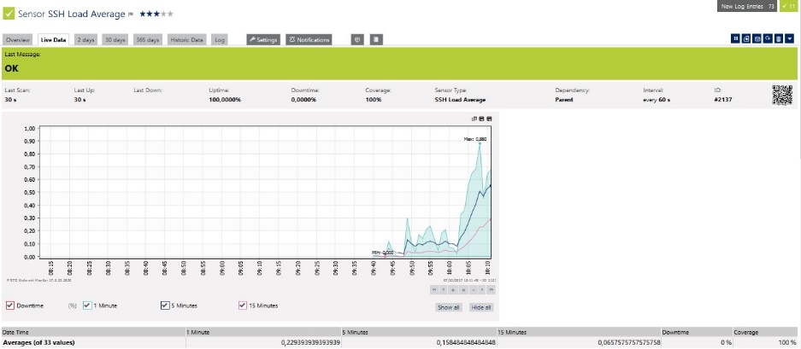
Figure 4.57 CPU Load after 3 OS SQLmap exploitation on web2 server

Description:
The graphs from Figure 4.56 and 4.57 show that using OWASP will also cause the CPU Load average reach 1,9 in interval 5 minutes when the web2 server or without OWASP only reach 0.5 in interval 5 minutes.

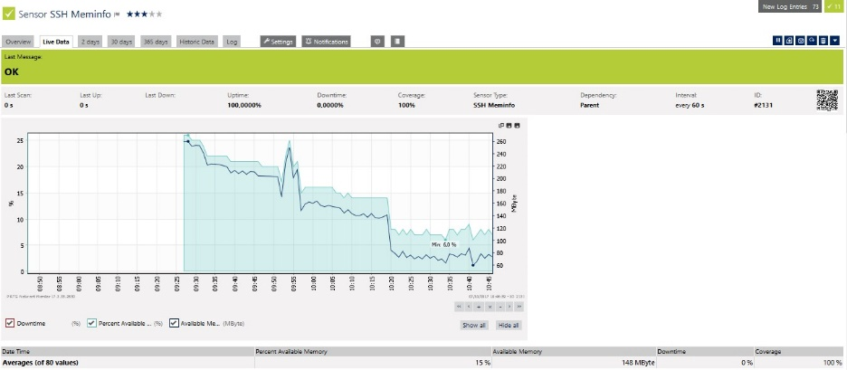
Memory Free:
Figure 4.58 Free Memory after 3 OS SQLmap exploitation on web1 server

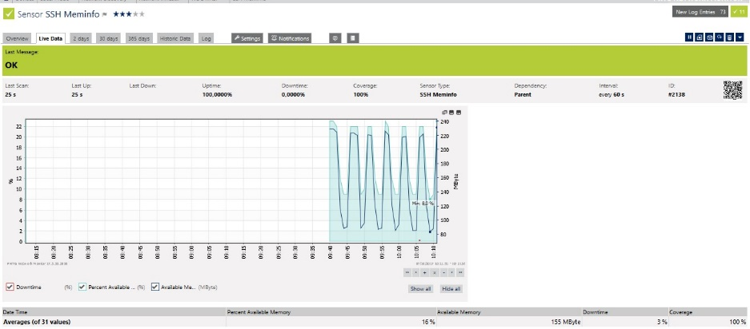
Figure 4.59 Free Memory after 3 OS SQLmap exploitation on web2 server

Description:
The graphs from Figure 4.58 and 4.59 show that the OWASP web1 server ever reached 6% of available memory when NOOWASP web2 server only ever reached to 8%. That may be cause by the OWASP use a little bit more memory than the server without OWASP.

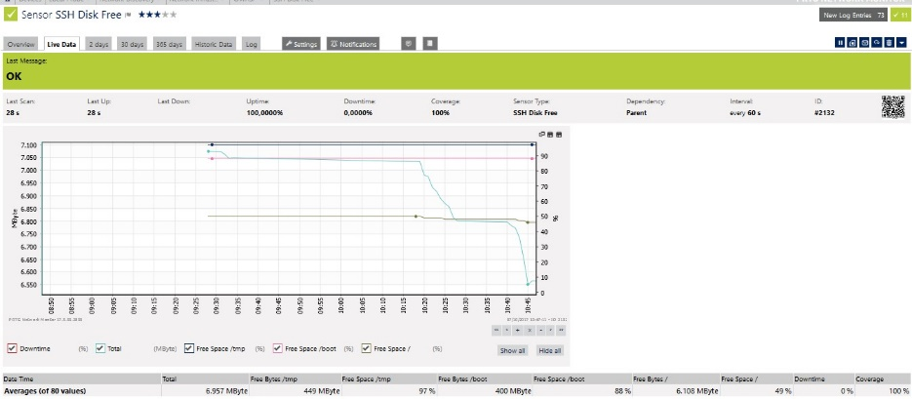
Free Disk:
Figure 4.60 Free Disk after 3 OS SQLmap exploitation on web1 server

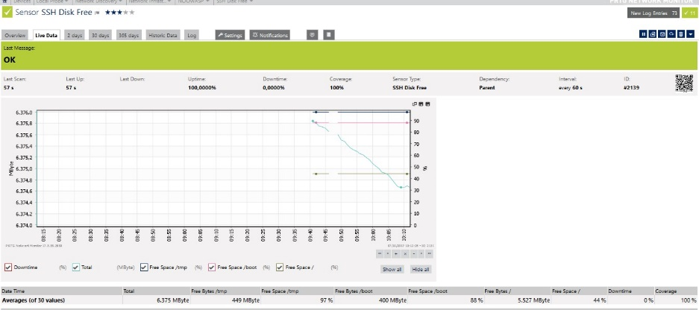

Figure 4.61 Free Disk after 3 OS SQLmap exploitation on web1 server

Description:
The graphs from Figure 4.60 and 4.61 show that on OWASP web1 server, the average free disk around 6.957Mb and on NOOWASP web2 server with the average around 6.375Mb. It show that using OWASP, the Free Disk was covered during SQLmap exploitation.

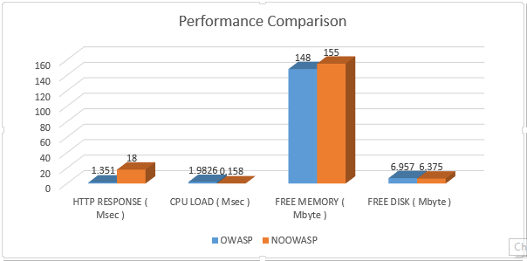
All the result above will be show in the Figure 4.62 below in chart.
Figure 4.62 Performance result in chart

Analyzing from the chart, almost all of the result didn’t have too much different only in Http Response which are 1.351 comparing to 18. But because its count in Msec, it didn’t affect too much at all.

XSS (Cross Site Scripting) using BeEF Framework tool
BeEF is a application which can be use for hooking a target PC using Cross Site Scripting Method. Its will be use for testing both web server that already built.

KaliLinux BeEF XSS
BeEF exploitation using Kali Linux OS for testing web1 and web2 server cross site scripting vulnerable was success. Both of the web servers are success to been injected a hook page which redirect the page into hook page. That cause the target PC can be control by the attacker. The detail of the BeEF exploitation using Kali Linux result will be attach in the attachment Page point D on page A-42 ‘ Kali Linux BeEF Tools Exploitation ‘ .

Backbox BeEF XSS
BeEF also been performed using Backbox OS for testing web1 and web2 server. The result was same with the test before. Both of the web server was vulnerable to be inject the cross site script. The detail of the testing will be attach in the Backbox BeEF testing attachment page point E on page A-47 ‘ Backbox BeEF Tools Exploitation ‘ .

Parrot BeEF XSS
Parrot BeEF was failed to done BeEF testing. This OS didn’t support BeEF which caused by conflict between BeEf dependencies including the Ruby-RVM environment with Parrot Apache services. The detail of failed will be show in the figure 4.63:

Figure 4.63 BeEF failed to be installed on Parrot OS

Performance Comparison
In BeEF exploitation, it can’t be done performance tracking or comparison. BeEF was a cross site scripting which only make a redirect page without scanning. So, it didn’t affect any point of Http response, CPU Load, Memory Free and Disk Free.

XSS (Cross Site Scripting) using XSSer
The last testing method will be done by using XSSer application. XSSer will scan and inject hundred of Cross Site Scripting Query into site page. This testing method will be done thrice at differences Operating System. Each of the Operating System will use XSSer to exploit the servers (Web Server with OWASP and web server without OWASP) for 10 times for each web server.

Kali Linux XSSer XSS
OWASP web1 server:
The same XSSer tools exploitation also done using Parrot OS. The result of this testing will be show in the table 4.10 and 4.11:
Table 4.10 XSSer Expoitation on OWASP web1 server using Kali Linux OS
XSSer Expoitation on OWASP web1 server using Kali Linux OS
 | Before | After | Description
Result | - | Failed | XSSer failed to be inject into web server caused of URL issue
Http Response | 928 Msec | 346 Msec | Didn’t affect web1 server response time.
CPU Load | 0.167 | 0.167 | Didn’t affect web1 server CPU Load.
Memory Free | 238 Mb | 190 Mb | During the exploitation time, available memory usage was down to 190.
Free Disk | 6.142 Mb | 6.142Mb | Didn’t affect web1 server Free Disk.
OWASP Hit List |  | 10 logs | -
Table 4.11 XSSer Expoitation on NOOWASP web2 server using Kali Linux OS
XSSer Expoitation on NOOWASP web2 server using Kali Linux OS
 | Before | After | Description
Result | - | Failed | XSSer failed to be inject into web server caused of URL issue.
Http Response | 20 Msec | 45.032 Msec | Average Response time was up to 45.032 Msec during exploitation but didn’t affect too much because its count as Msec.
CPU Load | 0 | 0.019 | Its only increase a bit, but there is 2 times CPU Load error during exploitation.
Memory Free | 209 | 212 | Didn’t affect web1 server Free Memory.
Free Disk | 6.683 Mb | 6.683 Mb | Didn’t affect web1 server Free Disk, but there is an Error during exploitation.
Further information will be show in the Kali Linux OS XSSer Tools exploitation attachment page point F on page A-52 ‘ Kali Linux XSSer Tools Exploitation ‘ .

Backbox XSSser XSS
Unfortunately Backbox isn’t provided and support XSSer. XSSer testing can’t be done using BackBox OS.

Parrot XSSer XSS
OWASP web1 server:
The same XSSer tools exploitation also done using Parrot OS. The result of this testing will be show in the table 4.12 and 4.13:
Table 4.12 XSSer Expoitation on OWASP web1 server using Parrot OS
XSSer Expoitation on OWASP web1 server using Parrot OS
 | Before | After | Description
Result | - | Failed | XSSer failed to be inject into web server caused of URL issue
Http Response | 928 Msec | 346 Msec | Didn’t affect web1 server response time.
CPU Load | 0.167 | 0.167 | Didn’t affect web1 server CPU Load.
Memory Free | 238 Mb | 190 Mb | During the exploitation time, available memory usage was down to 190.
Free Disk | 6.142 Mb | 6.142Mb | Didn’t affect web1 server Free Disk.
OWASP Hit List |  | 10 logs | -

Table 4.13 XSSer Expoitation on NOOWASP web2 server using Parrot OS
XSSer Expoitation on NOOWASP web2 server using Parrot OS
 | Before | After | Description
Result | - | Failed | XSSer failed to be inject into web server caused of URL issue.
Http Response | 20 Msec | 45.032 Msec | Average Response time was up to 45.032 Msec during exploitation but didn’t affect too much because its count as Msec.
CPU Load | 0 | 0.019 | Its only increase a bit, but there is 2 times CPU Load error during exploitation.
Memory Free | 209 | 212 | Didn’t affect web1 server Free Memory.
Free Disk | 6.683 Mb | 6.683 Mb | Didn’t affect web1 server Free Disk, but there is a Error during exploitation.
Further information will be show in the Parrot OS XSSer Tools exploitation attachment page point G on page A-62 ‘ Parrot XSSer Tools Exploitation ‘ .

Implementation Testing
After several attack testing that has been done at both web server, now OWASP will be implemented on pcr.ac.id web application for testing the security of pcr.ac.id sites. The web application is different from the one written in the Scope of Problems (mahasiswa.pcr.ac.id or akademik.pcr.ac.id) due to the security of PCR data and information. So the author only get a permission of PCR old sites. Pcr site which only can be test was client side interface, the admin interface wasn’t allow.
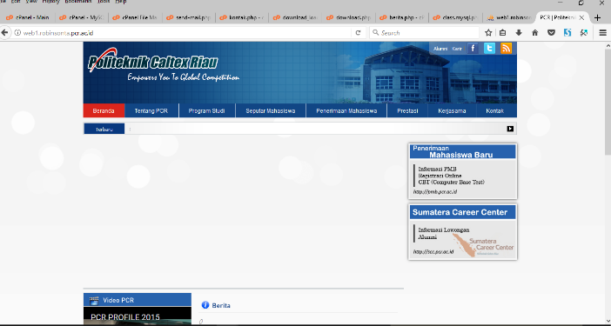
The Figures 4.64 and 4.65 will show the interface of both web server that already been put PCR old sites also the contains of the database.

Figure 4.64 PCR site implemented on OWASP web1 server

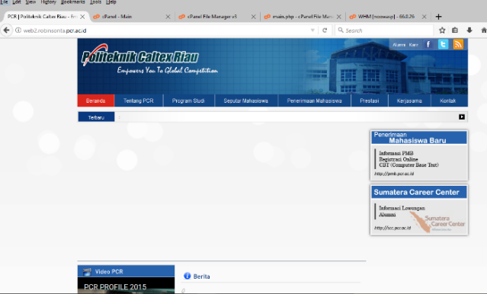

Figure 4.65 PCR site implemented on NOOWASP web2 server
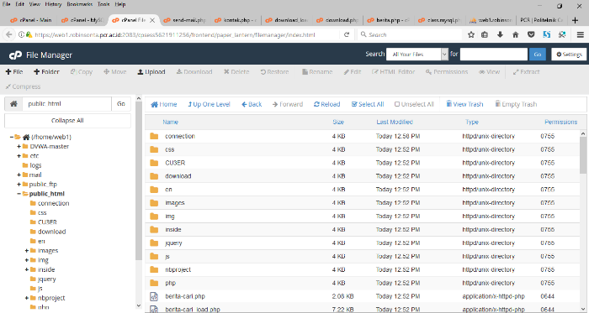

Figure 4.66 PCR site file in OWASP web server File Manager
Figure 4.66 show the contains of File Manager on Cpanel Account.

SQL Injection Attack
SQL Injection attack testing which is a attack that injecting SQL query into a form field that will expose the data inside of the data cant be done in the client side of PCR old sites. The access to administrator interface was forbidden so the author cant done this testing as show in the Figure 4.67.

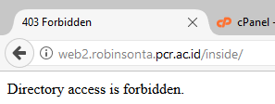
Figure 4.67 Directory access is forbidden

SQL Injection using SQLmap Tool
Some actions that can use against SQL Injection by developer was hiding web application site extension such as .php or .html and hiding the GET and POST request of the web application. Using both of that action, sql injection attackers will not get the information of the site that been targeted and the parameter that can be injected.
PCR web application is one of the web application that applied both of the security above during development process. This cause SQLmap Exploitation tools failed to do SQL Injection. Even the action was failed, but OWASP web server success detect the attacks and show it in the Hit List.
The table 4.14 will show the exploitation result to PCR page on both web servers.
Table 4.14 SQLmap Exploitation Result on PCR Site at both web servers
Operating  System | Web Server Result |  | Hit List OWASP
 | OWASP | NOOWASP
Kali Linux | Failed | Failed | 800+ Logs
Back Box | Failed | Failed | 1000+ Logs
Parrot | Failed | Failed | 1600+ Logs
Furthermore information about SQLmap Exploitaiton on PCR Site at both web servers will be attach in the attachment page point H on page A-72 ‘ SQLmap Exploitation on PCR Sites on both web server ‘ ..

BeEF Exploitation
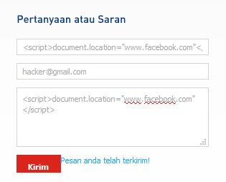
BeEF which is a Cross Site Scripting Exploitation tools that only work with Stored type. That cause BeEF couldnot been try for PCR sites which form field at Kontak pages didn’t store the information that been input by user, but its directly send it into admin email using mail service. This also an action by PCR site developer to counter Cross Site Scripting by malicious attackers.

Figure 4.68 BeEF Inject Testing on Kontak Page form field
Figure 4.68 show that kontak page didn’t save and reload the page but instant send it using javascript.

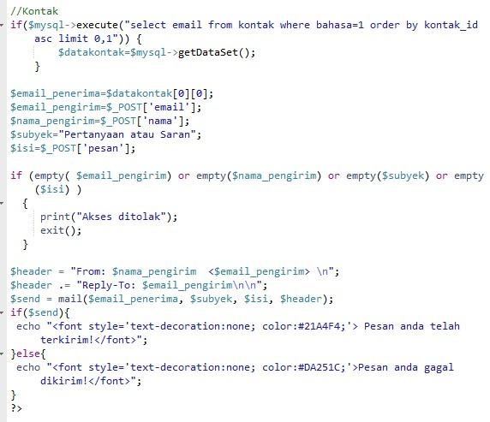

Figure 4.69 Kontak page script

Figure 4.69 show that the method of kontak form field which send the information that input by user to the admin email.

XSSer Tools Exploitation
Cross Site Scripting exploitation using XSSer tools also done on both web server. The result were all of the XSSer exploitation was failed, but OWASP web server success recorded all of the expoitation to the server. More detail will be show in table 4.15.
Table 4.15 XSSer Exploitation Result on PCR Site at both web servers
Operating  System | Web Server Result |  | Hit List OWASP
 | OWASP | NOOWASP
Kali Linux | Failed | Failed | 6 Hit Logs
Back Box | - | - | -
Parrot | Failed | Failed | 12 Hit Logs
Furthermore information about XSSer Exploitaiton on PCR Site at both web servers will be attach in the attachment page.

Performance Testing
After several attack testing, now there will be a performance testing which will try to visit or make a request to the web server using 100 clients to both web server. The data will be use to compare the Http Response, CPU Load, Free Memory and Free Disk of both servers.
An application call Web Stress were used to simulated 100 clients visit with the conditions below:
- Number of Users are 100 and Test run for 1 minutes.
- 2 Urls that tested : web1.robinsonta.pcr.ac.id & web2.robinsonta.pcr.ac.id
There is two result from performance testing, first is from web stress application report that show average request time of OWASP web server is higher than NOOWASP web server. Either with the Percentage of Errors as show in the Figure 4.70.
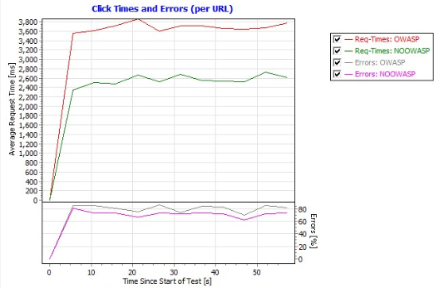

Figure 4.70 Web Stress Performance Testing Result
Comparison of the Http Response, Cpu Load, Free Memory and Free Disk of both servers will be display in table 4.16:
Table 4.16 Performance Result after Web Stress simulation for 100 Clients
Attribute | Average Result
 | OWASP | NOOWASP
HTTP Response | 5.028 Msec | 4.046 Msec
CPU Load | 0.148 / 5 Minutes | 0,13 / 5 Minutes
Free Memory | 17% / 171 Mbyte | 12% / 121 Mbyte
Free Disk | 2.399 MByte | 2.162 Mbyte
All the result above will be show in chart on Figure 4.71 below:
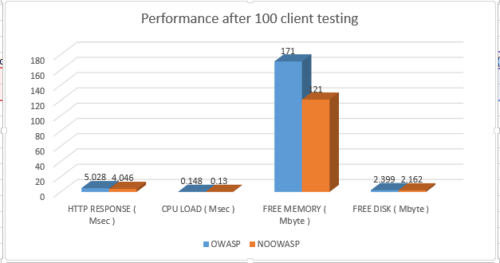
Figure 4.71 Performance after 100 client testing
Analyzing from figure 4.73, Only Free Memory variable that show a big different of two web server. OWASP web server use 5% more Free Memory or about 50 Mbyte more. But it didn’t influence other performance at all.

All detail Figures of the Performance Testing will be attach in the attachment page point I on page A-77 ‘Performance Testing’.

Analyze
      - After attack testing using 7 kinds of SQL Injection on web servers, the result show that there was some attack type already counter or covered by the MySQL patching itself. ( based on the results reference to IV.2.1 SQL Injection )
      - SQLmap Exploitation Tool, sometimes even already detected there was a WAF/IDS/IPS its still force to inject dozens of query that can cause OWASP Hit List flooding. ( based on the results reference to IV.2.2 SQL Injection using SQLmap Tool )
      - There are 3 type of Cross Site Scripting, DOM, Reflected and Stored type. BeEF is a tool that used to do cross site scripting stored type. Stored type cross site scripting can’t been detected by OWASP ModSecurity Web Application Firewall. This may be caused by some web application actually save the information directly into database without filtering the parameter input by user. The solution is filter all the input parameter from user and exception on input form field during Web Application Development time. ( based on the results reference to IV.2.3 XSS using BeEF Framework tool )
      - XSSer only can be done for the web application which has shown page extention such as .php, .html , etc . Its can be cover during Web Application Development time by hiding the page extention. ( based on the results reference to IV.2.4 XSS using XSSer )
      - OWASP didn’t affect too much the HTTP Response time, CPU load, Free Memory and Free Disk. ( based on the results reference to IV.2.2.4 Performance Comparison & IV.2.6 Performance Testing )
      - 100 Clients Performance testing only affect HTTP response time and available memory cause of the testing was only aim port 80 of the web application. ( based on the results reference to IV.2.6 Performance Testing )

The summary of testing result on DVWA web server will be show in the table 4.15:
Table 4.15 Attack Testing Result on DVWA web server
 | Operating System
 | Kali Linux |  | Back Box |  | Parrot
Attack Type | OWASP | NOOWASP | OWASP | NOOWASP | OWASP | NOOWASP
SQL Injection | Failed | Success | Failed | Success | Failed | Success
SQLmap | Failed | Success | Failed | Success | Failed | Success
BeEF | Success | Success | Success | Success | Success | Success
XSSer | Failed | Failed | Failed | Failed | Failed | Failed
Table 4.15 show that OWASP success on securing web application from SQL Injection, SQLmap Exploitation and XSSer Exploitation Attack but failed to secure web application from BeEF or Cross Site Scripting Stored Type Attack.
The summary of testing result on PCR web server will be show in the table 4.16:
Table 4.16 Attack Testing Result on PCR web server
 | Operating System
 | Kali Linux |  | Back Box |  | Parrot
Attack Type | OWASP | NOOWASP | OWASP | NOOWASP | OWASP | NOOWASP
SQL Injection | Failed | Failed | Failed | Failed | Failed | Failed
SQLmap | Failed | Failed | Failed | Failed | Failed | Failed
BeEF | Failed | Failed | Failed | Failed | - | -
XSSer | Failed | Failed | - | - | Failed | Failed
The table 4.16 show that PCR web application already secure without OWASP because of PCR web application implemented some counter action during Web Application Development time such as hiding page extention and parameter filtering. But OWASP still detect and counter it during Tool Scanning and Exploitation time which show in the Hit List.

BAB V
CONCLUSION AND ADVICE

CONCLUSION
The conclusions of this final project are as belows:
- OWASP ModSecurity success 100% detect and secure web application from SQL Injection after 15 times testing using 3 difference Operating Systems.
- OWASP ModSecurity failed to secure web application from Cross Site Scripting Stored type that caused the attacker successfully hook target PC.
- OWASP ModSecurity success 100% detect and secure web application from SQLmap exploitation tools which was done using 3 diffence Operating Systems.
- OWASP ModSecurity success 100% detect and secure web application from XSSer exploitation tools which was done using 3 diffence Operating Systems.
- Comparison result show that there wasn’t any big affect that will influence web application performance after using OWASP ModSecurity.

ADVICE
In current research, it still has many shortcomings due to time constraints, budget cost and thoughts of the author. Many things can be studied and developed more deeply. Advice expected for future development include:
- Extend security coverage using OWASP Modsecurity Web Application Firewall such as Scanner Detection, DOS Protection, IP Reputation, etc.
- Extending Core Rule Set of OWASP ModSecurity for securing some cross site scripting attacks that didn’t provided by OWASP ModSecurity.
- Research on another WAF and make a comparison of the result with OWASP ModSecurity.

REFERENCES
Backbox | A Free Open Source Community Project. (n.d.). Retrieved from BackBox: https://backbox.org
Chris, A. (2002). Advanced SQL Injection In SQL Server Application. Software Insigth Security Research ( NISR ) Publication.
Conallen, J. (1999). Building Web Applications with UML. Addison Wesley.
Curphey, M., & Groves, D. (2006). Retrieved from Open Web Application Security Project: https://www.owasp.org/index.php/OWASP_ModSecurity_Core_Rule_Set_Project
Dharma, M. H. (2011). Simulasi dan Analisa Keamanan Jaringan Menggunakan Honeypot. Pekanbaru: Politeknik Caltex Riau.
Endraca, A., King, B., Nodalo, G., Maria, M. S., & Sabas, I. (2013). Web Application Firewall (WAF). International Journal of e-Education, e-Business, e-Management and e-Learning.
Feri, S. (2014). Implementasi Firewall Aplikasi Web untuk Mencegah SQL Injection Menggunakan Naxsi. Yogyakarta: Universitas Islam Negeri Sunan Kalijaga.
Justin, C. (2009). SQL Injection Attacks and Defense. Burlington: Syngress Publishing, Inc.
Kali LInux | Penetration Testing and Ethical Hacking Linux Distribution. (n.d.). Retrieved from kali.org: http://kali.org
Mate Vibhakti, T. M. (2014). Building A Secure & Anti-Theft Web Application By Detecting and Preventing Owasp Critical Attacks. International Journal of Engineering Research and Applications (IJERA).
Muniz Jospeh, L. A. (2013). Web Penetration Testing with Linux. Birmingham, UK: Packt Publishing Ltd.
Parrot Project. (n.d.). Retrieved from Parrot OS: www.parrotsec.org
Pedersen, A. (2006). cPanel User Guide and Tutorial. Birmingham: Packt Publishing.
Pritchett Willie L, S. D. (2013). Kali Linux Cookbook. Birmingham,UK: Packt Publishing Ltd.
Randhe Kirit, M. V. (2012). Defense against SQL Injection and Cross Site Scripting Vulnerabilities. International Journal of Science and Research (IJSR).
Rudi, R. (2011). Membangun Server yang Tahan Terhadap Serangan Brute Force Menggunakan Fail2ban pada Debian 2.0 Squeeze. Pekanbaru: Politeknik Caltex Riau.
Shah Junaid Latief, K. A. (2014). Cross Site Scripting (XSS) : The dark side of HTML. International Journal of Engineering and Computer Science, 4066-4068.
Spett, K. (2005). Cross-Site Scripting. SPI Dynamic, Inc.
Syafrizal, M. (2005). Pengantar Jaringan Komputer. Yogyakarta: ANDI.
Vogt Philipp, N. F. (n.d.). Cross-Site Scripting Prevention with Dynamic Data Tainting and Static Analysis. Secure Systems Lab Technical University Vienna.
Wardana, H. K., Novan, S., & Handoko. (2009). Jurusan Teknik Elektro Fakultas Teknik Universitas Kristen Satya Wacana. Aplikasi Penggunaan Simple Network Management Protocol (SNMP) dalam Jaringan, 93-108.
Yulianingsih. (2017). Melindungi Aplikasi dari Serangan CrossSite Scripting (XSS) dengan Metode MetaCharacter. FakultasTeknik dan MIPA Universitas Indraprasta PGRI, Vol.03 , No.01.

ATTACHMENT A
- Kali Linux SQLmap Tools Exploitation
OWASP web1 server was failed to been injected using SQLmap tools as show by the figure A.1.
A.1 SQLmap exploitation using Kali Linux OS on OWASP web1 server

At the figure above, show that SQLmap tools detected there was a WAF/IPS/IDS in the web server but continue to doing scan that result the tools fail to inject any query to the web server. The test was done 10 times using SQLmap, the result were all of the attempt were failed. The video of KaliLinux SQLmap exploitation on OWASP web1 server will be attach later on the report CD.
Figure A.2 and A.3 will show a little part of ModSecurity Hit List with total detect about 800 logs.
Figure 4.64 ModSecurity Hit List after S QLmap tools exploitation using Kali Linux OS (1)

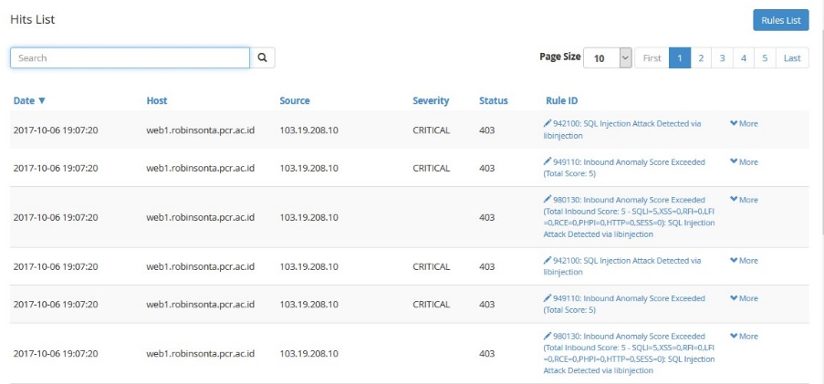

A.2 ModSecurity Hit List after SQLmap tools exploitation using Kali Linux OS (1)

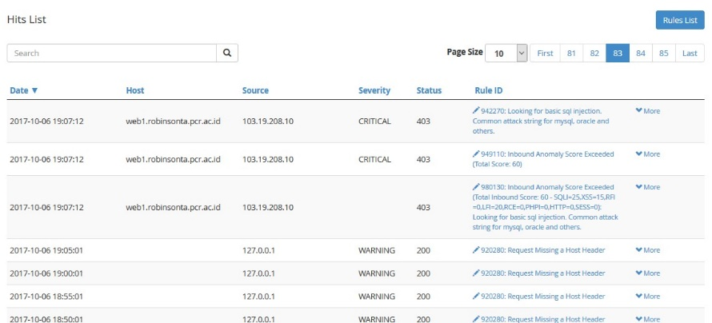

A.3 ModSecurity Hit List after SQLmap tools exploitation using Kali Linux OS (2)

Performance test also been done at the web server during do SQLmap exploitation. Figures A.4 and A.5 will show the comparison between HTTP response, CPU Load, Memory Free and Disk Free of web server before and after exploitation.

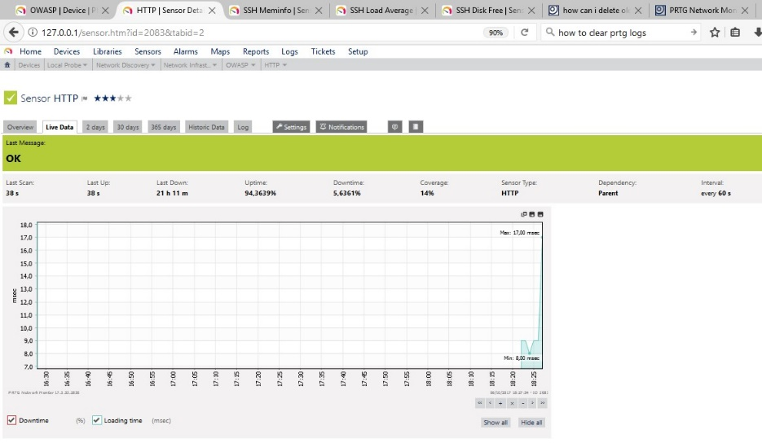
HTTP response :
A.4 Http Response before doing SQLmap tools exploitation using Kali Linux OS on OWASP web1 server

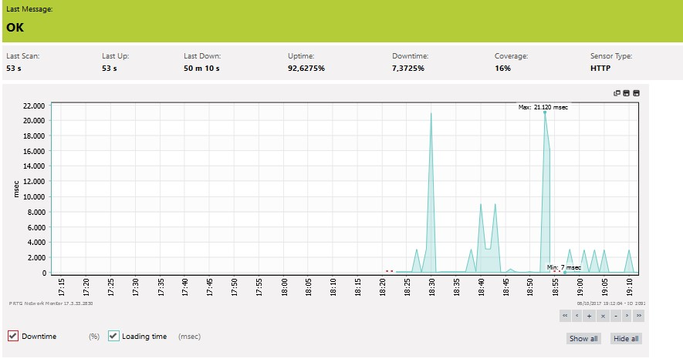

A.5 Http Response after doing SQLmap tools exploitation using Kali Linux OS on OWASP web1 server

Description :
Before doing exploitation, average response time was reaching maximal time about 17 miliseconds, but after exploitation has been done, the average maximal time has been reached about 21 miliseconds. 4 miliseconds more than average before. But cause of the time is in milliseconds, seems like it didn’t affect to much to the web server.
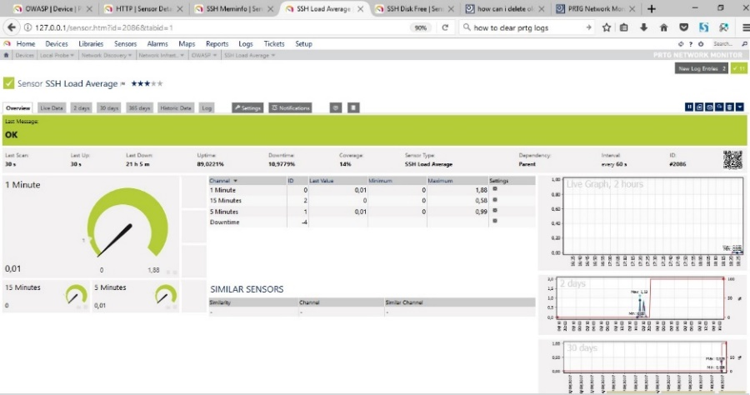
CPU Load Average :

A.6 CPU Load before doing SQLmap tools exploitation using Kali Linux OS on OWASP web1 server

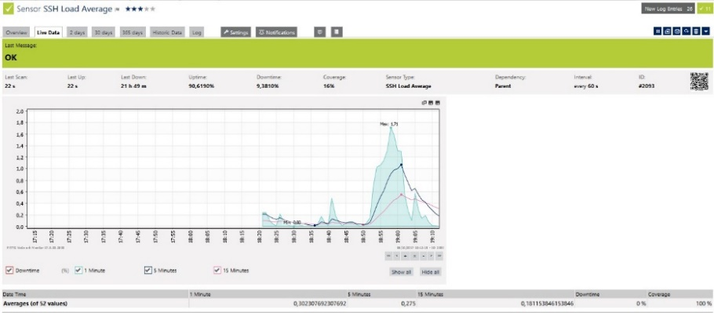
A.7 CPU Load after doing SQLmap tools exploitation using Kali Linux OS on OWASP web1 server

Description :
By looking the graphic after the exploitation at Figure A.6 and A.7, its show that during the exploitations, CPU Load was reaching 1,71 , 5 times bigger than normal which only average about 0,2 - 0,4 . But the coverage still 100 %, so its didn’t make affect for the server at all.
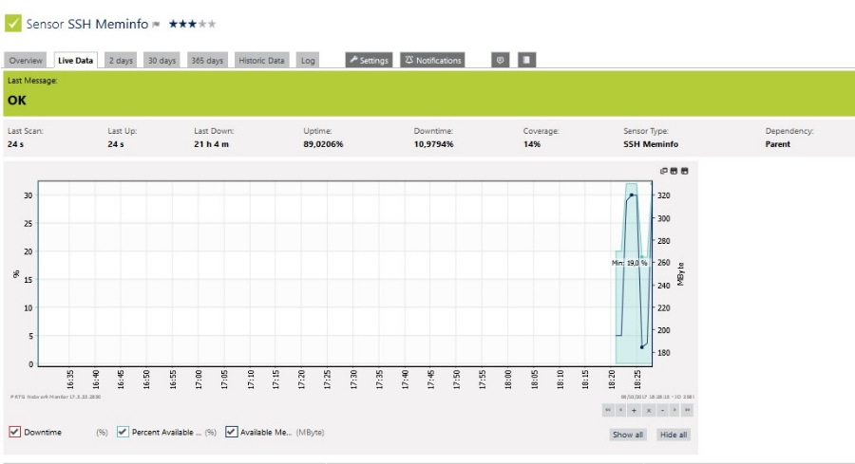
Memory Free

A.8 Memory Free before doing SQLmap tools exploitation using Kali Linux OS on OWASP web1 server

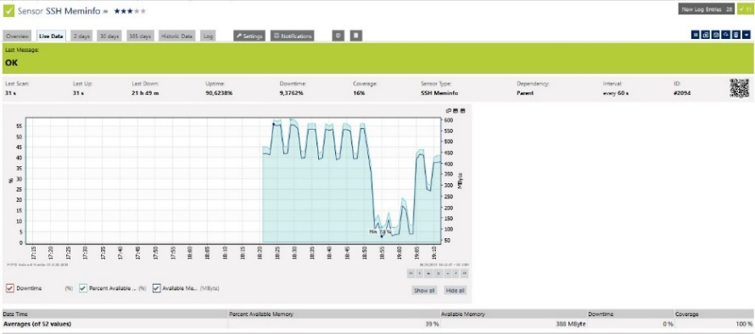
A.9 Memory Free after doing SQLmap tools exploitation using Kali Linux OS on OWASP web1 server

Description :
Before exploitation as show in the Figure A.8, the graph show that the minimal average available memory was 19%, but during exploitation A.9, the number decrease into 7%. Memory Load became normal after the exploitation already finish. Its can be concluded that if there is a lot of exploitation done in the same time, even it isn’t risk the web server data lost, it will be also possibly cause memory flooding that can make the server down for seconds.
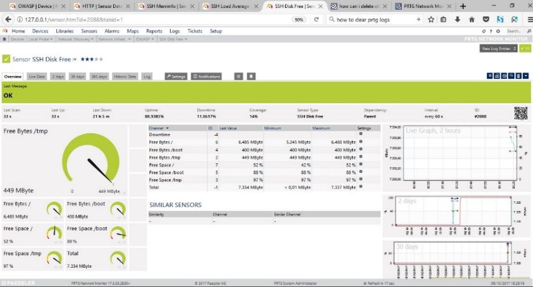
Free Disk :

A.10 Free Disk before doing SQLmap tools exploitation using Kali Linux OS on OWASP web1 server

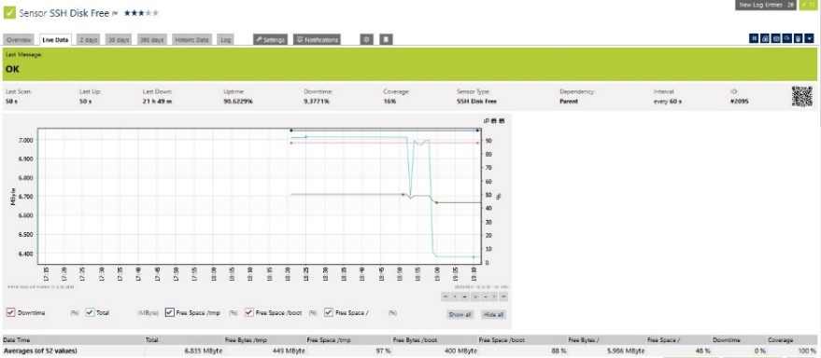
A.11 Free Disk after doing SQLmap tools exploitation using Kali Linux OS on OWASP web1 server

Description :
Before the exploitation as show in the Figure A.10, the average available memory was about 7.3 Mb in total but decrease to 6.8 after the expoitation was done as show in the Figure A.11.
NO OWASP web2 server :
Web2 server which without OWASP ModSecurity™ protection was successed to been injected using SQLmap tools as show by the figure below.

A.12 QLmap success exploitating the database name of NOOWASP web2 server and trying to inject table expoitation query

The picture A.12 is showing the result of SQLmap database name exploitation that cause the web2 server display the database name. After getting the database name, the attacker trying to get the tables name using the database name with second query as show in the Figure A.13.

A.13 NOOWASP web2 server display tables name
Injection success that make the web2 server display the tables name, next was trying to exploiting the name of columns inside users table using the query above.

A.14 NOOWASP web2 server display columns names

Figure A.14 show that the columns name exploitation was success. We getting all the columns names. Now, we will try to get the important data such as username and password of inside the tables with the query on the Figure A.14.

A.15 NOOWASP web2 server show all the username and password after decryption

Fours of the figure A.15, show that SQLmap tools detected the name of the database first , then the tables inside, columns then user and password inside. SQLmap also success to convert the password that has been encrypted using common password tools. The test was done 10 times using SQLmap, the result were all of the attempts were successed. The video of KaliLinux SQLmap exploitation on NOOWASP web2 server will be attach later on the report CD.
Performance test also been done at the web server during do SQLmap exploitation. Figures below will show the comparison between HTTP response, CPU Load, Memory Free and Disk Free of web server before and after exploitation.

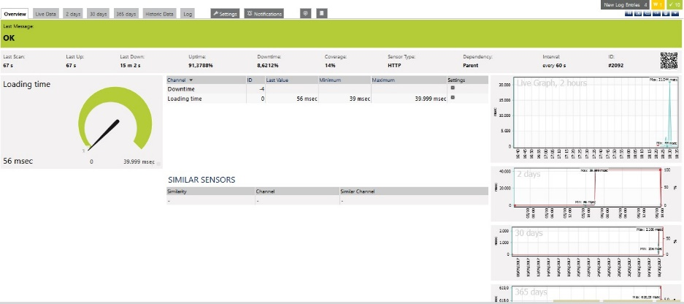
HTTP response :

A.16 Http Response before doing SQLmap tools exploitation using Kali Linux OS on NOOWASP web2 server

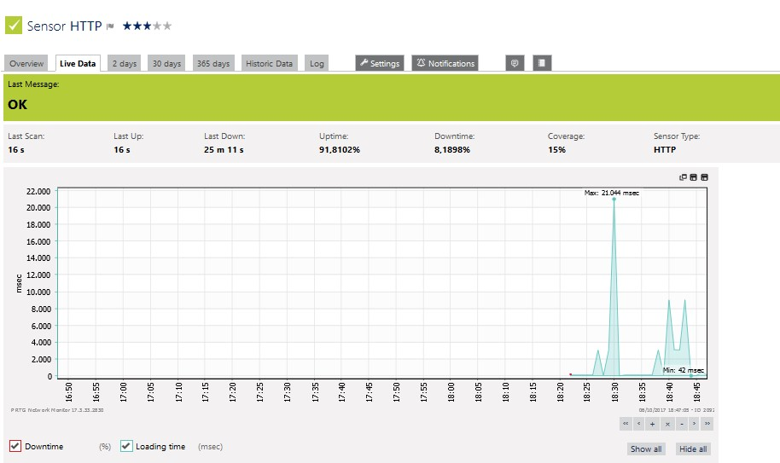

A.17 Http Response after doing SQLmap tools exploitation using Kali Linux OS on NOOWASP web2 server
Description :
Before doing exploitation as show in the Figure A.16, average response time was reaching maximal time about 39 miliseconds, but after exploitation has been done as shown in the Figure A.17, the average maximal time has been reached about 42 miliseconds. Three miliseconds more than average before. But cause of the time is in milliseconds, seems like it didn’t affect to much to the web server.
CPU Load Average :
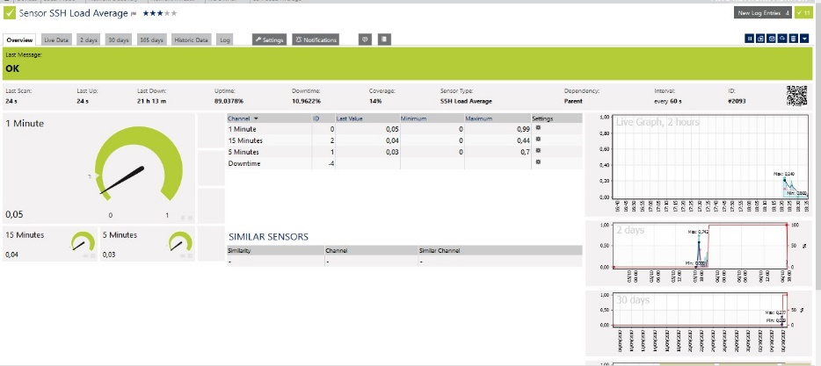
A.18 CPU Load before doing SQLmap tools exploitation using Kali Linux OS on NOOWASP web2 server

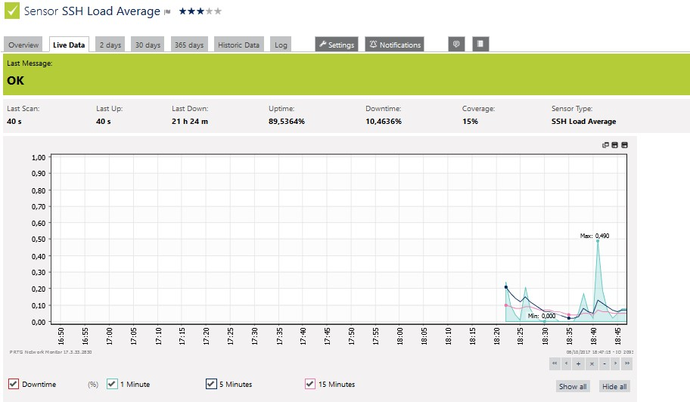
A.19 CPU Load after doing SQLmap tools exploitation using Kali Linux OS on NOOWASP web2 server

Description :
By looking the graphics after the exploitation in Figure A.19, its show that during the exploitations, CPU Load was reaching 0,49 , 9 times bigger than normal which only average about 0,05 - 0,06 . But the downtimes almost the same, around 10miliseconds. Its didn’t make affect for the server at all.
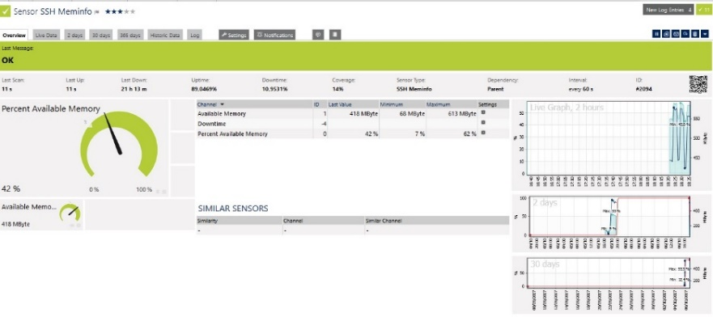
Memory Free

A.20 Memory Free before doing SQLmap tools exploitation using Kali Linux OS on NOOWASP web2 server

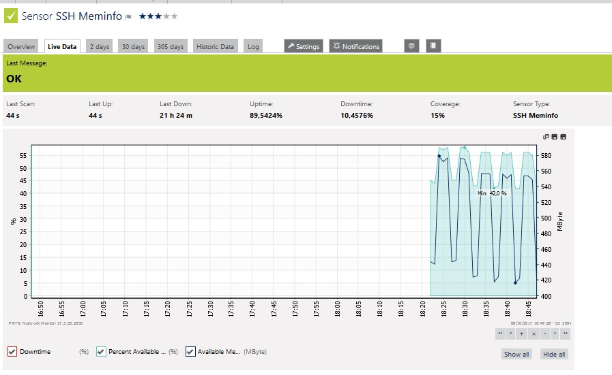

A.21 Memory Free after doing SQLmap tools exploitation using Kali Linux OS on NOOWASP web2 server

Description :
Before exploitation as show in the Figure A.20 , the graph show that the minimal average available memory was 42%, but during exploitation as show in the Figure A.21 , the number decrease into 5%. Memory Load was up and down during the injection moments. It became normal after the exploitation already finish. Its can be concluded that if there is a lot of exploitations done in the same time, the web server isn’t only risk the data lost, it will be also possibly cause memory flooding that can make the server down for seconds.
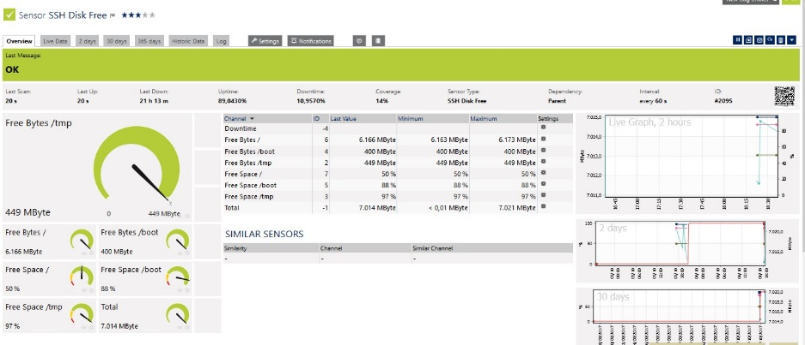
Free Disk :

A.22 Free Disk before doing SQLmap tools exploitation using Kali Linux OS on OWASP web1 server

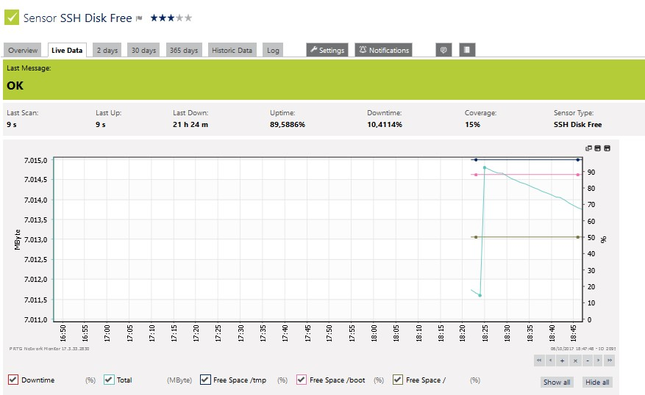

Description :

A.23 Free Disk after doing SQLmap tools exploitation using Kali Linux OS on OWASP web1 server

Description :
Before the exploitation as show in the Figure A.22 , the average available memory was about 90% more in total but decrease to 65% more after the expoitation was done as shown in the Figure A.23.
- BackBox SQLmap Tools Exploitation
OWASP web1 server :
OWASP web1 server was failed to been injected using SQLmap tools in Backbox as show by the figure B.1. SQLmaps detected there were Web Application Firewall/ Intrusion Prevension System / Intrusion Detection System but also giving us a chance to give it a try even there was a protection.

B.1 SQLmap Tools using Backbox OS detected WAF/IPS/IDS
By answering Y or yes, SQLmap will inject a dozen of query try to break the protection but failed as the figure show below.

B.2 SQLmap Tools using Backbox OS Failed to doing SQL Injection on OWASP web1 server

Both the figure B.2, show that SQLmap tools detected there was an WAF/IPS/IDS in the web server but continue to doing tons of injection even it was rejected by the server. Because of that, the mod_sec hit list database was full and couldnt be check one by one. The test was done 10 times using SQLmap, the result were all of the attempt were failed but flooding mod_sec database. The video of BackBox SQLmap exploitation on OWASP web1 server will be attach later on the report CD.
Figure B.3 and B.4 will show a little part of ModSecurity Hit List with total detect about 5000 logs.
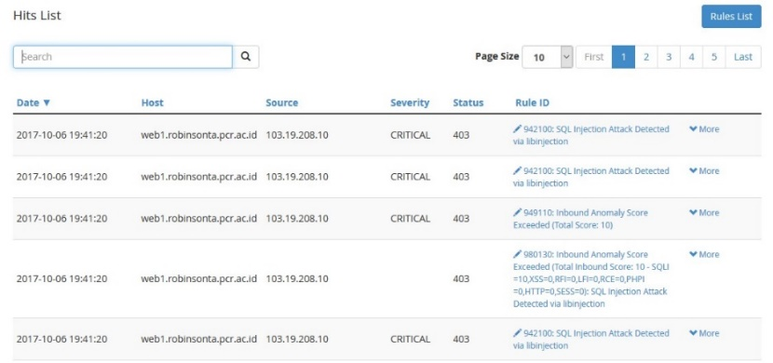

B.3 OWASP ModSecurity Hit Lists after SQLmap tools exploitation using Back Box OS (1)

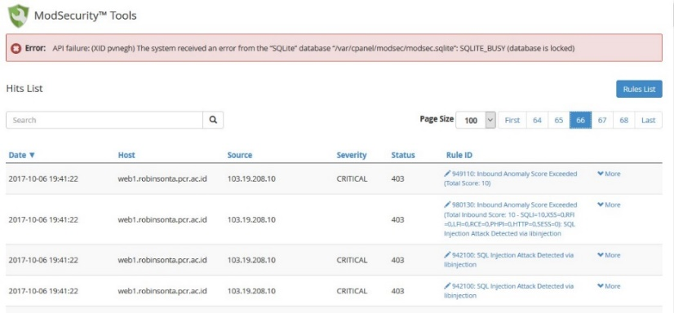

B.4 exploitation using Back Box OS (2)

Performance test also been done at the web1 server during do SQLmap exploitation. Figures B.5 and B.6 will show the comparison between HTTP response, CPU Load, Memory Free and Disk Free of web1 server before and after exploitation.

HTTP response :
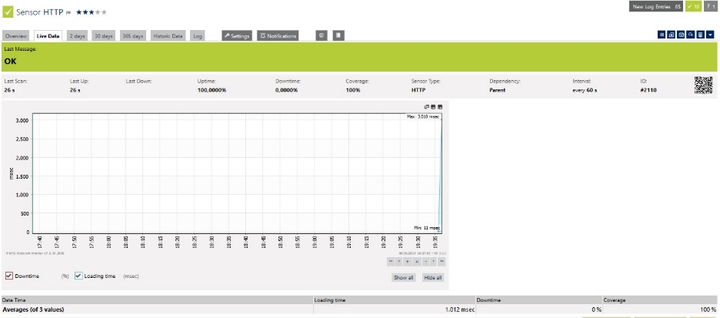

B.5 Http Response before doing SQLmap tools exploitation using Back Box OS on OWASP web1 server

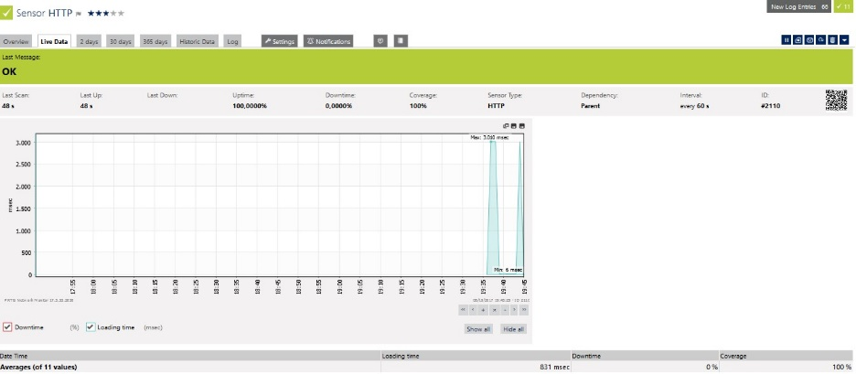

B.6 Http Response after doing SQLmap tools exploitation using Back Box OS on OWASP web1 server

Description :
Before doing exploitation as show in the Figure B.5, average response time was about 1,012 miliseconds, but after exploitation( Figure B.6) has been done, the average response time down to 831 miliseconds and up again to 1,012 miliseconds. Its look like the exploitation didn’t affect web1 server response time at all.

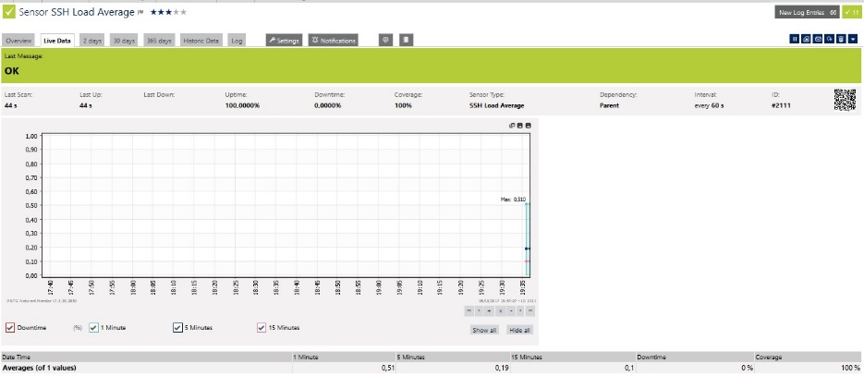
CPU Load Average
B.7 CPU Load before doing SQLmap tools exploitation using Back Box OS on OWASP web1 server

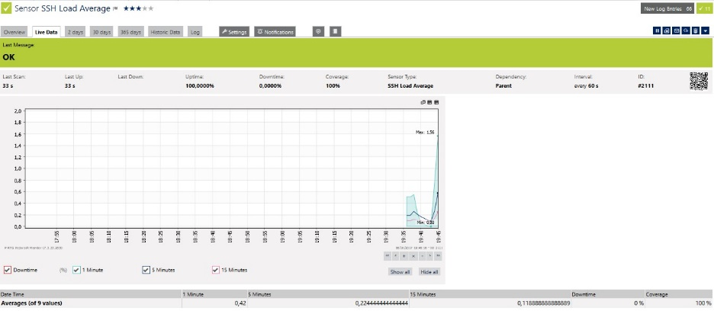

B.8 CPU Load after doing SQLmap tools exploitation using Back Box OS on OWASP web1 server

Description :
By looking the graphic after the exploitation ( Figure B.8 ), its show that during the exploitations, CPU Load was reaching 1.56 , 3 times bigger than normal which only average about 0,51 ( Figure B.7). But downtime still in 0% that means the server still in healthy condition.

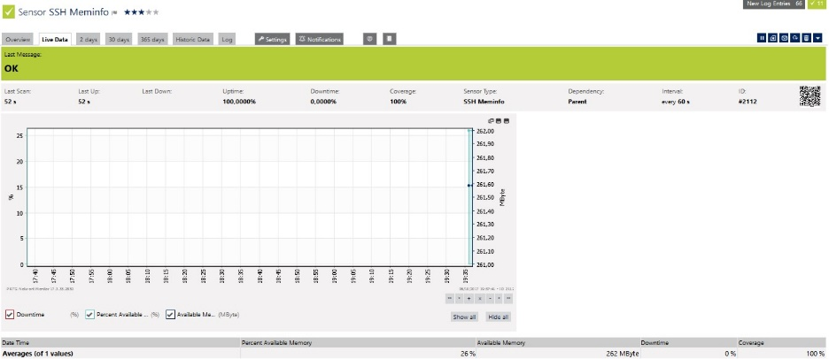
Memory Free
B.9 Memory Free before doing SQLmap tools exploitation using BackBox OS on OWASP web1 server

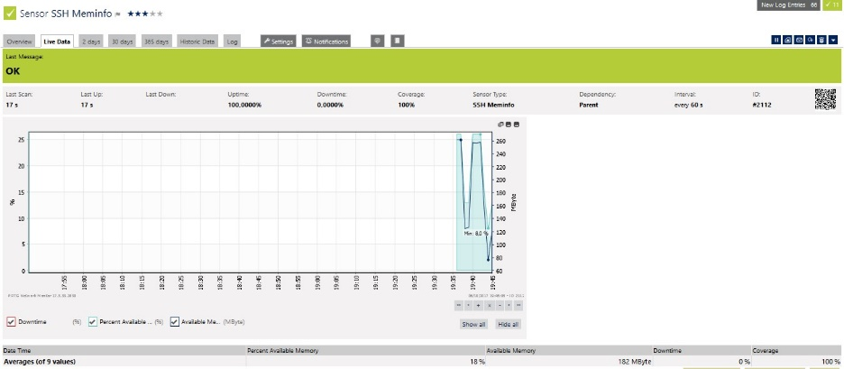

B.10 Memory Free after doing SQLmap tools exploitation using BackBox OS on OWASP web1 server

Description :
Before exploitation ( Figure B.9 ), the graph show that available memory was 262Mb , but during exploitation ( Figure B.10 ), the number decrease into 182Mb. Memory Load became normal after the exploitation already finish. Its can be concluded that if there is a lot of exploitation done in the same time, even it isn’t risk the web server data lost, it will be also possibly cause memory flooding that can make the server down for seconds.

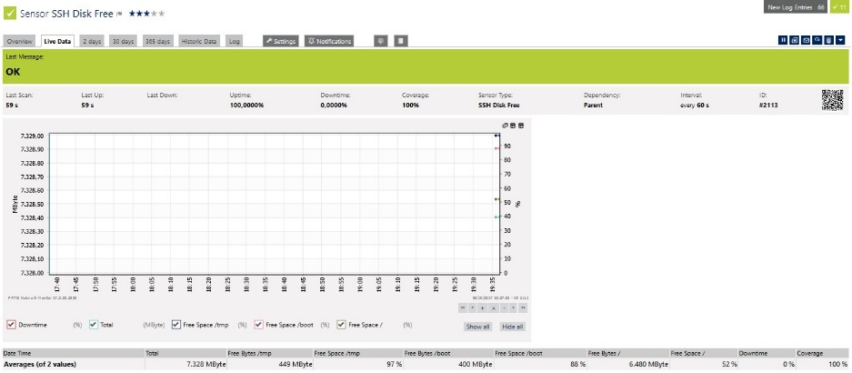
Free Disk :

B.11 Free Disk before doing SQLmap tools exploitation using Back Box OS on OWASP web1 server

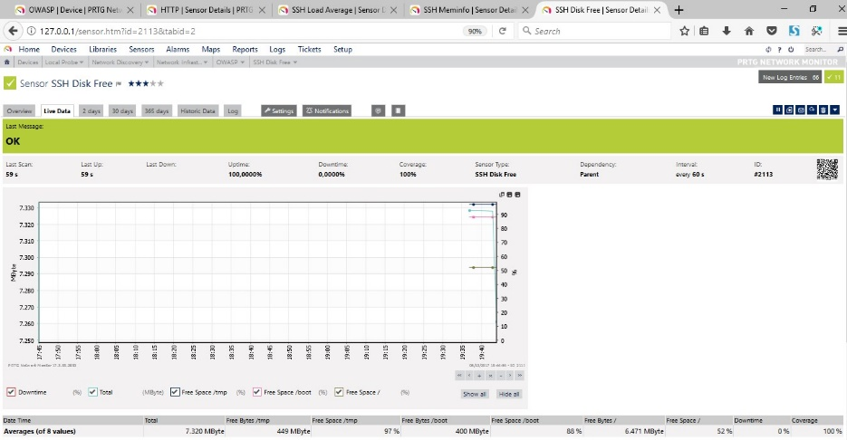
B.12 Free Disk after doing SQLmap tools exploitation using Back Box OS on OWASP web1 server

Description :
Before the exploitation( Figure B.11 ),, the average available memory was about 7.328 Mb in total but decrease to 7.320 after the expoitation was done( Figure B.12 ),. With those little number of Mb down, the web1 server will not be affected Free Disk lost too much if there was a single Injection using SQLmap.
NO OWASP web2 server :
Web2 server which without OWASP ModSecurity™ protection was successed to been injected using SQLmap tools as show by the figure B.13.

B.13 SQLmap success exploitating the database name of NOOWASP web2 server using Backbox OS and trying to inject table expoitation query

Web2 server successed been injected using SQLmap using Backbox OS that return the database name. Next step was exploiting tables name inside web2_database ( Figure B.14 and B.15 ),.
The query use for exploiting tables name was :
Sqlmap –u “http://web2.robinsonta.pcr.ac.id/vulnerabilities/sqli/?id=1&Submit=submit” –cookie=PHPSESSID=nonfjbut7mj14qpumh67sbs753; security=low” --random-agent –D web2_database --tables

B.14 SQLmap success exploit the database table name of web2 server using Backbox OS and trying to inject column expoitation query

B.15 SQLmap success exploitating the database column names of NOOWASP web2 server using Backbox OS and trying to data expoitation query

B.16 SQLmap detecting there was an encrypted data and offer a decrypting process

B.17 NOOWASP web2 server show all the username and password after decryption process by SQLmap using Backbox OS

All the figures B.14, B.15, B.16 and B.17 show the steps of SQLmap tools detected the name of database , then the tables inside, columns then user and password inside. SQLmap also success to convert the password that has been encrypted using common password words tool. The test was done 10 times using SQLmap, the result were all of the attempts were successed. The video of Backbox SQLmap exploitation on NO OWASP web2 server will be attach later on the report CD.
Performance test also been done at the web server during do SQLmap exploitation. Figures B.18 and B.19 will show the comparison between HTTP response, CPU Load, Memory Free and Disk Free of web server before and after exploitation.
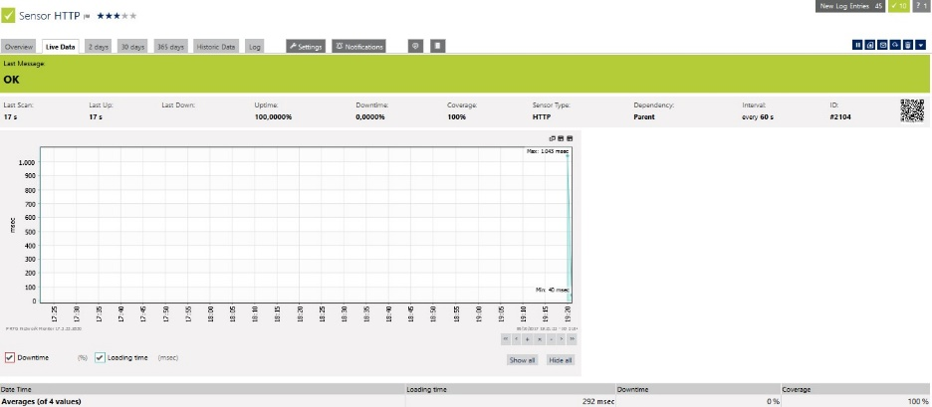
HTTP response :
B.18 Http Response before doing SQLmap tools exploitation using BackBox OS on NOOWASP web2 server

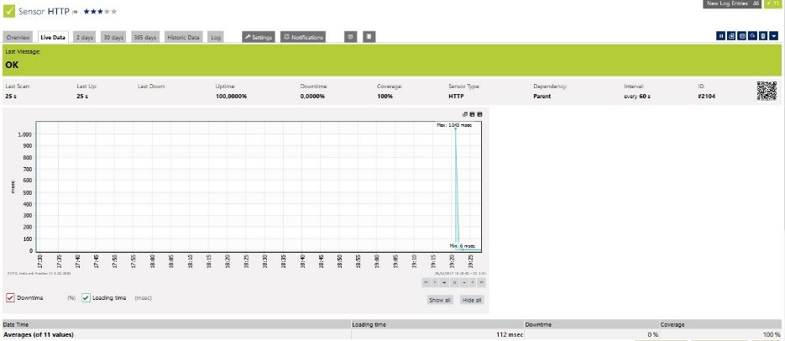

B.19 Http Response after doing SQLmap tools exploitation using BackBox OS on NOOWASP web2 server

Description :
Before doing exploitation( Figure B.18 ),, average response time was about 292 miliseconds, but after exploitation has been done( Figure B.19 ), the average response time down to 113 miliseconds. Web2 server response time reached 1,043 miliseconds during exploitation.
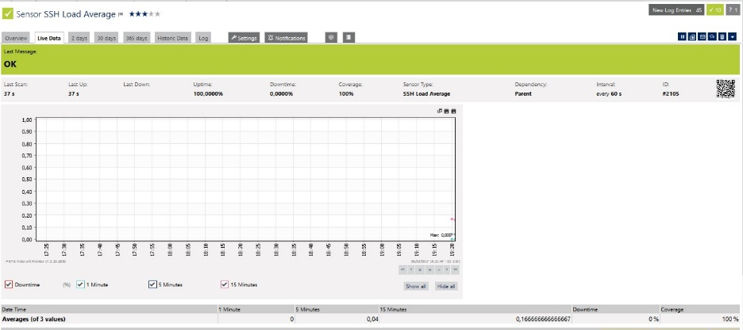
CPU Load Average
B.20 CPU Load before doing SQLmap tools exploitation using Back Box OS on NOOWASP web2 server

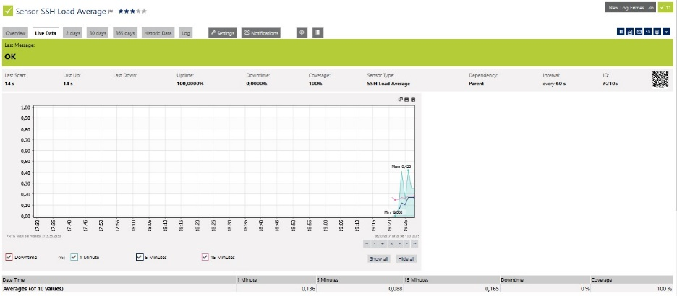

B.21 CPU Load after doing SQLmap tools exploitation using Back Box OS on NOOWASP web2 server

Description :
By looking the graphic after the exploitation ( Figure B.21 ),, its show that during the exploitations, CPU Load was reaching 1.56 , 3 times bigger than normal which only average about 0,51 ( Figure B.20 ),. But downtime still in 0% that means the server still in healthy condition.
Memory Free
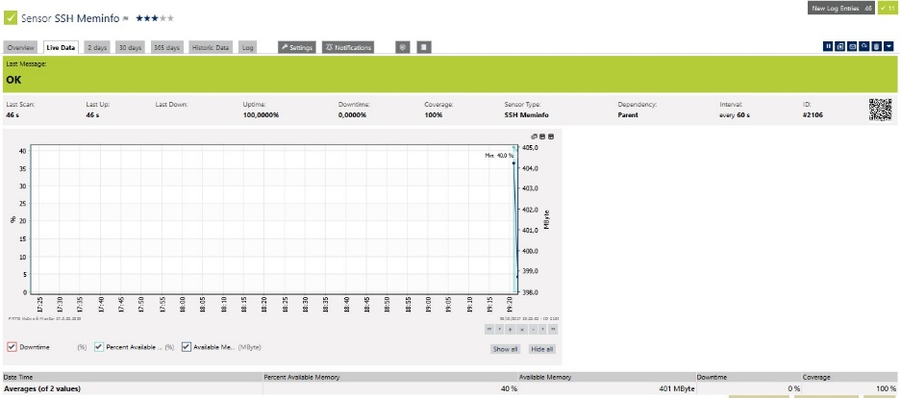
B.22 Memory Free before doing SQLmap tools exploitation using BackBox OS on NOOWASP web2 server

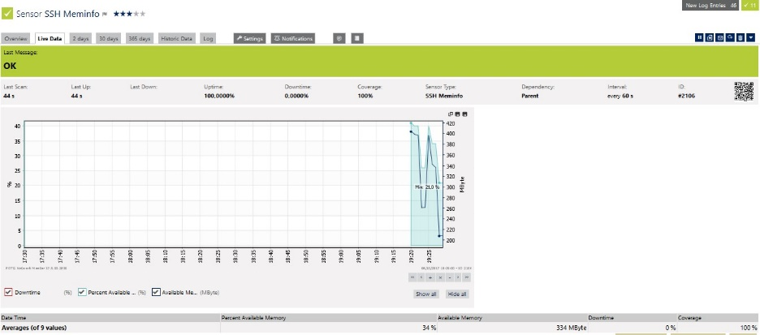
B.23 Memory Free after doing SQLmap tools exploitation using BackBox OS on NOOWASP web2 server

Description :
Before exploitation( Figure B.22 ), the graph show that available memory was 401Mb, but during exploitation ( Figure B.23 ), the number decrease into 334Mb. Memory Load became normal after the exploitation already finish. Its can be concluded that if there is a lot of exploitation done in the same time, even it isn’t risk the web server data lost, it will be also possibly cause memory flooding that can make the server down for seconds.
Disk Free :
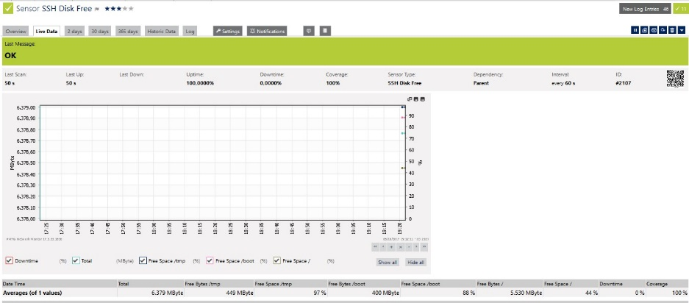
B.24 Free Disk before doing SQLmap tools exploitation using Back Box OS on NOOWASP web2 server

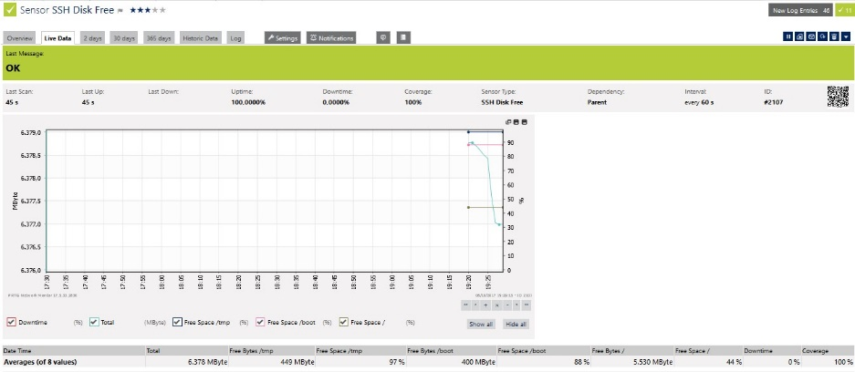

B.25 Free Disk after doing SQLmap tools exploitation using Back Box OS on NOOWASP web2 server

Description :
Before the exploitation( Figure B.24 ), the average available memory was about 6.379 Mb in total but decrease to 6.378 after the expoitation was done( Figure B.25 ),. With those little number of Mb down, the web2 server will not be affected Free Disk lost too much if there was a single Injection using SQLmap.
- Parrot SQLmap Tools Exploitation
OWASP web1 server :
OWASP web1 server was failed to been injected using SQLmap tools in Backbox as show by the figure C.1.
C.1 SQLmap Tools using Parrot OS detected WAF/IP/IDS

Even SQLmap replied that the target was protected by some kind of WAF/IPS/IDS. Its still get the information such as the back-end DBMS of the target is MySQL.

C.2 SqlMap Tools using Parrot OS Failed to SQL Inject on OWASP web1 server

At the figure C.2, show that SQLmap tools detected there was an WAF/IPS/IDS in the web server but continue to doing tons of injection even it was rejected by the server. Because of that, the mod_sec hit list database was full and couldnt be check one by one. The test was done 10 times using SQLmap, the result were all of the attempt were failed but flooding mod_sec database. The video of Parrot SQLmap exploitation on OWASP web1 server will be attach later on the report CD.
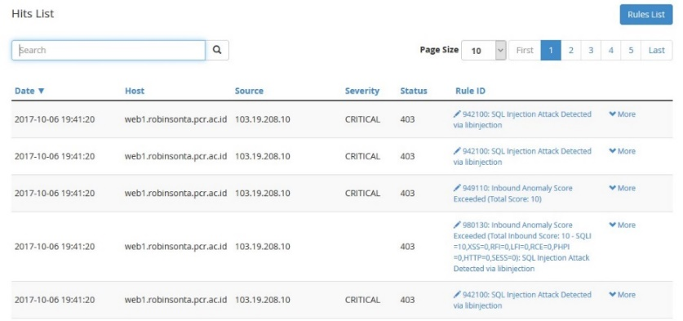
Figure C.3 and C.4 will show a little part of ModSecurity Hit List with total detect about 5000 logs.

C.3 OWASP ModSecurity Hit Lists after SQLmap tools exploitation using Parrot OS (1)

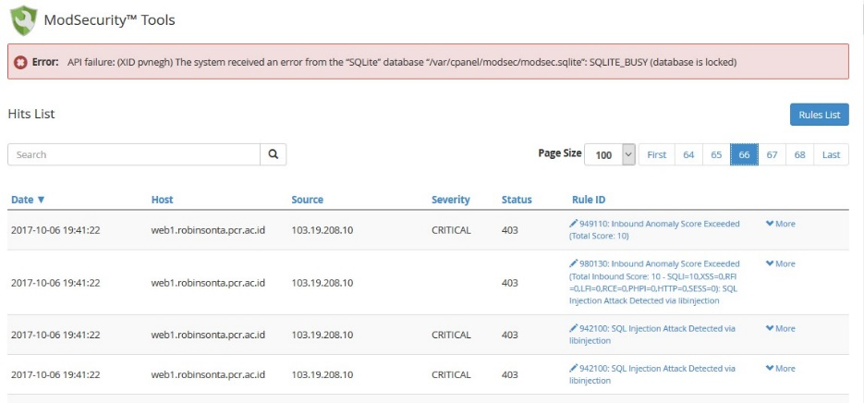

C.4 OWASP ModSecurity Hit Lists after SQLmap tools exploitation using Parrot OS (2)

Performance test also been done at the web server during do SQLmap exploitation. Figures C.5 – C.12 will show the comparison between HTTP response, CPU Load, Memory Free and Free Disk of web1 server before and after exploitation.
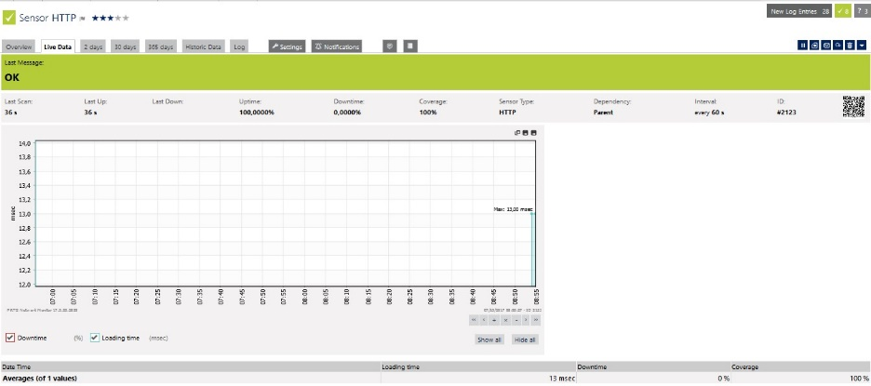
HTTP response :
C.5 Http Response before doing SQLmap tools exploitation using Parrot OS on OWASP web1 server

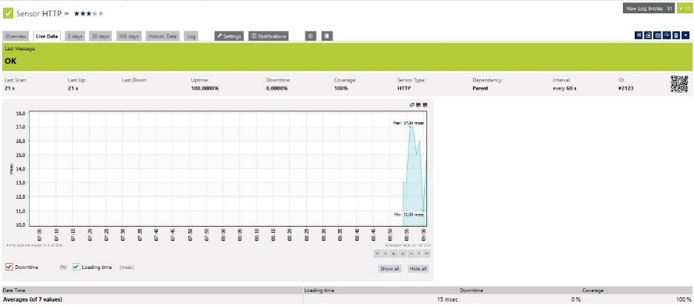

C.6 Http Response after doing SQLmap tools exploitation using Parrot OS on OWASP web1 server

Description :
Before doing exploitation ( Figure C.5 ) , average response time was about 13 miliseconds, but after exploitation has been done( Figure C.6 ), the average response time up to 15 miliseconds with maximal 17 miliseconds during exploitation. Its look like the exploitation didn’t affect too much web1 server response time at all.
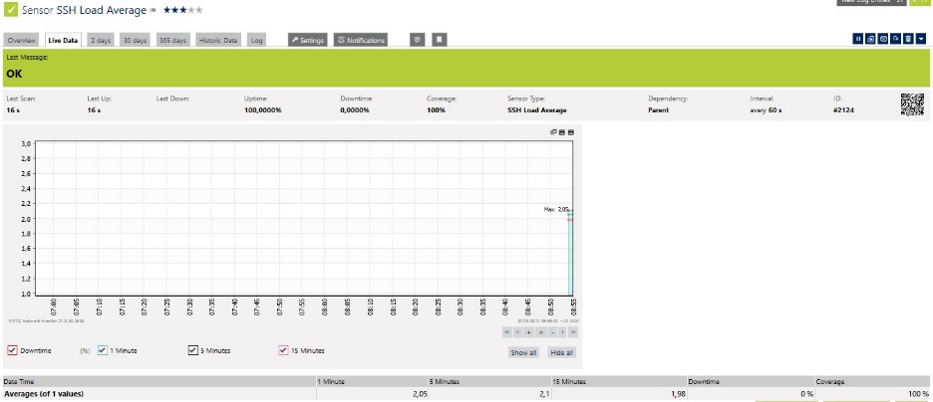
CPU Load Average

C.7 CPU Load before doing SQLmap tools exploitation using Parrot OS on OWASP web1 server

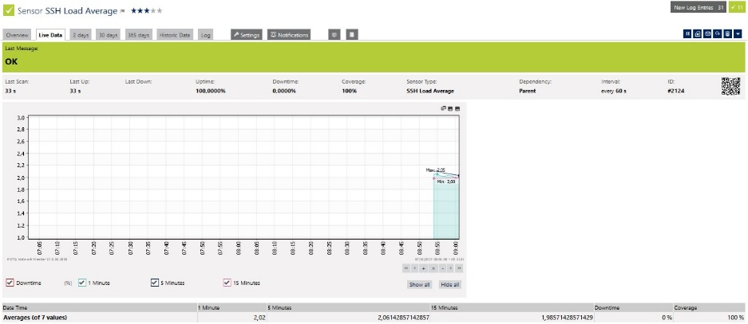

C. 8 CPU Load after doing SQLmap tools exploitation using Parrot OS on OWASP web1 server

Description :
At the first graph before the exploitation( Figure C.7 ), its show that in interval 5 minutes CPU Load, it was 2,1 . After the exploitation( Figure C.8 ), the second graph show the 5 minutes interval CPU Load down to 2,06. Seems like didn’t affect too much for CPU Load of web1 server.

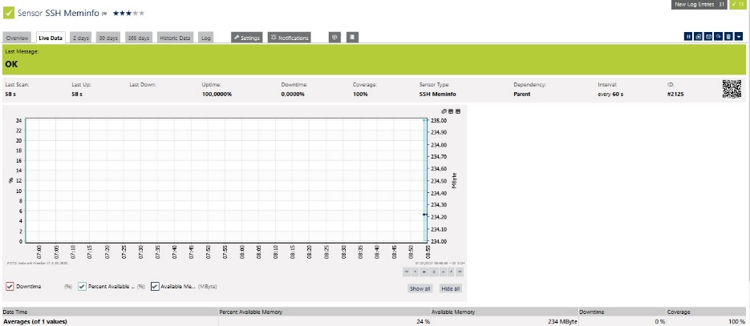
Memory Free

C.9 Memory Free before doing SQLmap tools exploitation using Parrot OS on OWASP web1 server

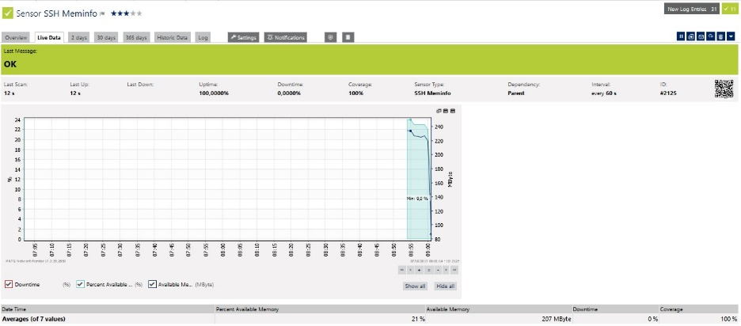

C.10 Memory Free after doing SQLmap tools exploitation using Parrot OS on OWASP web1 server

Description :
Before exploitation( Figure C.9 ), the graph show that available memory was 234Mb, but during exploitation( Figure C.10 ), the number decrease into 207Mb. Memory Load became normal after the exploitation already finish. Its can be concluded that if there is a lot of exploitation done in the same time, even it isn’t risk the web server data lost, it will be also possibly cause memory flooding that can make the server down for seconds.
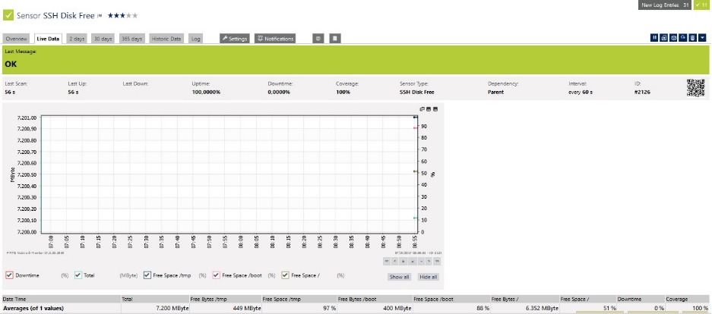
Free Disk :

C.11 Free Disk before doing SQLmap tools exploitation using Parrot OS on OWASP web1 server

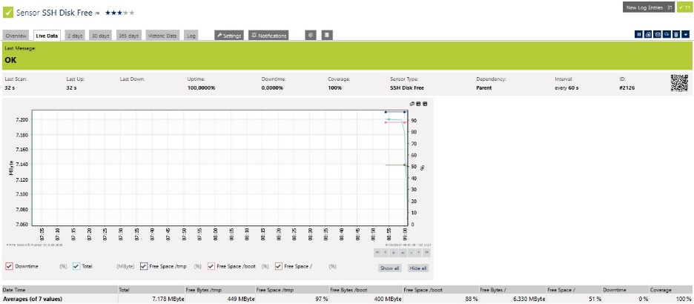

C.12 Free Disk after doing SQLmap tools exploitation using Back Box OS on OWASP web1 server
Description :
Before the exploitation( Figure C.11 ), the average available memory was about 7.200 Mb in total but decrease to 7.178 after the expoitation was done( Figure C.12 ). With those little number of Mb down, the web1 server will not be affected Free Disk lost too much if there was a single Injection using SQLmap.
NO OWASP web2 server :
Web2 server which without OWASP ModSecurity™ protection was successed to been injected using SQLmap tools as show by the figure C.13.

C.13 SQLmap success exploitating the database name of NOOWASP web2 server using Parrot OS and trying to inject table expoitation query

Web2 server successed been injected using SQLmap using Parrot OS that return the database name. Next step was exploiting tables name inside web2_database. ( Figure C.14 )

C.14 SQLmap success exploit the database table name of web2 server using Parrot OS and trying to inject column expoitation query

C.15 SQLmap success exploitating the database column names of NOOWASP web2 server using Parrot OS and trying to data expoitation query

C.16 SQLmap detecting there was an encrypted data and offer a decrypting process on Parrot OS

C.17 NOOWASP web2 server show all the username and password after decryption process by SQLmap using Parrot OS

At the figure C.13 – C.17, show that SQLmap tools detected the name of the database first, then the tables inside, columns then user and password inside. SQLmap also success to convert the password that has been encrypted using common password tools. The test was done 10 times using SQLmap, the result were all of the attempts were successed. The video of Parrot SQLmap exploitation on NO OWASP web2 server will be attach later on the report CD.
Performance test also been done at the web server during do SQLmap exploitation. Figures below will show the comparison between HTTP response, CPU Load, Memory Free and Disk Free of web server before and after exploitation.

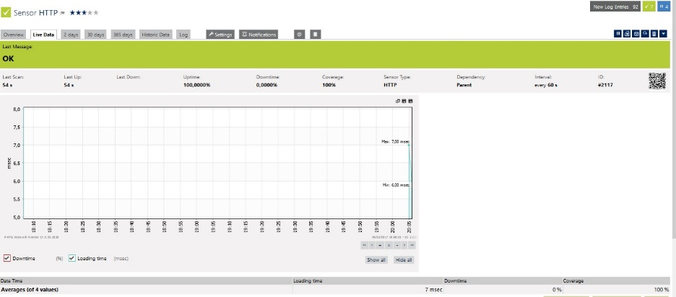
HTTP response :

C.18 Http Response before doing SQLmap tools exploitation using Parrot OS on NOOWASP web2 server

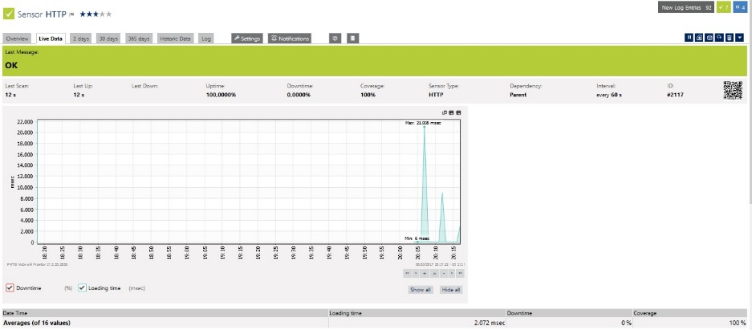

C.19 Http Response after doing SQLmap tools exploitation using Parrot OS on NOOWASP web2 server
Description :
Before doing exploitation( Figure C.18 ), maximal response time was about 7 miliseconds, but after exploitation has been done( Figure C.19 ), the maximal response time during response time up to 21 miliseconds. But web server still has 0% of downtime which mean its still healthy.

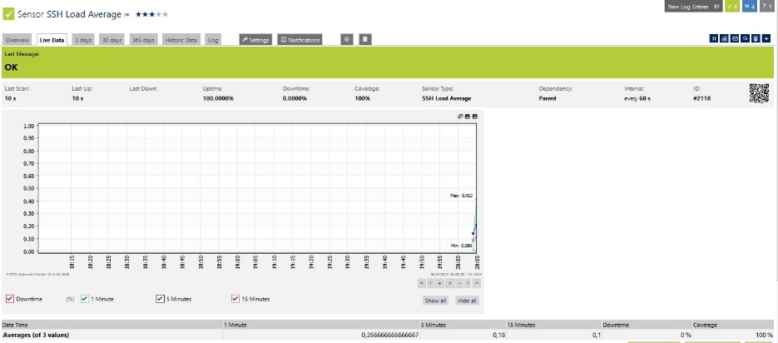
CPU Load Average

C.20 CPU Load before doing SQLmap tools exploitation using Parrot OS on NOOWASP web2 server

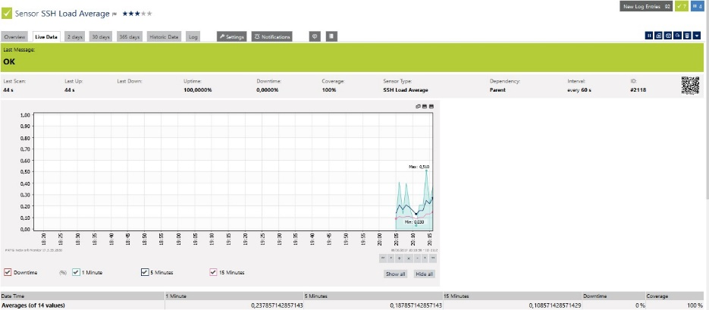
C.21 CPU Load after doing SQLmap tools exploitation using Parrot OS on NOOWASP web2 server

Description :
By looking the graphic after the exploitation( Figure C.21 ), its show that during the exploitations, CPU Load was reaching 0,510 maximal load, 0,1 load bigger than load before exploitation( Figure C.20 ) or in normal condition. But downtime still in 0% that means the server still in healthy condition.

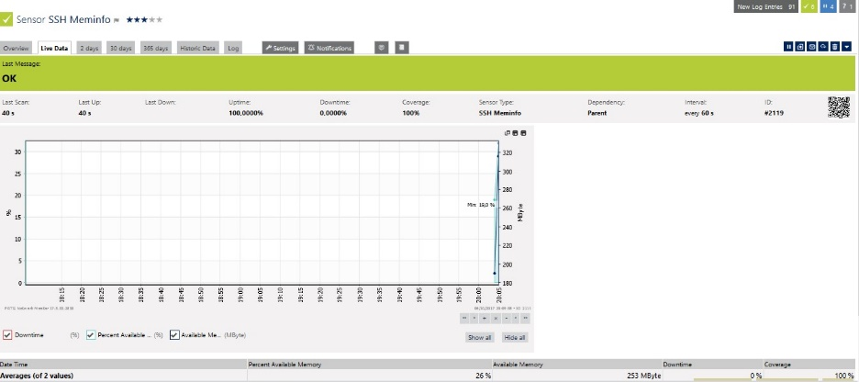
Memory Free

C.22 Memory Free before doing SQLmap tools exploitation using Parrot OS on NOOWASP web2 server

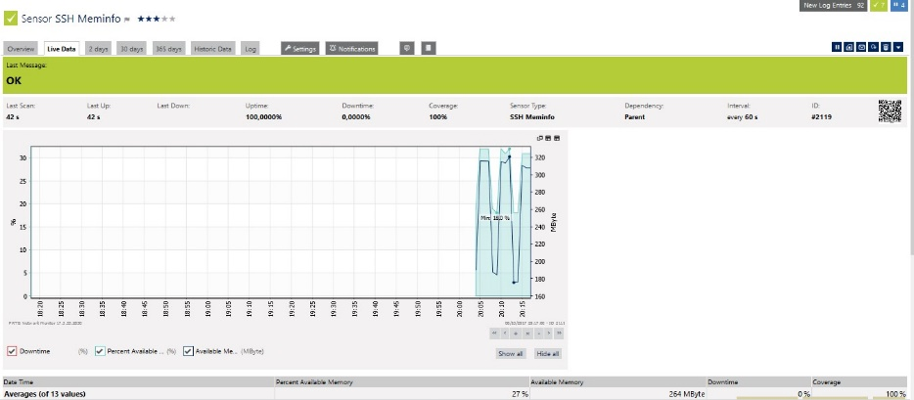
C.23 Memory Free after doing SQLmap tools exploitation using Parrot OS on NOOWASP web2 server

Description :
Both of the graphs show the unstable available memory which up and down every minute. The graph after exploitation( Figure C.23 ) didn’t show any big changes also with the available memory. Its mean that exploitation using Parrot did not cause any affect to NOOWASP web2 server memory.

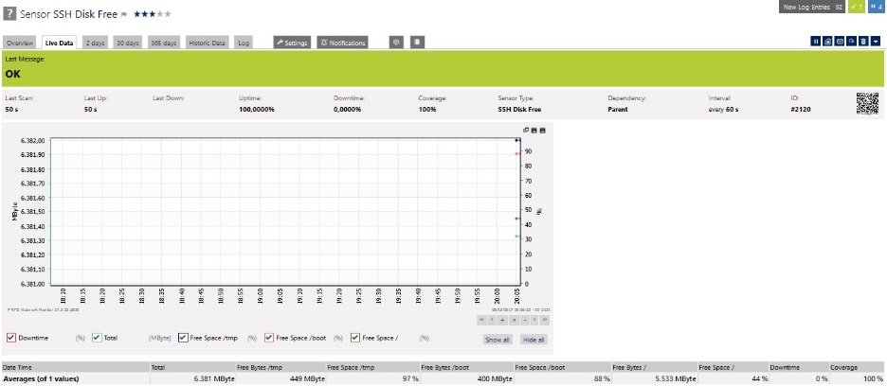
Disk Free :
C.24 Free Disk before doing SQLmap tools exploitation using Parrot OS on NOOWASP web2 server

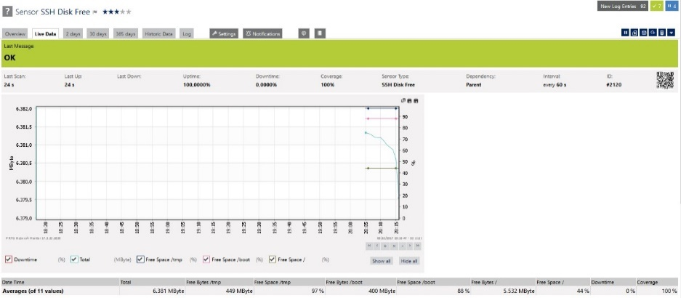

C.25 Free Disk after doing SQLmap tools exploitation using Parrot OS on NOOWASP web2 server

Description :
Before the exploitation( Figure C.24 ), the blue point in the graph was in 70 more percentage which down to around 20 percentage during exploitation by SQLmap using Parrot OS

- Kali Linux BeEF Tools Exploitation
OWASP web1 server :
OWASP failed to protected the server from XSS using BeEF where cause the site was directing page into hook/trap page that been prepared by BeEF.
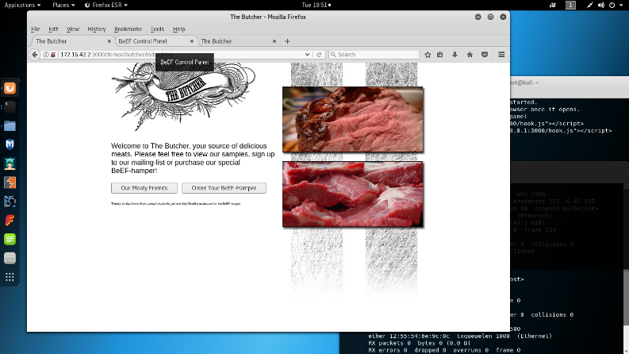
All the progress will be shown step by step in the figures D.1 – D.5 :

D.1 Kali Linux BeEF Trap Page with Attacker PC IP

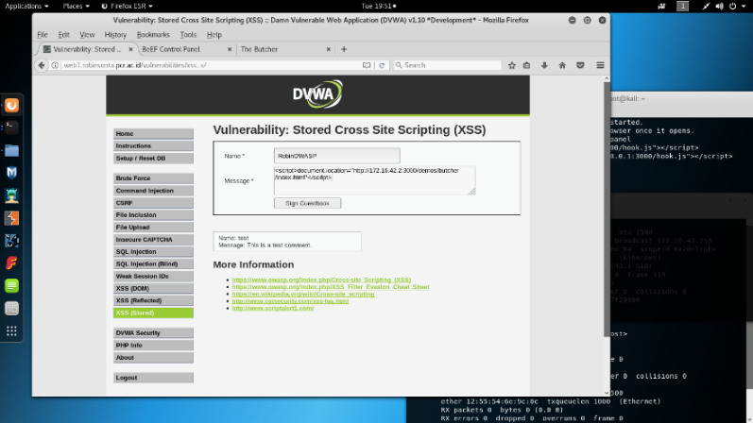
The figure D.1 is a Trap page that prepared by BeEF

D.2 BeEF Script injecting into OWASP XSS Stored
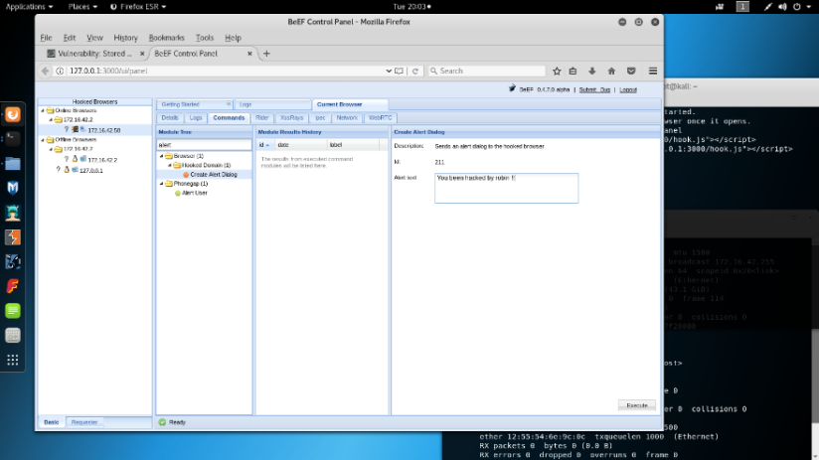
The link of that page was being injected to Stored page using script command which will cause this page will redirect to trap page later.

D.3 Kali Linux BeEF hooked a target PC
Client or target PC which have been redirect to the trap page will be fully spied by the attacker. Above is the example of attacker sending alert to hooked target PC. ( Figure D.3 )
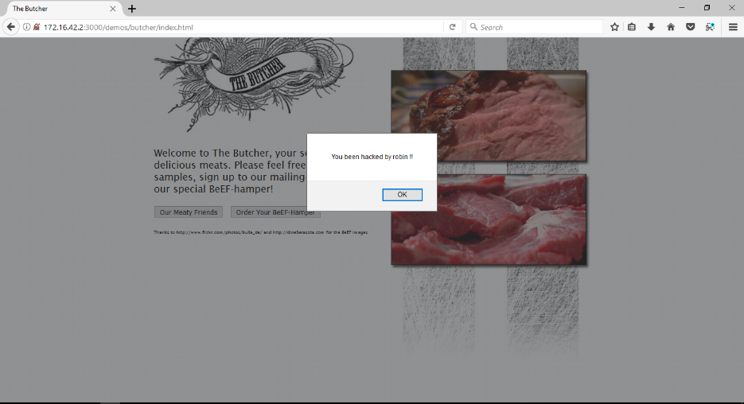
D.4 Target PC got a alert message sent by BeEF attacker

Target PC display the alert that was send by attacker PC. ( Figure D.5 )
OWASP ModSecurity Tools has caught zero hit list or logs after BeEF attack. This mean that OWASP ModSecurity was vulnerable to Cross Site Scripting using BeEF. ( Figure D.5 )
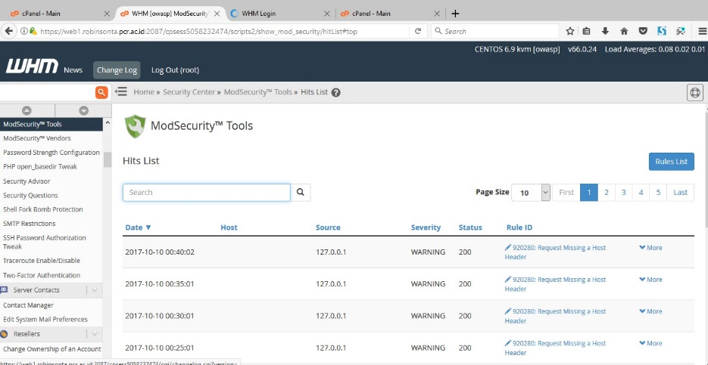

D.5 OWASP ModSecurity Tools got nothing after Kali Linux BeEF attack
NOOWASP web2 server :
NOOWASP web2 server was successed to been injected cross site script using BeEF.
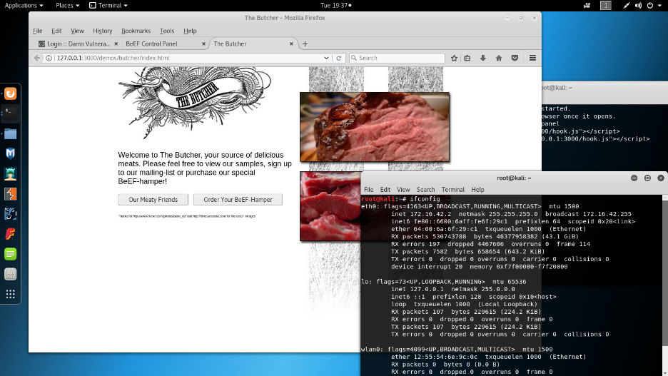
All the progress will be shown step by step in the figures D.6 – D.10 :
D.6 BeEF hook page with IP Address

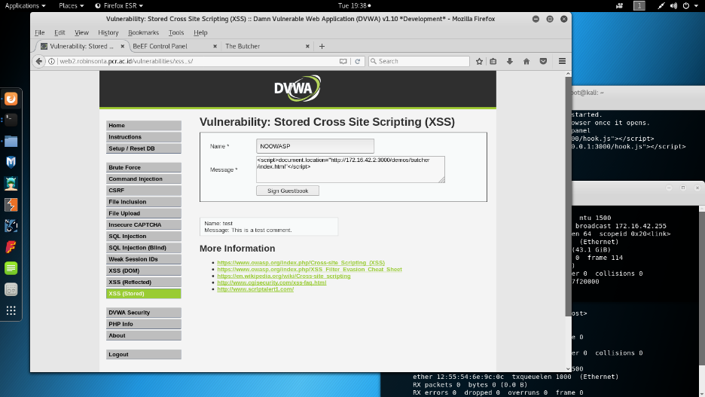

D.7 BeEF hook page link inject into NOOWASP XSS Stored Page

Hook script was being injected into NOOWASP web2 server in the stored page. After the client or target click the page, it will be hooked by BeEF tools as shown on Figure D.8 :

D.8 BeEF hook a target PC from NOOWASP page and try to send a fake login page
After got a target, BeEF send a fake login form to target PC. ( Figure D.9 )

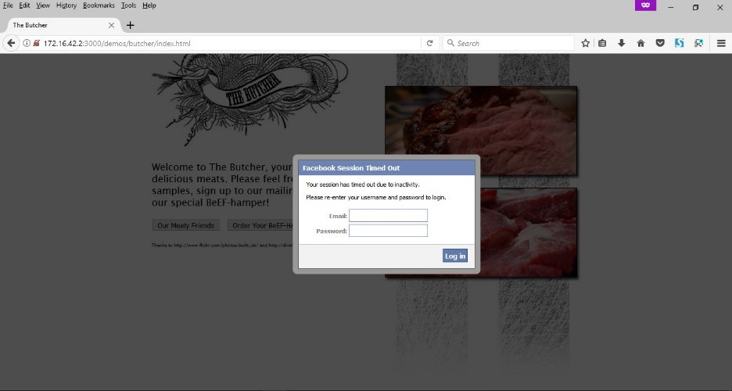
D.9 Fake From Login PopUp sent by BeEF

If the target was filled the form with username and password, then it will be send to attacker. ( Figure D.10 )
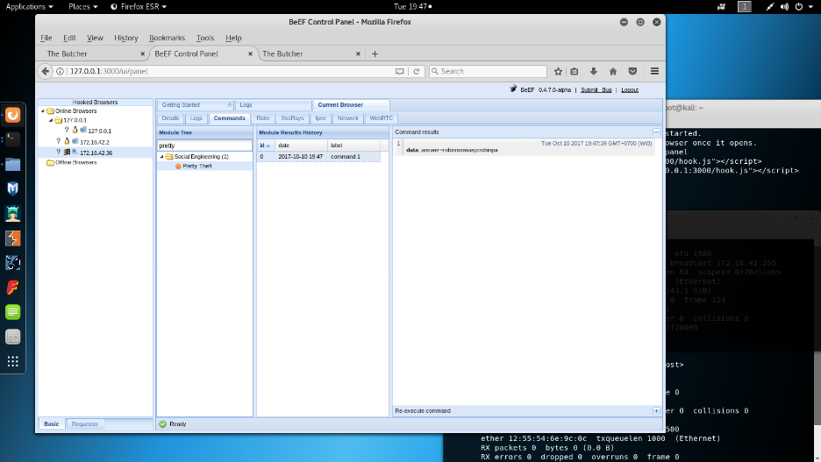

D.10 BeEF got username and password after target filled the form

BeEF show the username and password that filled by target PC in the login form before. ( Figure D.10 )
Description :
OWASP failed when securing web server from Cross Site Scripting ( Stored ), its must be caused by Cross Site Scripting is injecting script to the database through form field which the data will be shown on the site. Solution of the Cross Site Scripting is securing the site on php script or when development.
- Backbox BeEF Tools Exploitation
OWASP web1 server :
OWASP also failed to protected the server from BeEF XSS using Backbox OS where caused the site was directing page into hook/trap page that been prepared by BeEF.
All the progress will be shown step by step in the figures E.1 – E.3 :
E.1 Kali Linux BeEF Trap Page with Attacker PC IP
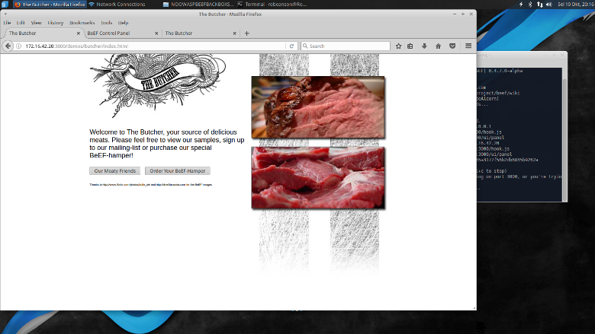

The figure E.1 is a Trap page that prepared by BeEF

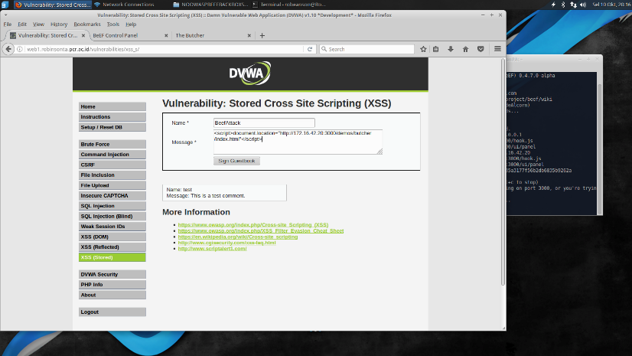

E.2 BeEF Script injecting into OWASP XSS Stored

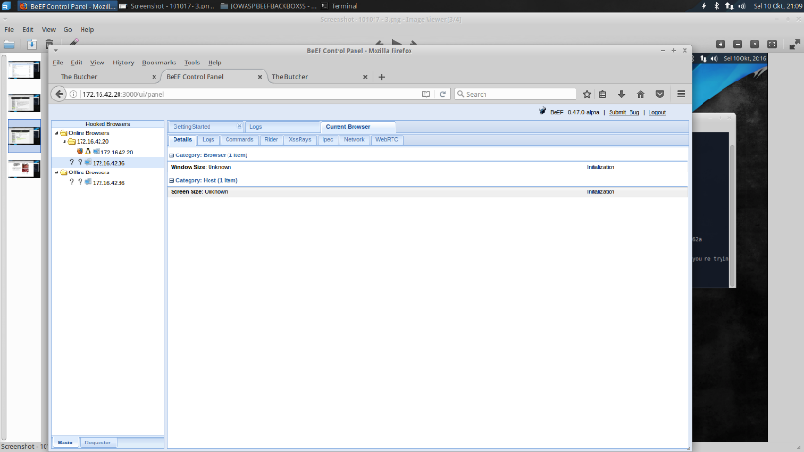
The link of that page was being injected to Stored page using script command which will cause this page will redirect to trap page later. ( Figure E.2 )
E.3 Kali Linux BeEF hooked a target PC

BeEF sometimes getting error after hooked a target. After the IP of target PC was appeared, BeEF isnt show the action we can do to the target PC. It must me cause of the OS itself, this problem only happened twice in Backbox OS. ( Figure E.3 )
NOOWASP web2 server :
NOOWASP web2 server was successed to been injected cross site script using BeEF.
All the progress will be shown step by step in the figures E.4 – E.9 :
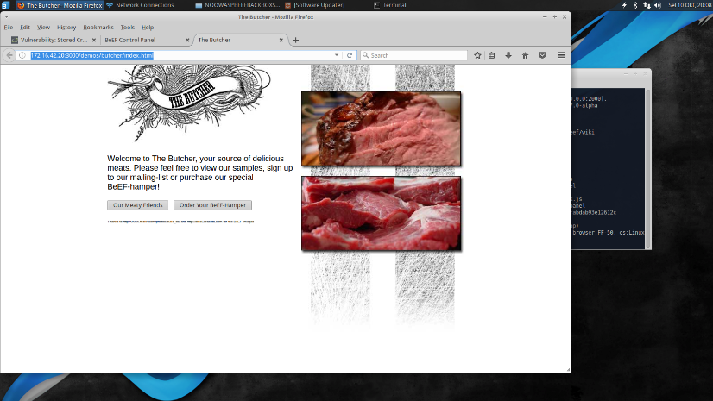

E.4 BeEF hook page with IP Address

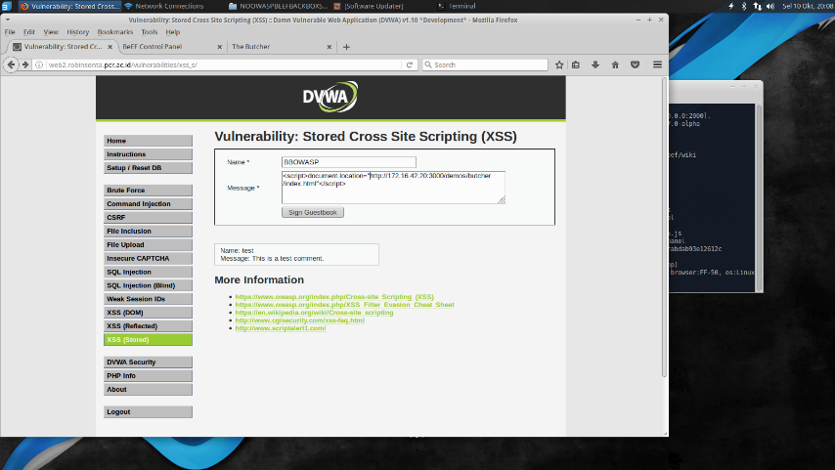

E.5 BeEF hook page link inject into NOOWASP XSS Stored Page

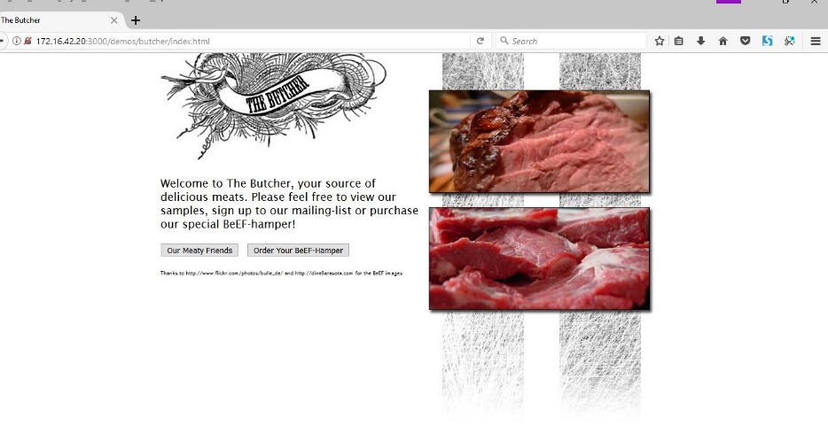
Hook script was being injected into NOOWASP web2 server in the stored page.In the client side, if the link have been clicked, it will be directed to hook page . ( Figure E.6 )
E.6 Target PC got hooked

After the client or target click the page, it will be hooked by BeEF tools as shown E.7 :
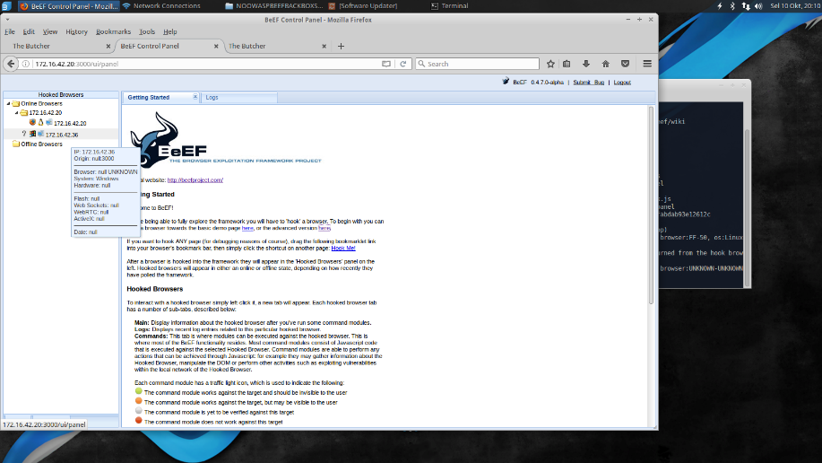

E.7 BeEF hook a target PC from NOOWASP page

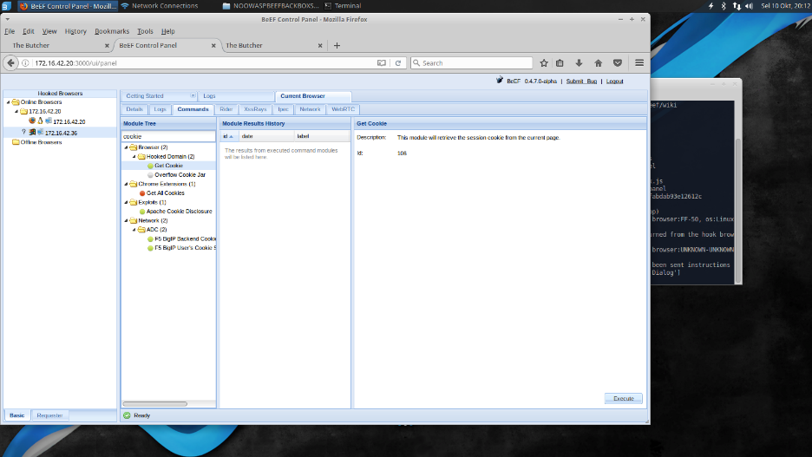

E.8 BeEF try to get cookie data from hooked PC

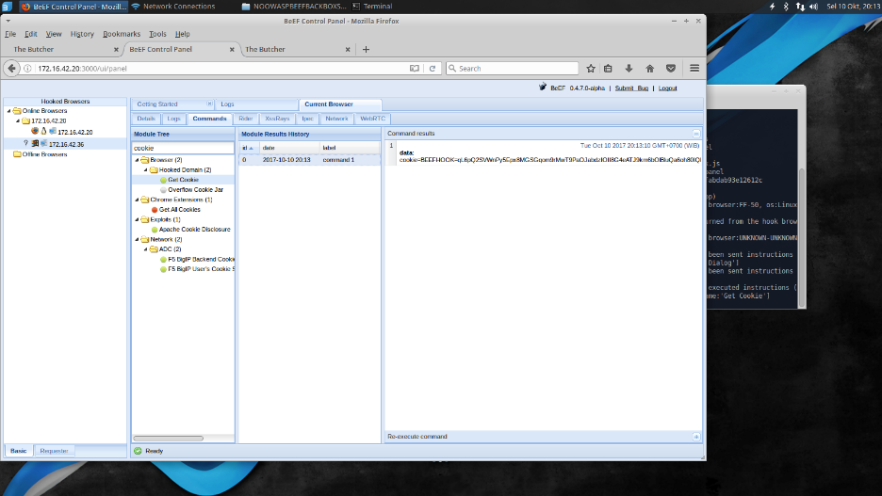

E.9 BeEF got target cookies data

BeEF success steal the cookies of target PC and display it on BeEF show the cookies from the target PC . ( Figure E.8 – E.9)

- Kali Linux XSSer Tools Exploitation
OWASP web1 server :
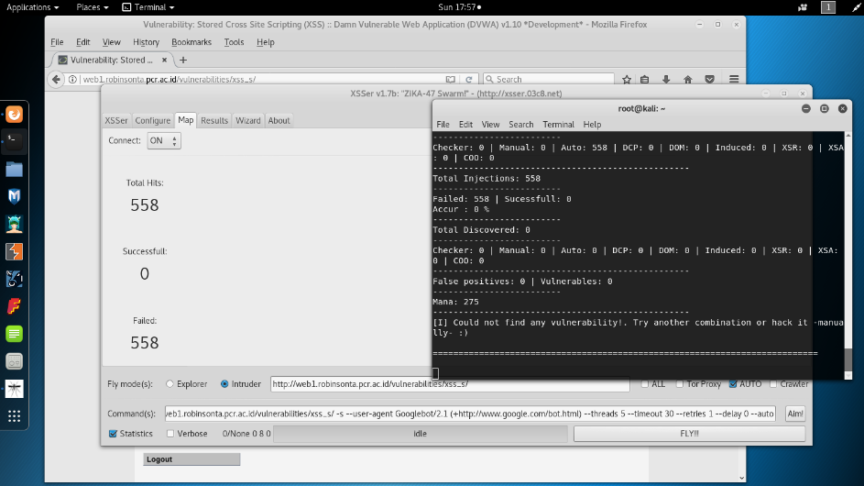
OWASP web1 server was failed to been injected using XSSer tools as show by the figure below.

F.1 XSSer using Kali OS exploitation failed to injected into OWASP web server

At the figure F.1 , show that XSSer tools inject 558 queries into web server page, but all of the queries injection was failed. The test was done 10 times using XSSer, the result were all of the attempt were failed. The video of KaliLinux XSSer exploitation on OWASP web1 server will be attach later on the report CD.
Figure F.2 will show a little part of ModSecurity Hit List with total detect about 12 logs after XSSer exploitation.

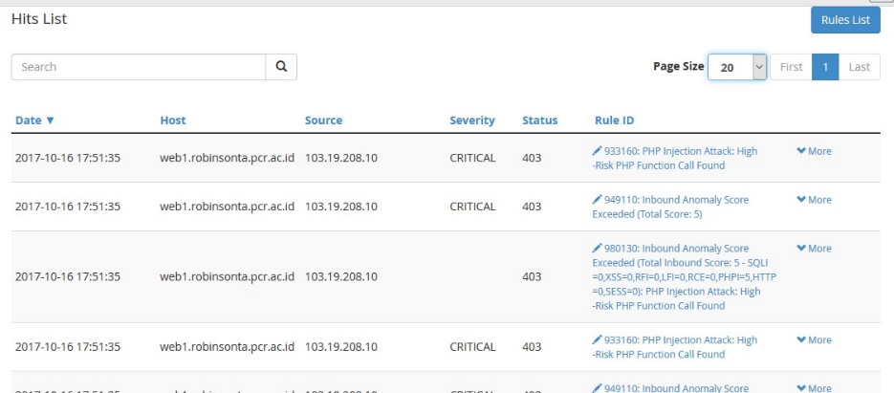

F.2 OWASP ModSecurity HitList after XSSer Kali OS Exploitation

Performance test also been done at the web server during XSSer exploitation. Figures F.3 – F.10 will show the comparison between HTTP Response, CPU Load, Memory Free, and Disk Free of web server before and after exploitation.
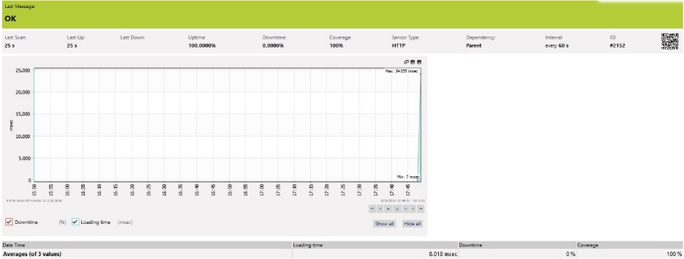
HTTP response :

F.3 Http Response before doing XSSer tools exploitation using Kali Linux OS on OWASP web1 server

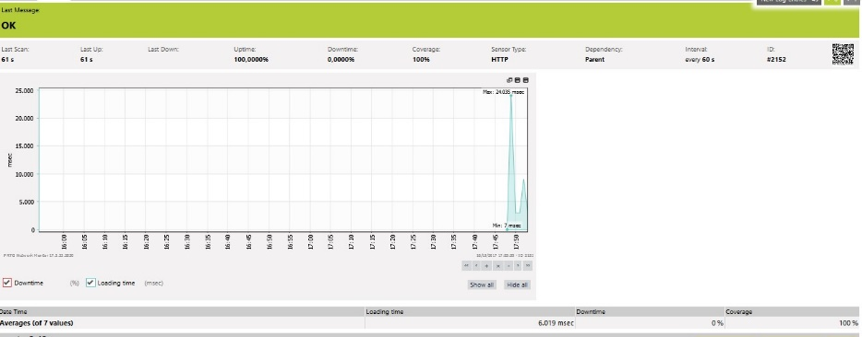

F.4 Http Response after doing XSSer tools exploitation using Kali Linux OS on OWASP web1 server

Description :
Before doing exploitation ( Figure F.3 ), average response time was about 8 miliseconds, but after exploitation has been done, the average maximal time has done to 6 miliseconds. Its mean that XSSer explotation didn’t affect OWASP web server Http Response time.
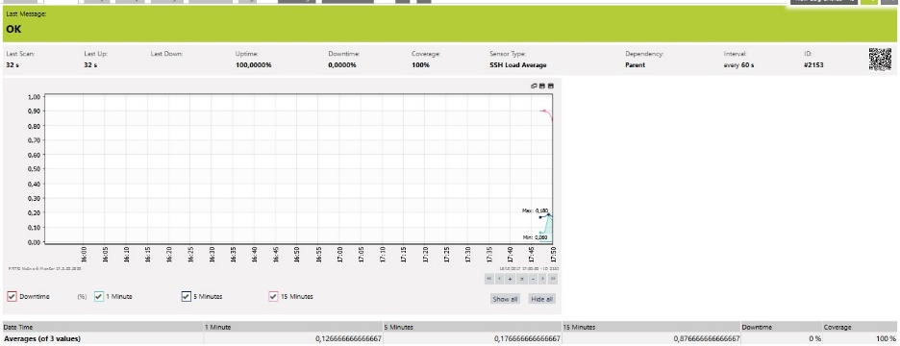
CPU Load Average :

F.5 CPU Load before doing XSSer tools exploitation using Kali Linux OS on OWASP web1 server

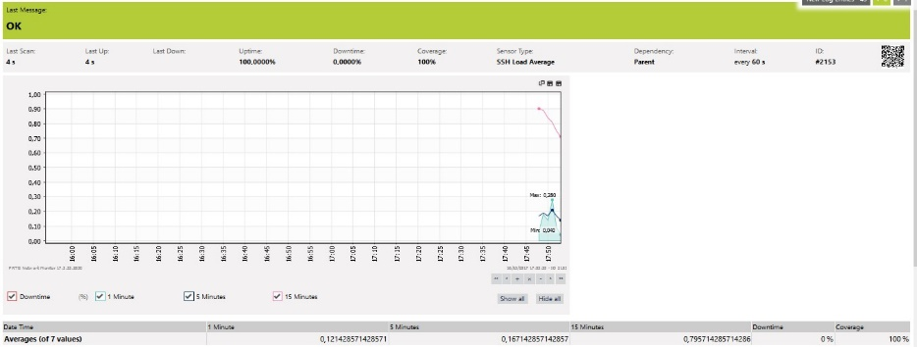

F.6 CPU Load after doing XSSer tools exploitation using Kali Linux OS on OWASP web1 server

Description :
CPU Load maximal time was increased about 0,1 Msec from 0.180 to 0.280. But with didn’t affect to much to the web server. ( Figure F.5 & F.6 )
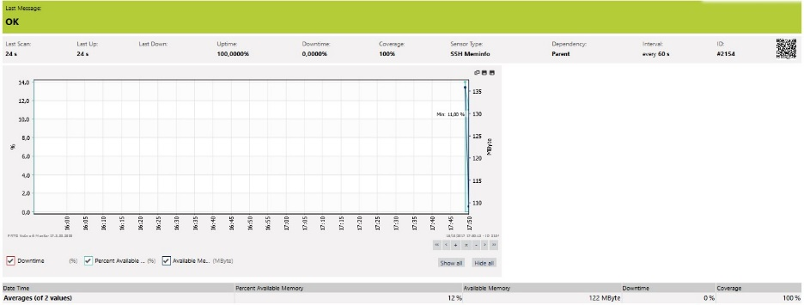
Memory Free

F.7 Memory Free before doing XSSer tools exploitation using Kali Linux OS on OWASP web1 server

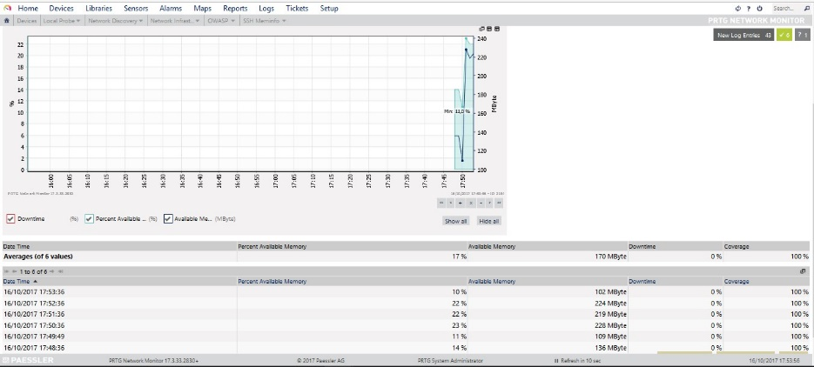
F.8 Memory Free after doing XSSer tools exploitation using Kali Linux OS on OWASP web1 server

Description :
After analyze from the Memory Change Log ( Figure F.7 & F.8 ), its seems like the free memory didn’t show any affect of the XSSer exploitation.
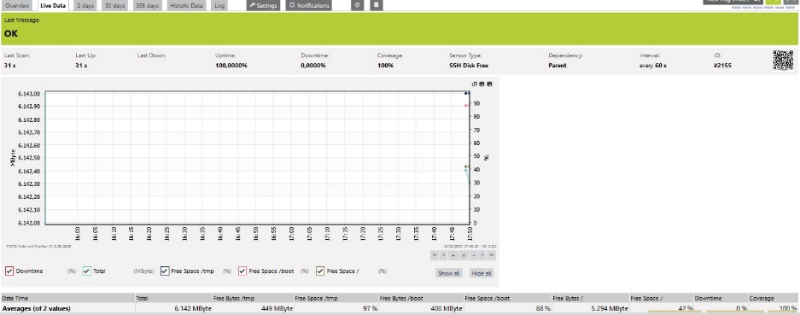
Free Disk :

F.9 Free Disk before doing XSSer tools exploitation using Kali Linux OS on OWASP web1 server

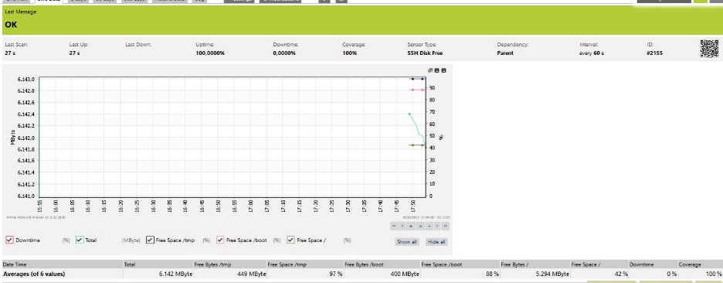

F.10 Free Disk after doing Xsser tools exploitation using Kali Linux OS on OWASP web1 server

Description :
The total of Free Disk was same 1.642, before and after exploitation ( Figure F.9 & F.10 ). It didn’t show any affect change.
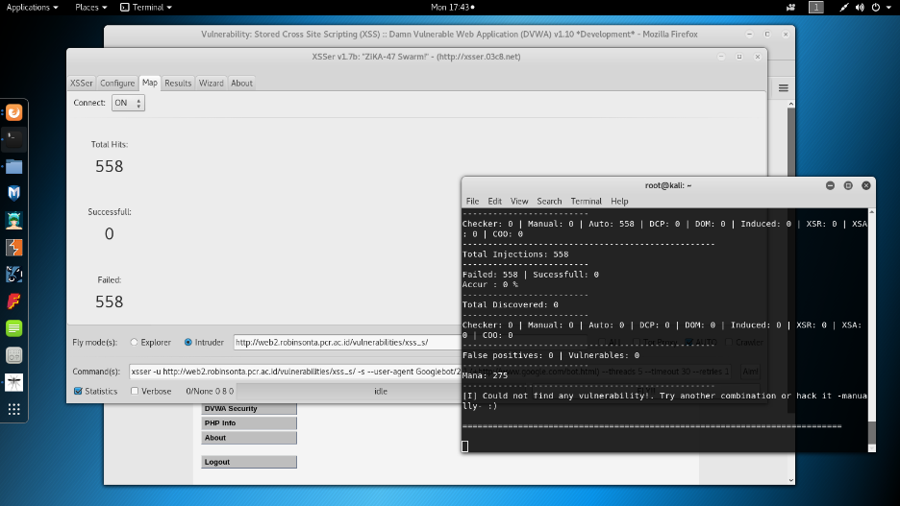
NO OWASP web2 server :

F.11 XSSer Kali OS Exploitation failed to inject CSS query into NOOWASP web2 server

Even there wasn’t any Web application Firewall, XSSer still failed to do CSS Injection into web server. This may be cause that XSS work only in web page which still show .php in the end of the URL link. ( Figure F.11 )
The test was done 10 times using XSSer, the result were all of the attempts were failed. The video of KaliLinux XSSer exploitation on NOOWASP web2 server will be attach later on the report CD.
Performance test also been done at the web server during do XSSer exploitation. Figures F.12 – F.19 will show the comparison between HTTP response, CPU Load, Memory Free and Disk Free of web server before and after exploitation.
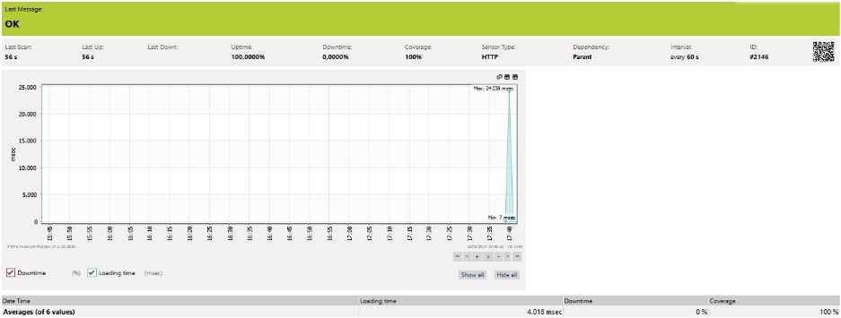
HTTP response :

F.12 Http Response before doing XSSer tools exploitation using Kali Linux OS on NOOWASP web2 server
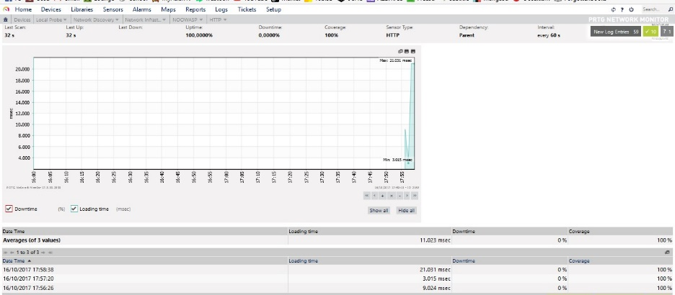

F.13 Http Response after doing XSSer tools exploitation using Kali Linux OS on NOOWASP web2 server

Description :
By looking at the Http Response log, the response time ever reach 21 Msec during the XSSer exploitation. Its mean there was a little increasing time, but didn’t affect too much. ( Figure F.12 & F.13 )
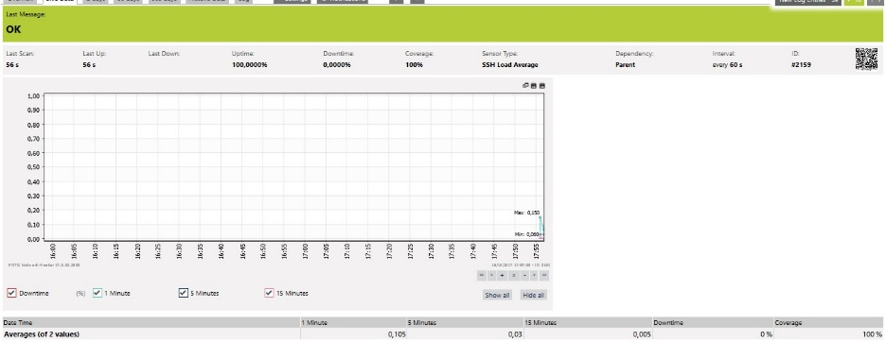
CPU Load Average :

F.14 CPU Load before doing XSSer tools exploitation using Kali Linux OS on NOOWASP web2 server

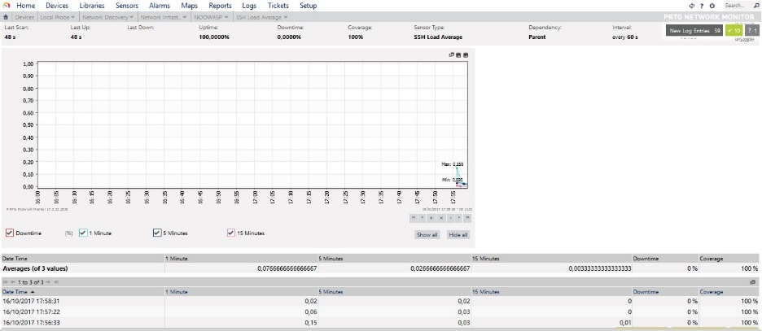

F.15 CPU Load after doing XSSer tools exploitation using Kali Linux OS on NOOWASP web2 server

Description :
The CPU Load logs show that there isn’t any change of CPU Load during the exploitation ( Figure F.14 & F.15 ).
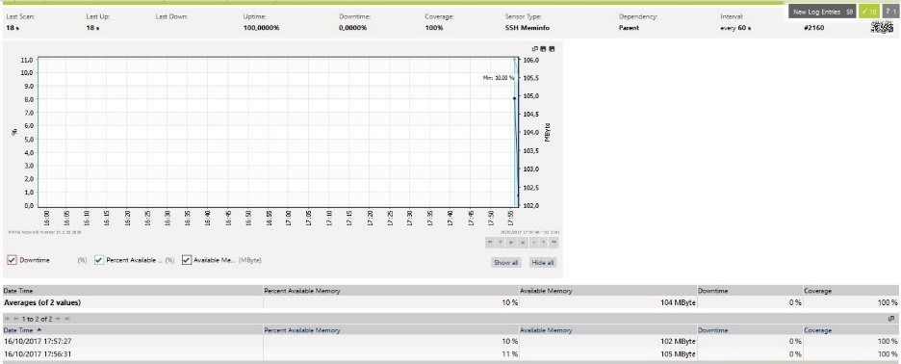
Memory Free

F.16 Memory Free before doing XSSer tools exploitation using Kali Linux OS on NOOWASP web2 server

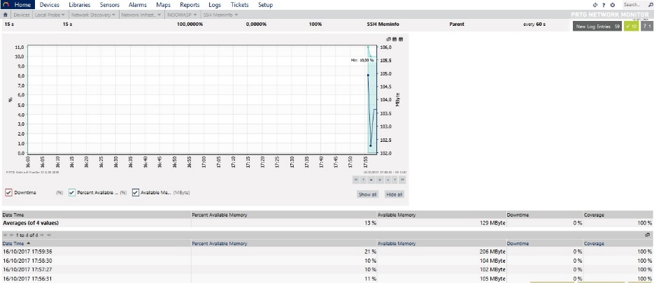

F.17 Memory Free after doing XSSer tools exploitation using Kali Linux OS on NOOWASP web2 server

Description :
Memory change Logs show that the number of available memory every reached 23% after expoitation. This mean that XSSer exploitation didn’t affect the Memory of web server. ( Figure F.16 & F.17 )
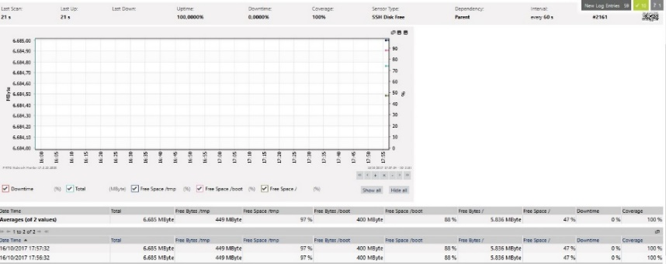
Free Disk :

F.18 Free Disk before doing XSSer tools exploitation using Kali Linux OS on OWASP web1 server

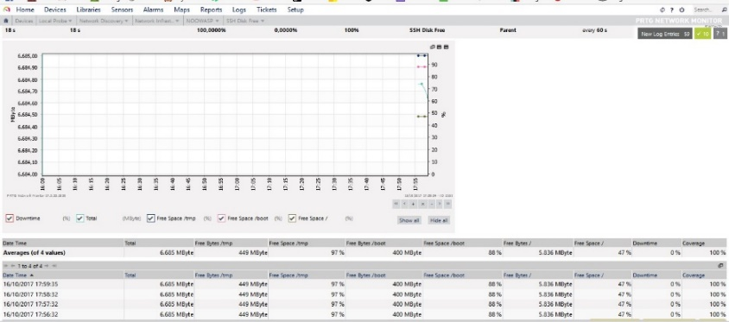

F.19 Free Disk after doing XSSertools exploitation using Kali Linux OS on OWASP web1 server

Description :
Free Disk Change Logs also show nothing change during the XSSer exploitation, the total of Free Disk stay at 6.685 MByte ( Figure F.18 & F.19)

- Parrot OS XSSer Exploitation
OWASP web1 server :
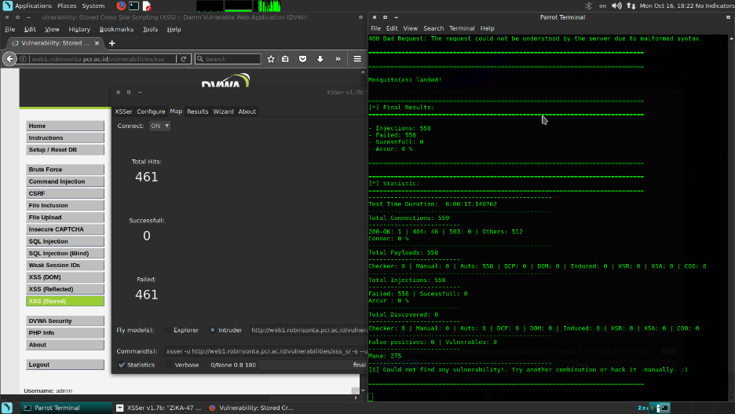
OWASP web1 server was failed to been injected using XSSer tools as show by the figure G.1.

G.1 XSSer using Parrot OS exploitation failed to injected into OWASP web server

At the figure G.1, show that XSSer tools inject 461 queries into web server page, but all of the queries injection was failed. The test was done 10 times using XSSer, the result were all of the attempt were failed. The video of KaliLinux XSSer exploitation on OWASP web1 server will be attach later on the report CD.
Figure G.2 will show a little part of ModSecurity Hit List with total detect about 30 logs after XSSer exploitation.

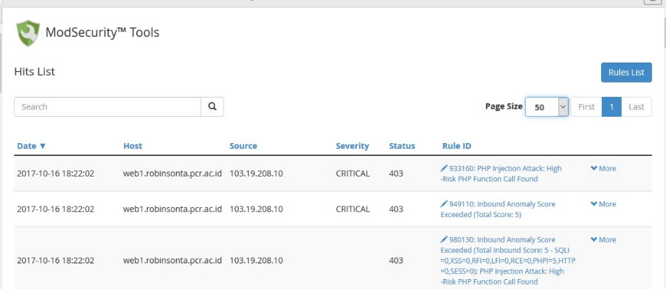

G.2 OWASP ModSecurity HitList after XSSer ParrotOS Exploitation

Performance test also been done at the web server during XSSer exploitation. Figures G.3 – G.10 will show the comparison between HTTP Response, CPU Load, Memory Free, and Disk Free of web server before and after exploitation.
HTTP response :
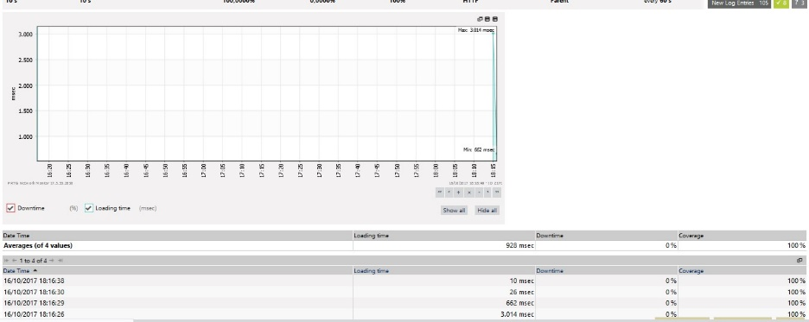

G.3 Http Response before doing XSSer tools exploitation using Parrot OS on OWASP web1 server

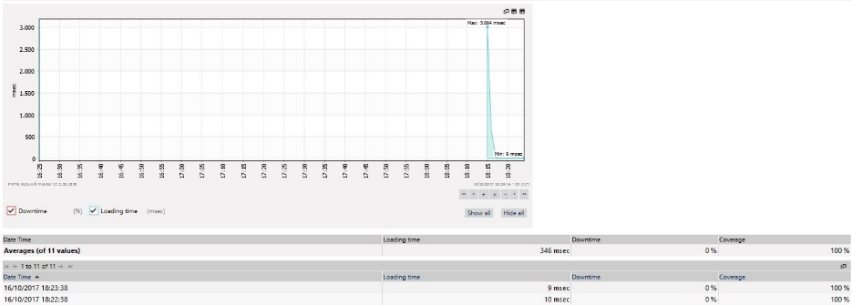

G.4 Http Response after doing XSSer tools exploitation using Parrot OS on OWASP web1 server

Description :
Before doing exploitation( Figure G.3 ), average response time was about 928 miliseconds, but after exploitation has been done( Figure G.4 ), the average maximal time has done to 346 miliseconds. Its mean that XSSer explotation didn’t affect OWASP web server Http Response time.
CPU Load Average :
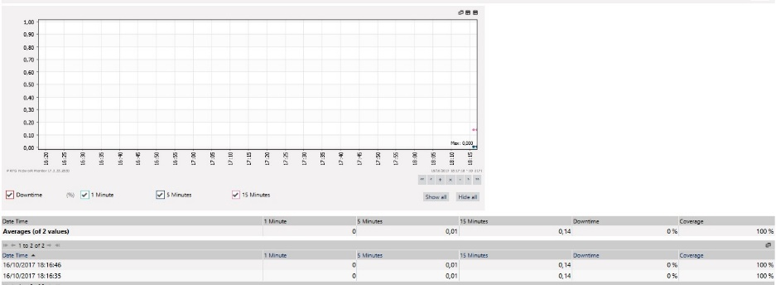

G.5 CPU Load before doing XSSer tools exploitation using Parrot OS on OWASP web1 server

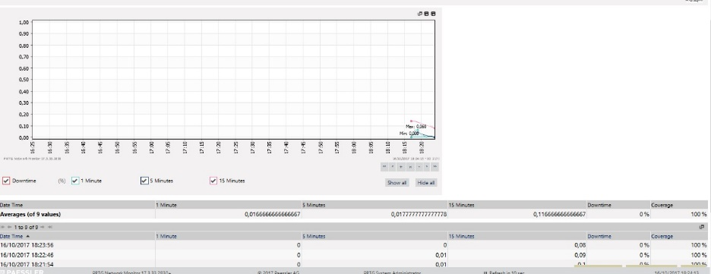

G.6 CPU Load after doing XSSer tools exploitation using Parrot OS on OWASP web1 server

Description :
CPU Load maximal time was increased after 9 attempts from 0 increase to 0,0166 Msec. But with this number it didn’t affect to much to the web server. ( Figure G.5 & G.6 )
Memory Free
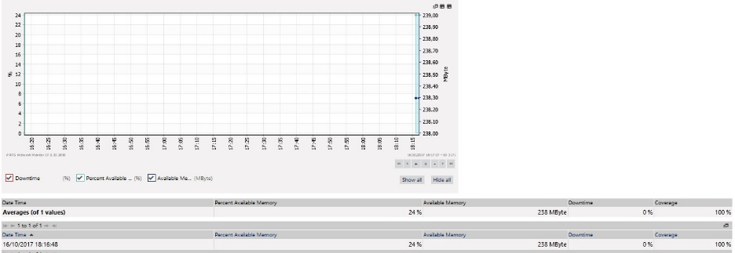

G.7 Memory Free before doing XSSer tools exploitation using Parrot OS on OWASP web1 server

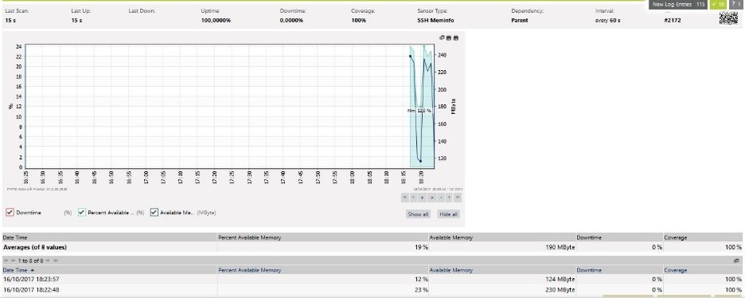

G.8 Memory Free after doing XSSer tools exploitation using Kali Linux OS on OWASP web1 server

Description :
After analyze from the Memory Change Log, the number of available memory was decreasing from 238 Mb to 190 Mb. ( Figure F.7 & G.8 )
Free Disk :
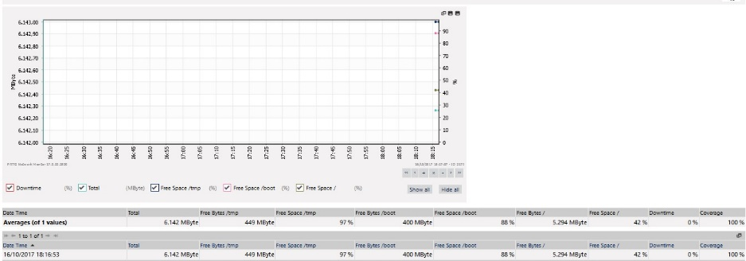

G.9 Free Disk before doing XSSer tools exploitation using Parrot OS on OWASP web1 server

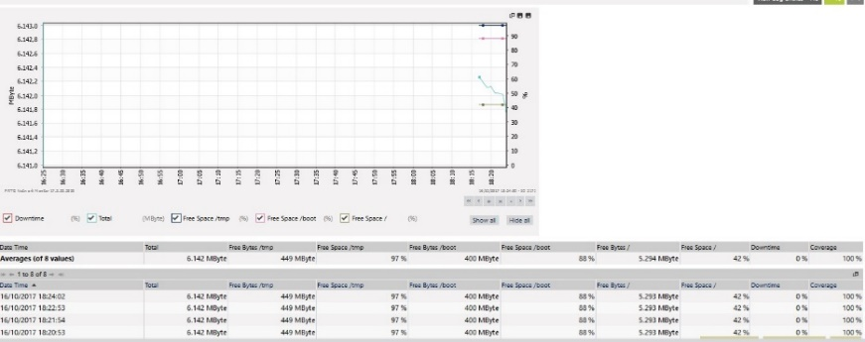

G.10 Free Disk after doing Xsser tools exploitation using Parrot OS on OWASP web1 server

Description :
The total of Free Disk was same 6.142, before and after exploitation. It didn’t show any affect change. ( Figure G.9 & G.10 )
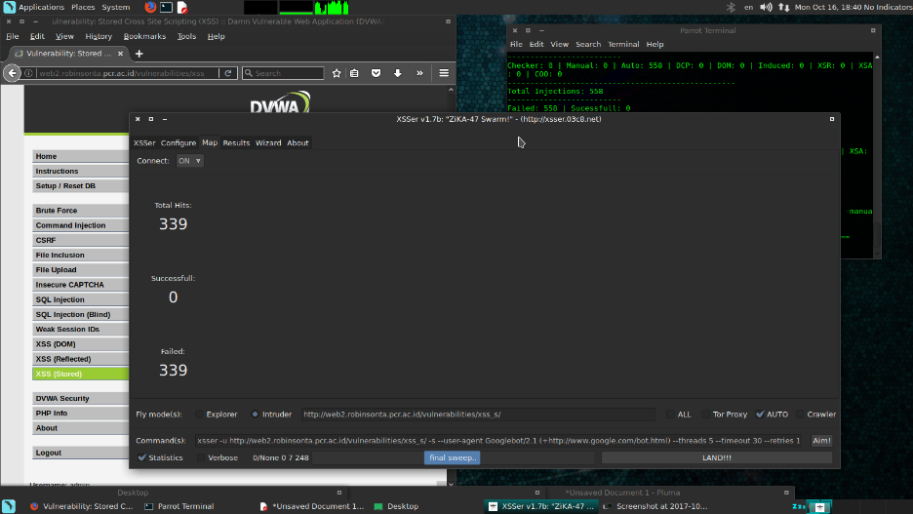
NO OWASP web2 server :

G.11 XSSer Parrot OS Exploitation failed to inject CSS query into NOOWASP web2 server

Even there wasn’t any Web application Firewall, XSSer still failed to do CSS Injection into web server. This may be cause that XSS work only in web page which still show .php in the end of the URL link. ( Figure G.11)
The test was done 10 times using XSSer, the result were all of the attempts were failed. The video of Parrot XSSer exploitation on NOOWASP web2 server will be attach later on the report CD.
Performance test also been done at the web server during do XSSer exploitation. Figures G.12-G.19 will show the comparison between HTTP response, CPU Load, Memory Free and Disk Free of web server before and after exploitation.
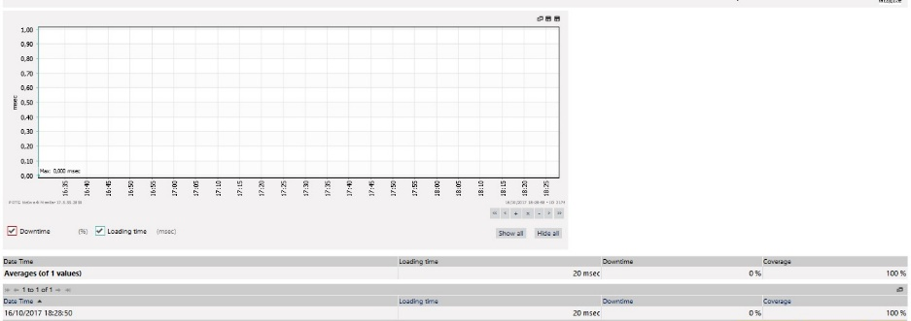
HTTP response :

G.12 Http Response before doing XSSer tools exploitation using Parrot OS on NOOWASP web2 server
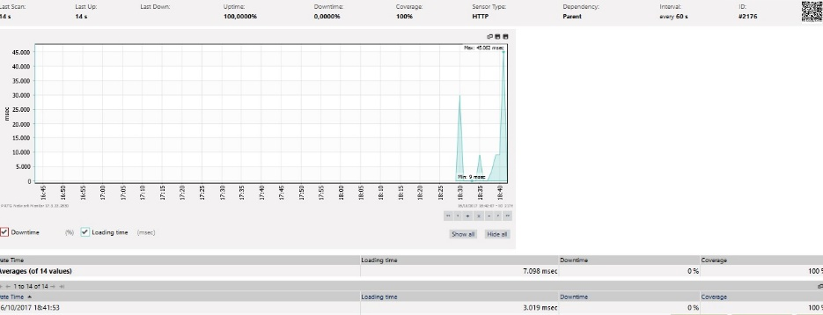

G.13 Http Response after doing XSSer tools exploitation using Parrot OS on NOOWASP web2 server

Description :
By looking at the Http Response log, response time before exploitation was 20 msec and after exploitation was 7.098 for 14 attempts value. Its mean there was not any affect to the response time. ( Figure G.12 & G.13 )
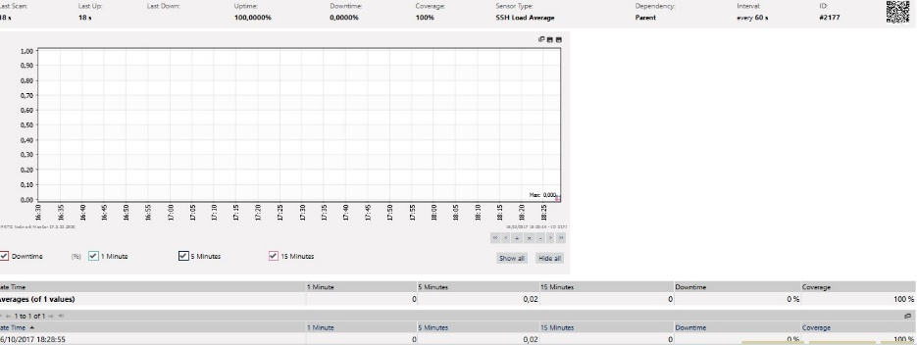
CPU Load Average :

G.14 CPU Load before doing XSSer tools exploitation using Parrot OS on NOOWASP web2 server

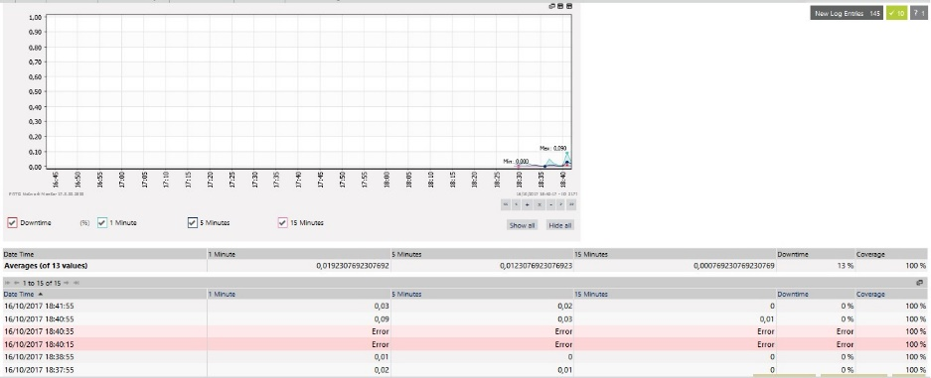
G.15 CPU Load after doing XSSer tools exploitation using Parrot OS on NOOWASP web2 server

Description :
The CPU Load logs show that the CPU Load increase from 0 to 0,019 with two times error after 13 times attempt values. ( Figure G.14 & G.15 )
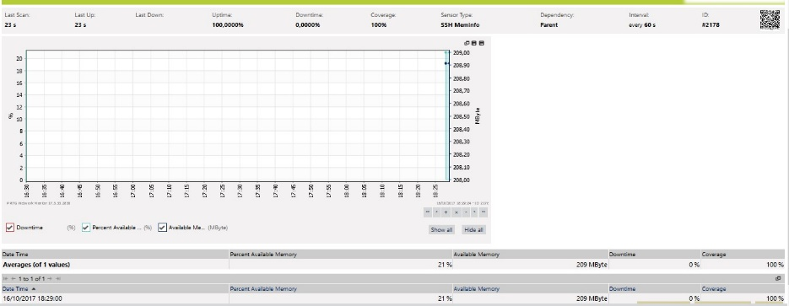
Memory Free

G.16 Memory Free before doing XSSer tools exploitation using Parrot OS on NOOWASP web2 server

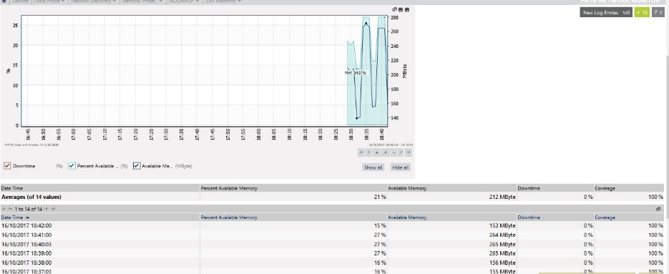

G.17 Memory Free after doing XSSer tools exploitation using Parrot OS on NOOWASP web2 server

Description :
Memory change Logs show there was a available memory jump during the exploitation but the number of available memory wasn’t change too much, from 209 to 212 MByte. ( Figure G.16 & G.17 )
Free Disk :
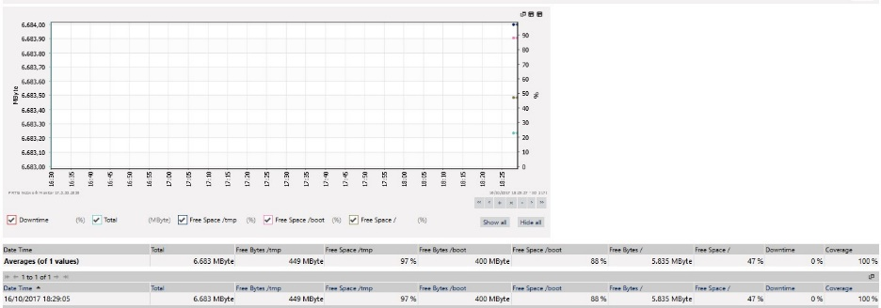

G.18 Free Disk before doing XSSer tools exploitation using Parrot OS on OWASP web1 server

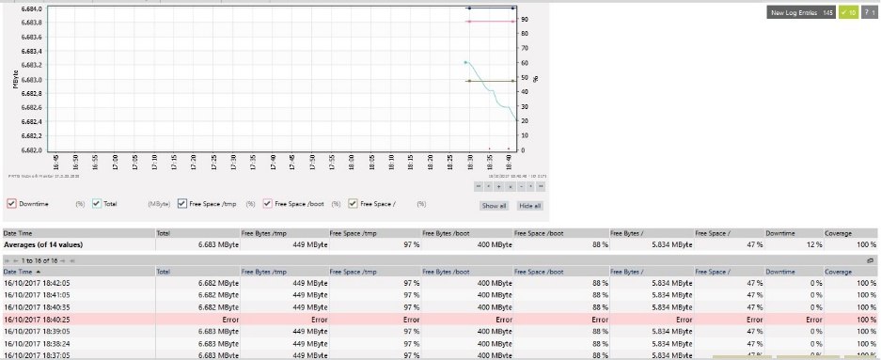

G.19 Free Disk after doing XSSertools exploitation using Parrot OS on OWASP web1 server

Description :
Free Disk Change Logs also show nothing change during the XSSer exploitation ( Figure G.19), the number of free disk stay in 6.683 MByte but there was a one error on the 14 attempts value.
- SQLMap Exploitation on PCR Sites on both web server
  - Kali Linux OS
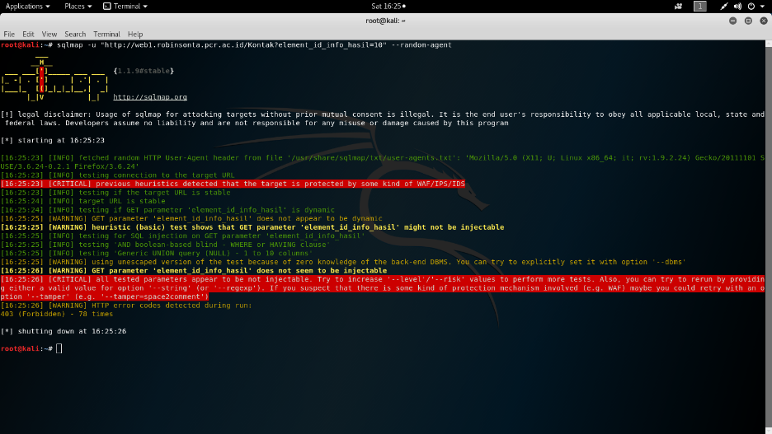
OWASP web1 server :
H.1 SQLmap Exploitation result to web1 server pcr site using Kali Linux

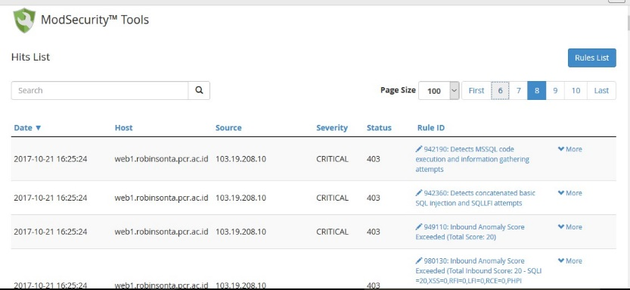

H.2 OWASP Hit List after SQLmap Exploitation on PCR site using Kali Linux OS

Hit list H.2 show the OWASP detect about 800+ logs during Kali Linux OS SQLmap Exploitation.

No owasp web2 server :
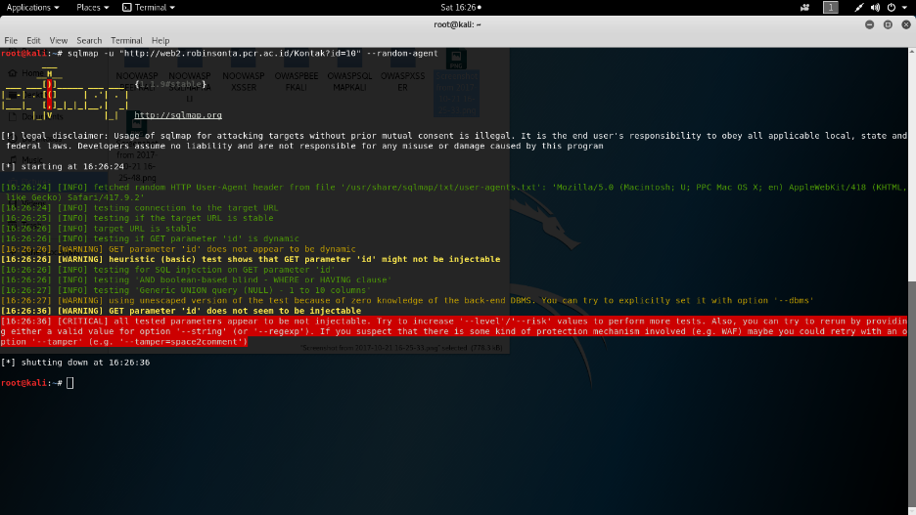
H.3 SQLmap Exploitation result to web2 server pcr site using Kali Linux

  - Backbox OS
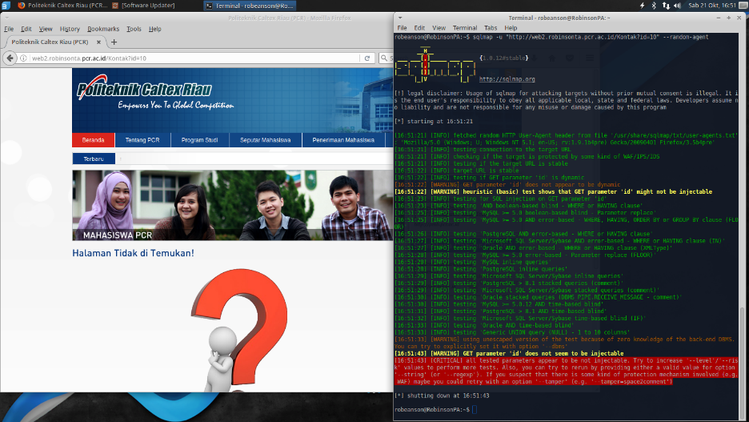
Owasp web1 server :

H4. SQLmap Exploitation result to web1 server pcr site using BackBox

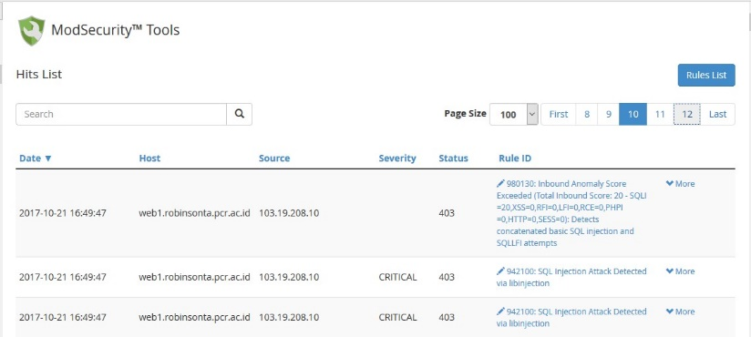

H.5 OWASP Hit List after SQLmap Exploitation on PCR site using BackBox OS

Hit list H.5 show the OWASP detect about 1000+ logs during Back Box OS SQLmap Exploitation.

No OWASP web2 server :
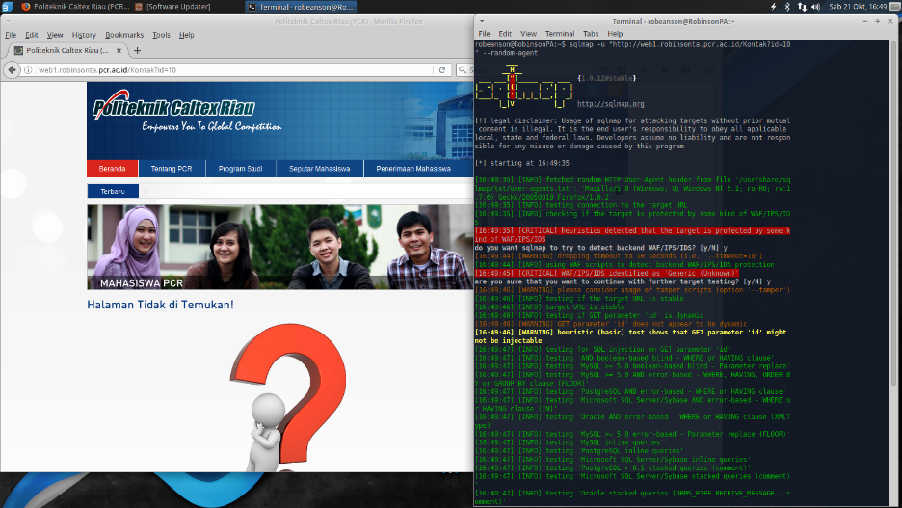

H.6 SQLmap Exploitation result to web2 server pcr site using BackBox

  - Parrot OS
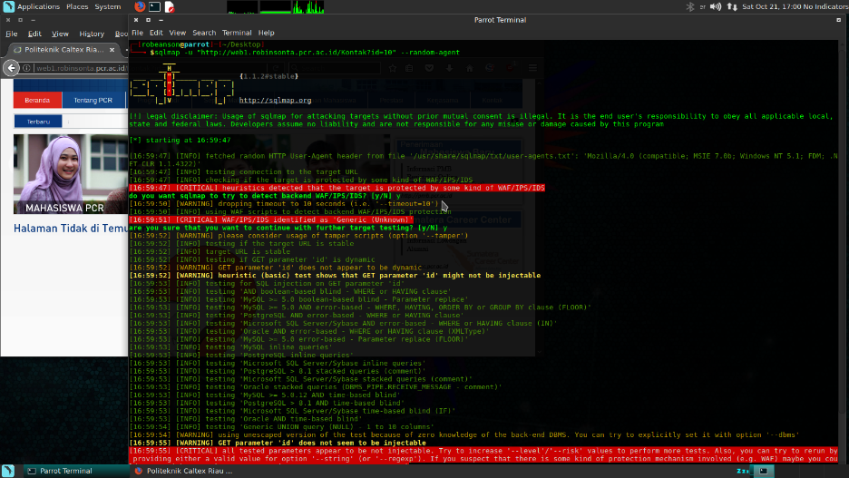
Owasp web1 server :

H.7 SQLmap Exploitation result to web1 server pcr site using Parrot

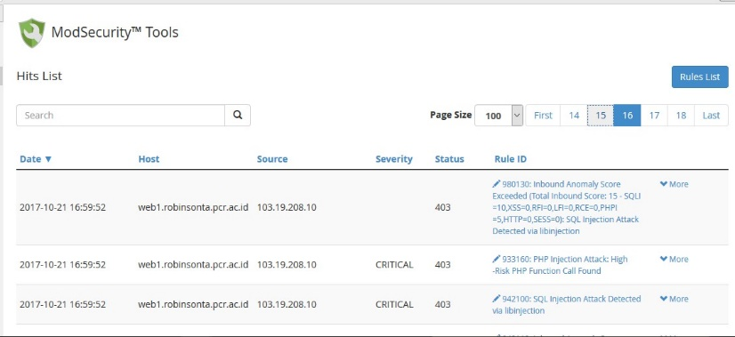

H.8 OWASP Hit List after SQLmap Exploitation on PCR site using Parrot OS

Hit list H.8 show the OWASP detect about 1600+ logs during Parrot OS SQLmap Exploitation.

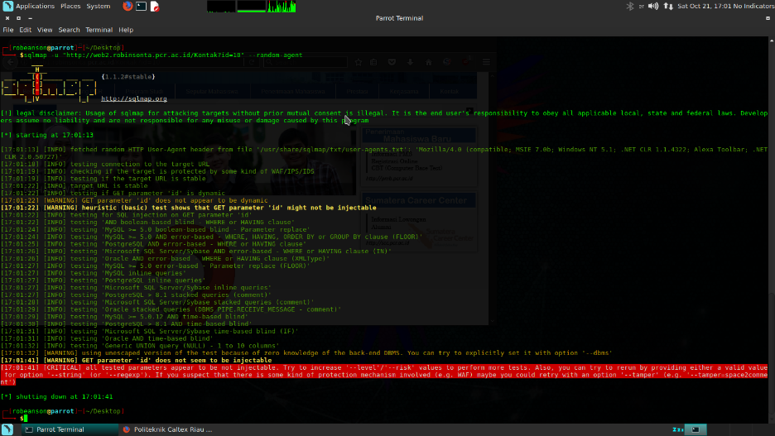
No OWASP web2 server :
H.9 SQLmap Exploitation result to web2 server pcr site using BackBox

- Performance Testing
Web Stress Configuration :
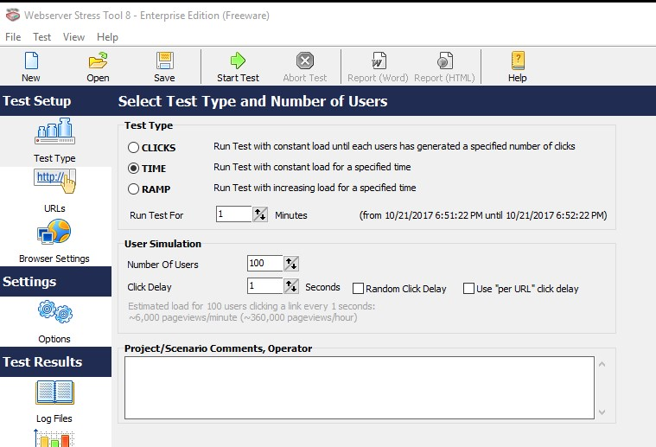

I.1 Web Stress Test Type Configuration

Figure I.1 show which test type that will be done for web server, the author choose time test type and run test for 1 Minutes with the number of users 100.
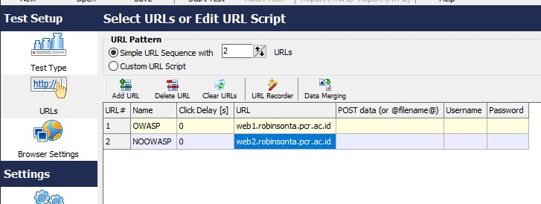

I.2 Web Stress URLs Configuration

There are two web application that will be test which are web1.robinsonta.pcr.ac.id and web2.robinsonta.pcr.ac.id ( Figure I.2 )

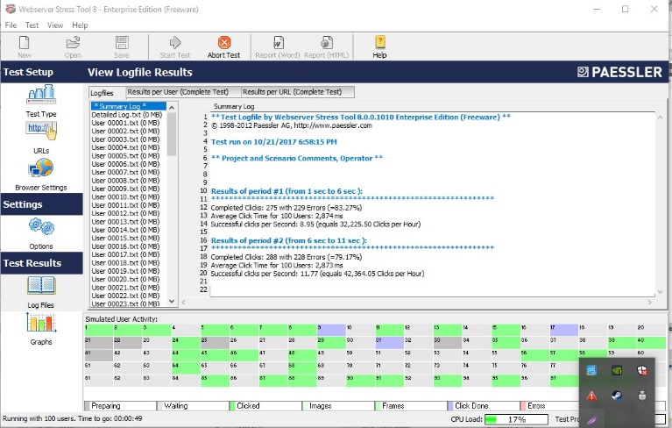
I.3 Web Stress on progress

Figure I.3 show that the test was on going.
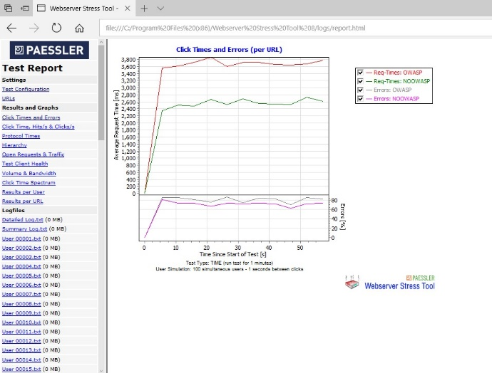
I.4 Web Stress Page Result

The Result of the test was shown in graphic mode with the information of the result. ( Figure I.4 )

During the web stress was done, PRTG also used for measuring the performance of both web servers with the result that will be show on Figure I.5 – I.12.
Performance Figures :
Http Response :
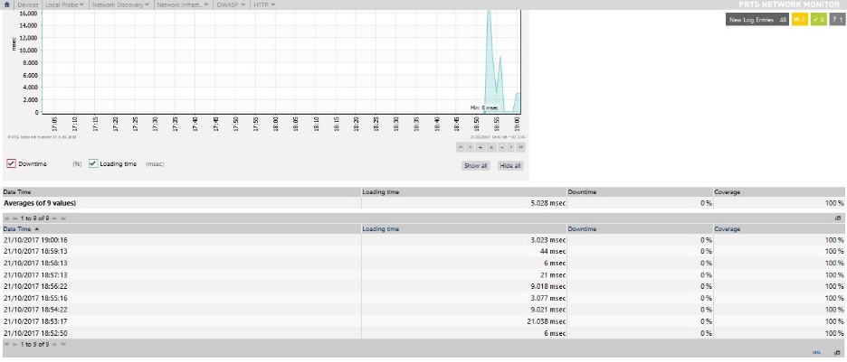
I.5 OWASP HTTP Response Result

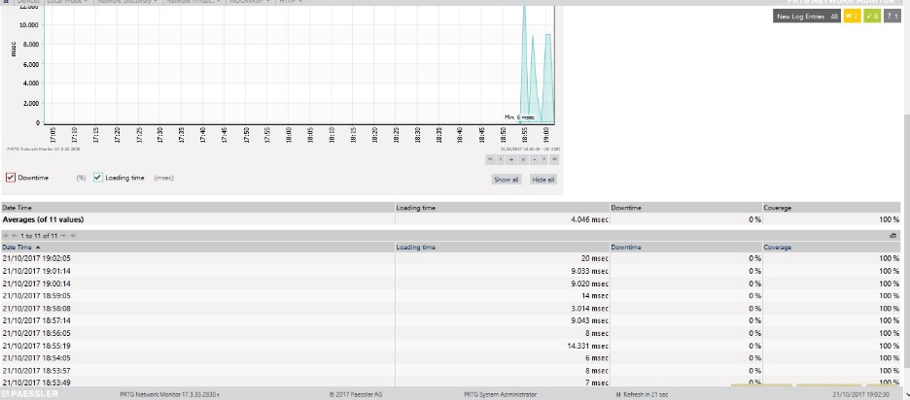
OWASP web server show the result 5.028 Msec response time on Figure I.5.

I.6 NOOWASP HTTP Response Result

NOOWASP web server show the result 4.046 Msec response time ON Figure I.6.
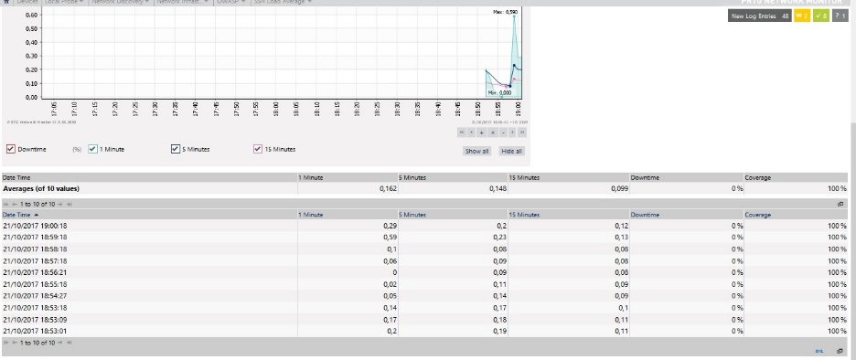
CPU Load :

I.7 OWASP CPU Load Result
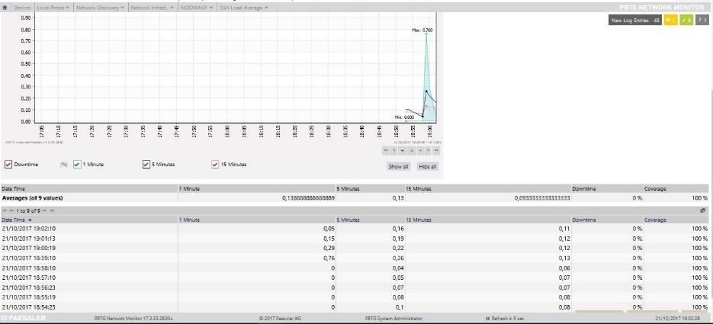
OWASP web server show the result 0.148 Load Time for 5 Minutes test on Figure I.7.

I.8 NOOWASP CPU Load Result

NOOWASP web server show the result 0.13 Load Time for 5 Minutes test on Figure I.8.

Free Memory :
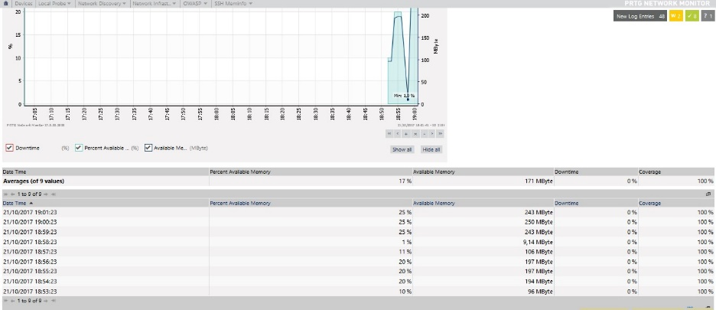
I.9 OWASP Free Memory Result

OWASP web server show the result 17% available memory or 171 Mbyte on Figure I.9.
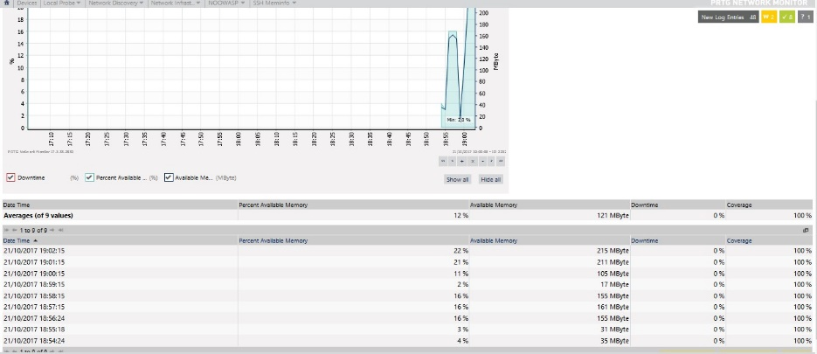

I.10 NOOWASP Free Memory Result
NOOWASP web server show the result 12% available memory or 121 Mbyte on Figure I.10.

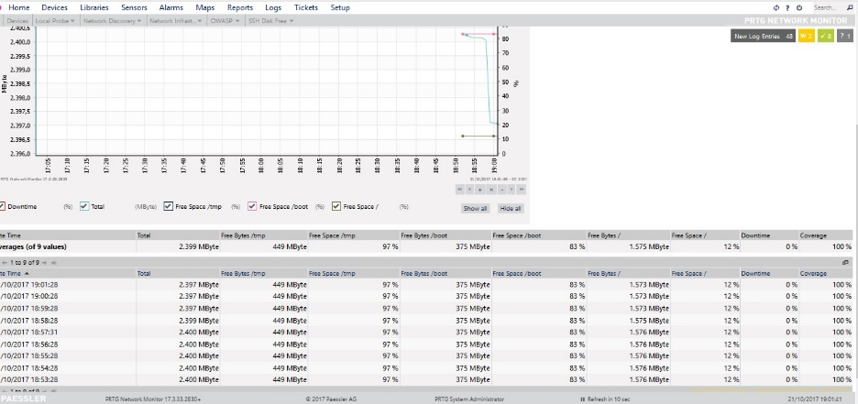
Free Disk :

I.11 OWASP Free Disk Result
OWASP web server show the result 2.399 Mbyte Disk Free after test on Figure I.11.
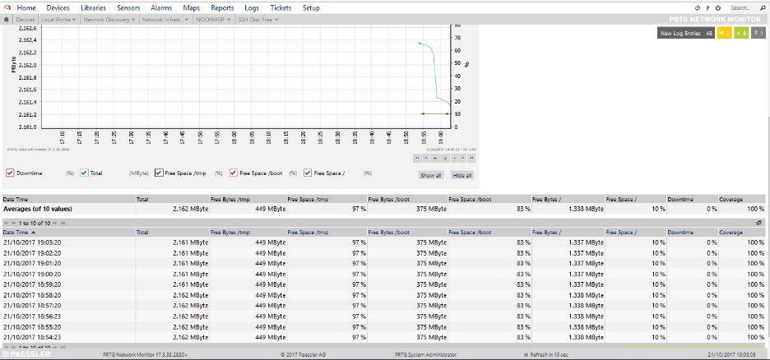
I.12 NOOWASP Free Disk Result

NOOWASP web server show the result 2.162 Mbyte Disk Free after test on Figure I.12.

